

**Including ‘end of life’ in the ageing portfolio**

**A Background Paper for Victorian Councils**

**The Victorian Councils: Supporting Communities Around End of Life Project**

**October 2019**

The *Victorian Councils: Supporting Communities Around End of Life Project* is a three-year collaborative project between the Municipal Association of Victoria and La Trobe University Palliative Care Unit, funded by the Department of Health and Human Services.

At the heart of the project is a new way of thinking about dying, death and bereavement and the need for society to have a better way to look after some of the most vulnerable people in the community.

*‘A good death gives people dignity, choice and support to address their physical, personal, social and spiritual needs.’*[1]

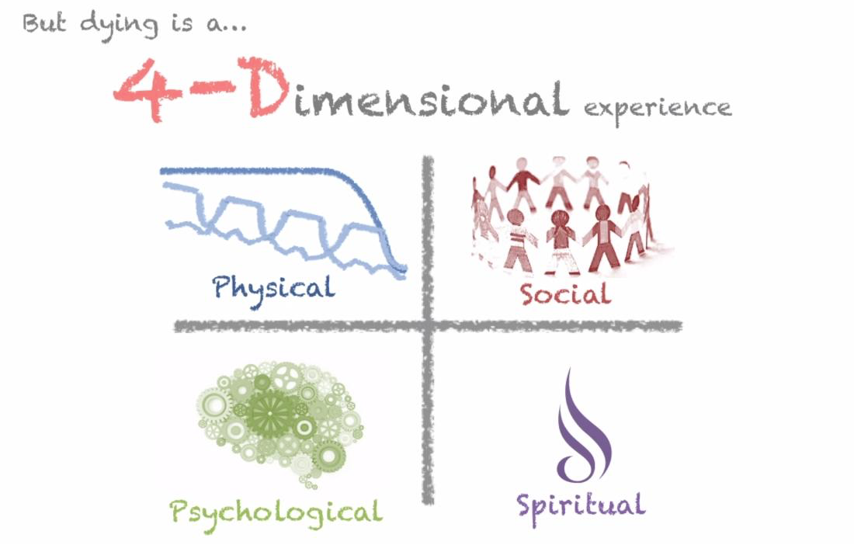

# 

# 

Image: Palliative care from diagnosis to death

*BMJ* 2017; 356 doi: <https://doi.org/10.1136/bmj.j878> (Published 27 February 2017) Cite this as: BMJ 2017;356:j878

Contents

Introduction 4

The Victorian Councils: Supporting Communities Around End of Life Project (the Project) 4

Why consider end of life in local government ageing discussions? – some key questions 5

Discussion context 6

A cultural change around how community and individuals deal with death 6

Medicalisation of death 6

Victoria’s Palliative Care Framework 7

Public Health context 7

Greater choices around end of life 8

Ageing populations and impact of death, dying and bereavement 9

Building community compassion 10

Issues impacting on end of life decisions 10

What are the opportunities for local government 11

At a strategic level 11

At a community/ support level 11

References 13

Attachment 1: Morbidity by LGA 14

# Introduction

## The Victorian Councils: Supporting Communities Around End of Life Project (the Project)

*The Victorian Councils: Supporting Communities Around End of Life Project* (the Project) is a partnership between the Municipal Association of Victoria (MAV) & La Trobe University Palliative Care Unit (LTUPCU) funded by the Department of Health and Human Services (DHHS) for three years (2017-2019). The overall aim of the Project is to explore how local government can be involved in building the capacity of communities to better accept that dying is a part of life and encourage more Victorians to actively participate in caring and supporting people at the end of their lives, at home and in their community.

The Project is operating at a time when the concept, understanding and responses to end of life are being challenged with an increasing push for dealing with death as a social (not just a medical) event. Understanding death in a social context[2] provides the overarching context of the Project and the reason behind funding an end of life project in local government.

To date, the Project has been well received in the positive ageing area and many councils have developed initiatives and actions to engage with their community on dying, death and bereavement.

The Project is now broadening its focus to include local government health and wellbeing planning and to explore opportunities arising out of the aged care reforms.

This paper is an internal MAV document aimed at facilitating discussion with councils on the rationale and potential for including end of life (as defined in the Project) considerations in councils future role in ageing. This paper presents the findings of a MAV scoping exercise exploring the context, rationale and opportunities for local government to consider end of life in its future role in ageing discussions.

What do we mean by end of life?

A number of terms, definitions and concepts are used when referring to dying, death and bereavement. ‘End of life’ is commonly used, however end of life is interpreted differently in different settings. For example, end of life can be associated with assisted dying, palliative care, end of life care or death itself.

For the purposes of the Project, a broad definition of end of life was developed to illustrate dying, death and bereavement as part of everyday life. Importantly, it was necessary to distinguish end of life as defined in our project from assisted dying, palliative care services and/or end of life care.

End of life as used in the Project refers to:

‘the period of time around dying and death and the impacts of this on the dying person, their family and their wider social and community networks’.

For more information about the Project and Project resources developed for councils please see:

[www.mav.asn.au/what-we-do/policy-advocacy/social-community/positive-ageing/end-of-life-project](http://www.mav.asn.au/what-we-do/policy-advocacy/social-community/positive-ageing/end-of-life-project)

# Why consider end of life in local government ageing discussions? – some key questions

# 

Does the ‘ageing well’ focus of local government extend to include a ‘good death’ or a ‘healthy dying’? Should it?

There is a tendency in ‘ageing well’ – a key outcome of councils work with ageing populations – to not include dying, death and bereavement. With a focus on wellbeing for maintaining independence and longevity, it appears that (healthy) dying has been an oversight.

Dying and death have become institutionalised and somewhat removed from everyday life. Dying in Australia is more institutionalised than the rest of the world.[3] Most people prefer to die at home or in a home like environment, however for the majority of people this does not happen. A failure to talk about and plan for death is one of the most significant obstacles to improving the quality of dying.[4] Across the globe, there has been an emergence of ideas, initiatives, campaigns and strategies to facilitate community conversations and ‘normalise’

What role could councils’ play in facilitating community conversations on dying, death and bereavement?

death as part of everyday life.

With an ageing population and the impacts of death on population wellbeing is there a role for council? What could this look like?

At any one time a significant proportion of the population is impacted by dying, death and bereavement. For every death, the impact can extend to famly, friends, carers, neighbours and professionals. However, with the institutionalisation of death and its removal from everyday life – the impact of death at a population level are not well understood.

Do the aged care reforms present an opportunity for LG to discuss how it might contribute to more compassion and capacity in the community to support a ‘good death’?

The concept of a ‘good death’ is emerging in policy, practice and in the community. A good death is considered to involve the individual person, their family and their community as well as the medical sector, if required. This shift involves a greater emphasis on providing services in the community and the importance of partnerships between the many services and supports around end of life. This concept promotes death as everybody’s responsibility.

# 

Is there a role for council ageing areas to support the ‘social setting’ side of end of life? For example, building knowledge in the community around end of life.

As people approach the end of their lives, the majority of caring occurs outside of the medical setting, namely by carers, family, friends and the community. In this ‘social setting’ people need a range of supports including information, respite and assistance with navigating a complex service system. An important area for development is how the ‘social setting’ or informal caring interfaces with the formal services.

# Discussion context

## A cultural change around how community and individuals deal with death

A drive to change how society views and deals with dying, death and bereavement is gaining momentum across the globe, driven by a number of factors including an ageing population, the emergence of the ‘compassionate communities’ movement and responses to the ‘medicalisation’ of death. Governments and communities (in the United Kingdom in particular) have been concerned about the ‘removal’ of death from everyday life and a consequent reduced capacity in communities to understand, support and manage death.

A ‘good death’ or a ‘healthy death’ is reported to be hindered by a lack of conversation/ understanding and/or acceptance of dying, particularly in western society. The momentum referred to above about changing the way society deals with end of life includes the many different approaches that are emerging to bring ‘the conversation’ into families and communities. How local government can help facilitate these conversations in the community has been a focal point of the project so far.

*We need the courage to promote mature discussions about a topic that may dislike, but that we cannot avoid*.’[5]

## Medicalisation of death

Medical, social advances and developments to eliminate and/or manage illness and health conditions are entwined with the medicalisation of death. This has had a profound impact on ageing, life expectancy, capacity to live with life threatening illnesses and ultimately how death is viewed and experienced by individuals, families and communities.

It could be argued that the impact of this situation, is that death has become the domain of the medical sector with little understanding and attention to death in (other) policy, planning or community sectors such as local government. An example of this is the relative absence of inclusions of death or end of life in health and wellbeing plans where much is promoted to improve wellbeing for living but stops short of including dying.

Current thinking around a ‘good’ death promotes the normalisation of death as part of life and acknowledges the intersections that death involves family, carers and community in addition to the medical sector. It is within this context that this Project aims to explore with local government the concept and rationale for giving some attention to expanding the focus in ageing to include end of life.

*‘This social approach returns the* responsibility *for care to whole communities, rather than solely health services, or dying persons and their carers, in isolation from the communities in which they live’*.[6]

## Victoria’s Palliative Care Framework

The recently released Victorian Palliative Care Framework embraces a new approach and direction that reflects greater choice for people about the care they receive as they approach the end of life.

The Framework:

* emphasises a person-centred approach
* promotes dying as part of life (a key principle guiding the Framework)
* promotes engaging with communities and embracing diversity as key priority areas, and
* includes local government agencies, clubs and organisations, to play a role in providing people with access to services and enhancing end of life awareness. This includes encouraging and facilitating people to have conversations about what matters to them to live well, to die well and to put plans in place for the future.

Palliative care is commonly understood and associated with end of life care however, there are a number of different practices and approaches to palliative care.

Health Promoting Palliative Care (HPPC) began with the formation of the LTUPCU (1998) but has been discussed since the turn of the century*.* Importantly, HPPC promotes engagement with communities around dying, death and bereavement and building community capacity through conversations, activity, information provision, public education and awareness raising and community development.

HPPC is important to understand as the philosophy or approach that underpins the aims of the Project and the rationale for exploring possible roles from local government around end of life.

## Public Health context

The relationship between Public Health and Palliative Care has not always been evident or well understood.

The public health approach to end of life promotes ‘good health – good death’ and is concerned with the health and wellbeing impact that dying, death and bereavement have on a person, a family and a community. The public health approach promotes death as a social event.

HPPC promotes engagement with communities around dying, death and bereavement and the building of community capacity through conversations, activity, information provision, public education, awareness raising and community development.

The project is currently engaging local government Health and Wellbeing Planners to discuss the links between public health and end of life and potential opportunities for councils to include end of life in their health and wellbeing plans.

## Greater choices around end of life

The Victorian Palliative Care Framework promotes the need for people to have greater choices around where people wish to die. The Framework emphasises a person centred approach for delivering care according to people’s preferences and goals.

A 2015 Victorian Government consultation ‘Greater say for Victorians: improving end-of-life care’ generated a diverse range of views on what is important for people at the end of their lives. A recent United Kingdom end-of-life care consultation generated a similar diversity of views which were distilled into seven main themes that mirrored the recent Victorian experience—see figure below.[7]

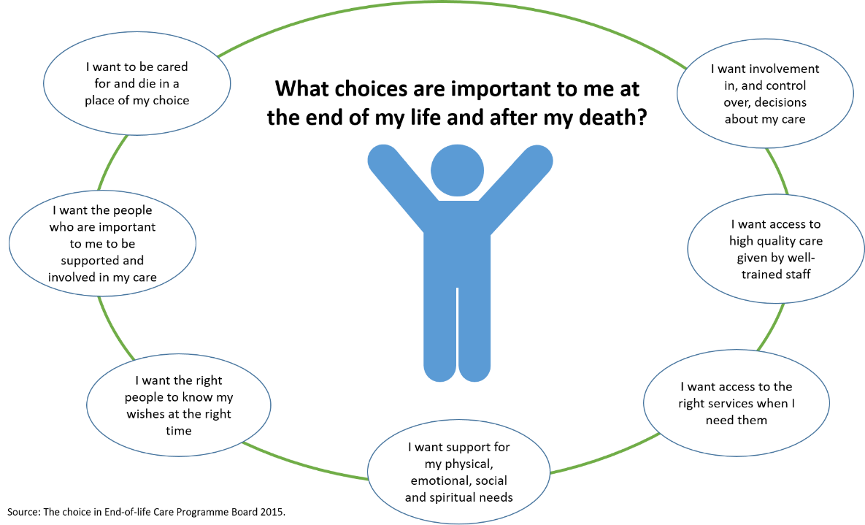

That many people with a life-limiting illness die in hospital when they would have preferred to die at home is continually reported and referred to in discussions around end of life choices. This scoping exercise however, found a need to further unpack what constitutes dying ‘at home’.

What is meant by ‘at home’ – does this include home like settings such as residential care?

What would need to happen both in services and in the community for more people to die in their place of choice?

*‘It is important that death at home becomes a real choice for people and that people and services understand what is necessary for this to be done and done well’.[8]*

## Ageing populations and impact of death, dying and bereavement

Life expectancy in Australia continues to increase, reaching 80.3 years of age for males and 84.4 years of age for females.[9] Over time as the population grows and ages, the number of deaths is projected to increase.[10]

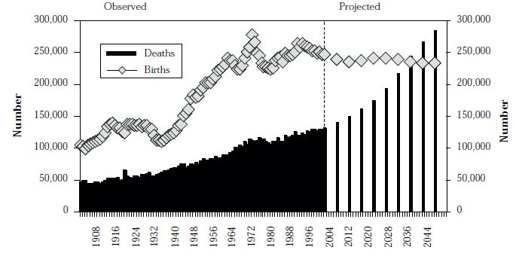

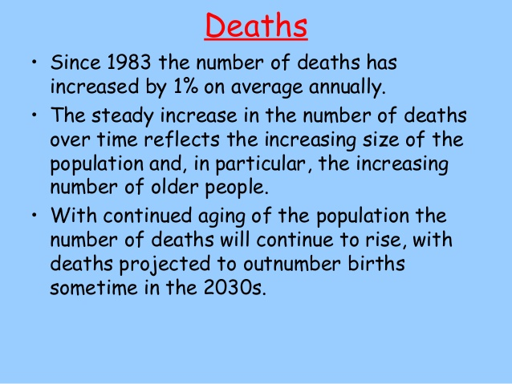

Australia’s Unique Human Characteristics 2013[11]

Births and Deaths Australia 20th century &projected [12]

Death statistics per LGA (see Attachment 1) indicate the number of deaths in any one community however, the impact of this death can expand beyond the individual to carers, family, community, and professionals. Impacts can include bereavement, isolation, loneliness, depression and health issues to name a few. Anecdotally, older people often refer to their life trajectory as one of loss – increasingly losing partners and friends.

*The impact of a single death affects a wider network of carers, family, friends, employers and communities, and has a direct impact on population health*.*[13]*

This scoping exercise found a number of resources developed for communities to deal with loss and grief associated with unexpected deaths or trauma, however, relatively little information with regard to the impact of expected normal deaths on the wider community. Given the number of people in any one community that may be impacted by a death, in particular older people, the absence of attention given to this in services, policy, strategies, (including age-friendly strategies, health and wellbeing strategies), is worthy of discussion.

*‘Death, dying and loss are universal experiences that have a major impact on health and wellbeing at a population level and are associated with significant burden and cost. Demographic, epidemiological and societal factors suggest that without action, this burden will increase’*.[14]

The above points provide some discussion topics on how local government can be involved around end of life.

## Building community compassion

Compassionate Communities is described as a global movement to engage communities to think about how care is provided to people who are dying.

‘*A compassionate community is a community that cares for and supports one another, particularly individuals at end of life and their families and carers. This approach relies on strong partnerships between the dying person, their families and carers, friends, local community, service providers, volunteers, community organisations and government and non-government agencies’*.[15]

The role of councils in their communities places them in an ideal position to build community capacity around particular issues or needs such as end of life. This could include facilitating connections between stakeholders, distribution of information, connecting people to supports and supporting carers. These could have significant impact on positive outcomes for the dying person and their carers.

## Issues impacting on end of life decisions

The scoping exercise identified a number of issues that impact on end of life decisions including the capacity for idividuals and their support network to carry out a persons end of life wishes. The many different capacities and circumstances that impact on decisions around end of life need to be realistically factored into compassionate communities and a good death discussions.

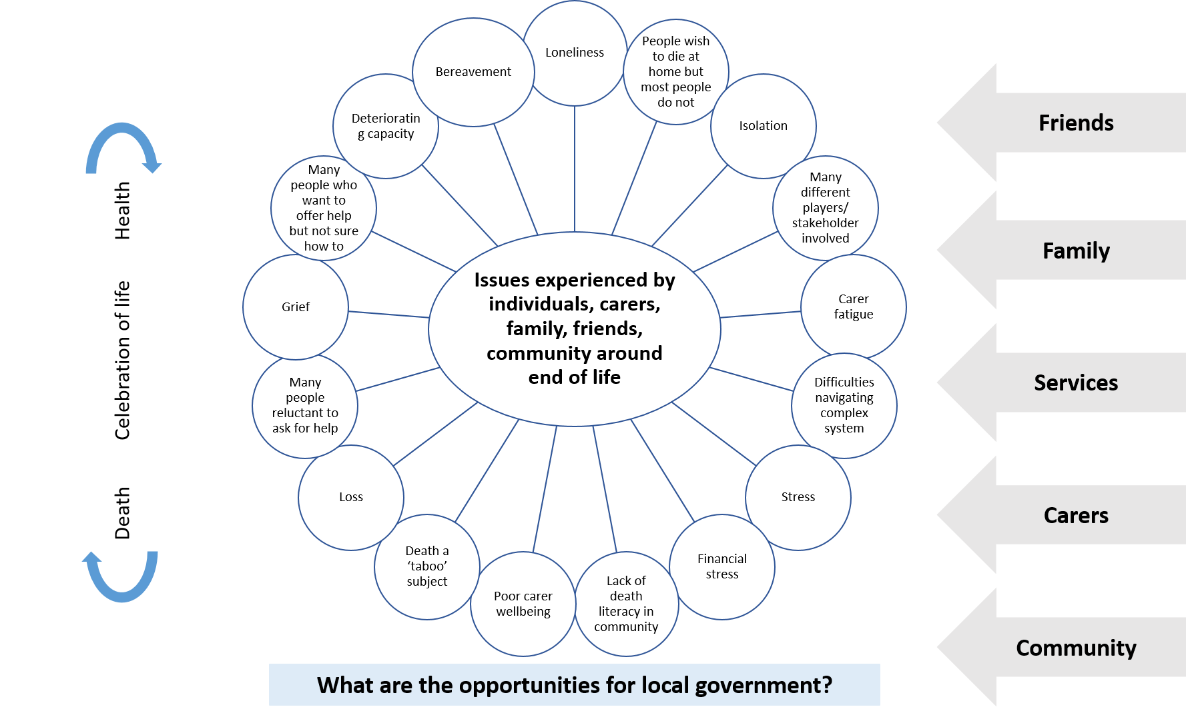

# What are the opportunities for local government

### At a strategic level

* Discuss the opportunities and possibility of end of life (as defined in the Project) being included in council’s role in supporting its ageing population.
* Expand healthy ageing to be inclusive of the last stages of life – for example, healthy ageing policy and strategies include end of life, public health and wellbeing plans include end of life.
* Explore the potential of local government to become further engaged with the support environment (not service delivery) around end of life – for example taking on a ‘information/connector’ role between the community and informal and formal services and supports. This role could include information on services and navigating the system for families and community.
* Expand workforce training for aged care workers/positive ageing workforce to build knowledge around end of life and possible support and service options available for individuals, carers, families.
* Explore opportunities presented through the Compassionate Communities movement to strengthen capacity in the community to support people to remain in their community or place of choice, as they live out the last stages of their lives.

### At a community/ support level

* Contribute to strengthening community understanding around death as a normal part of life – for example participate in Dying to Know Day, a national day promoting conversations about death and grief in the community, intergenerational activities promoting acceptance of ageing and death as part of normal life.
* Strengthen age friendly concept to include people at all stages of their life in council programs (eg, commonly as ones health deteriorates they stop attending social support/activities/ programs).
* Promote the importance of older people and their families to plan ahead for living out the last stages of their lives – for example, promote advance care planning at events, promote end of life support options that exist in the community.

*‘Failure to talk about and plan for death is one of the most significant obstacles to improve the quality of dying*.’[16]

An end of life service system environment diagram 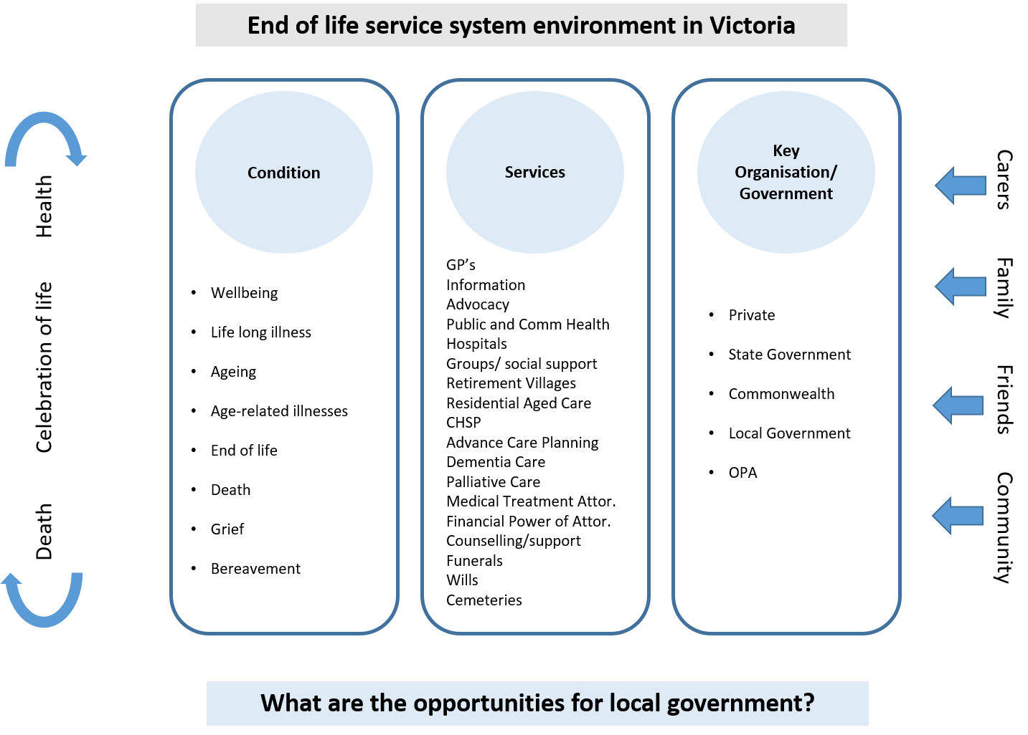is presented below to assist council discussions on potential roles and opportunities for local government to support improvements to how people, families and communities experience dying, death and bereavement.

## References

Auditor General, Palliative Care, 2015

Australia’s Health 2016 AIHW

Australian Senate (2012) Senate Community Affairs Reference Committee: Palliative Care in Australia, Australian Senate

Changing patterns of mortality reflect ageing population ABS 2016

Compassionate Communities – A Tasmanian Palliative Care Policy Framework 2017-2021

Dying well Hal Swerissen and Stephen Ducket Grattan Institute September 2014

End of life at Home creating an Ecology of Care Research report, Western Sydney University Horsfall, A Leonard, R.J Noonan, K Rosenberg 2015

Solutions Strategy Research Facilitation Ltd for Public Health England Developed with: PHE’s Chief Knowledge Officer and Health and Wellbeing directorates © Crown copyright 2016

The Policy Makers Guide to population ageing: Key concepts and issues. Figure 9 Births and Death Australia 20th Century and projected Department of Social Security

The rationale for a public health approach, Scottish Public Health Care Network Palliative and end of life care in Scotland: Michelle Gillies February 2016 p.49

Victoria in Future 2016, Victorian State Government

## Attachment 1: Morbidity by LGA

|  |  |  |
| --- | --- | --- |
|  | **2016** |  |
|  | Deaths | Standardised death rate |
|  |  |  |
| Alpine | 128 | 5.6 |
| Ararat | 119 | 5.8 |
| Ballarat | 806 | 6.1 |
| Banyule | 797 | 4.7 |
| Bass Coast | 324 | 5.5 |
| Baw Baw | 375 | 5.5 |
| Bayside | 799 | 4.4 |
| Benalla | 160 | 6.1 |
| Boroondara | 1,144 | 4.4 |
| Brimbank | 1,119 | 5.4 |
| Buloke | 109 | 6.7 |
| Campaspe | 349 | 5.9 |
| Cardinia | 445 | 5.6 |
| Casey | 1,247 | 5.3 |
| Central Goldfields | 219 | 7.5 |
| Colac-Otway | 216 | 6.3 |
| Corangamite | 155 | 6.2 |
| Darebin | 1,029 | 5.5 |
| East Gippsland | 495 | 5.9 |
| Frankston | 956 | 5.8 |
| Gannawarra | 119 | 5.5 |
| Glen Eira | 929 | 4.5 |
| Glenelg | 193 | 6.1 |
| Golden Plains | 115 | 6.9 |
| Greater Bendigo | 962 | 6.1 |
| Greater Dandenong | 1,057 | 5.7 |
| Greater Geelong | 1,993 | 5.9 |
| Greater Shepparton | 484 | 6.2 |
| Hepburn | 147 | 6.0 |
| Hindmarsh | 72 | 5.8 |
| Hobsons Bay | 606 | 5.4 |
| Horsham | 174 | 5.5 |
| Hume | 847 | 5.5 |
| Indigo | 131 | 6.4 |
| Kingston | 1,030 | 4.8 |
| Knox | 1,007 | 5.3 |
| Latrobe | 724 | 7.1 |
| Loddon | 75 | 5.9 |
| Macedon Ranges | 307 | 5.3 |
| Manningham | 888 | 4.2 |
| Mansfield | 70 | 5.4 |
| Maribyrnong | 440 | 6.0 |
| Maroondah | 806 | 5.6 |
| Melbourne | 376 | 4.4 |
| Melton | 452 | 5.7 |
| Mildura | 464 | 6.1 |
| Mitchell | 208 | 5.4 |
| Moira | 350 | 6.4 |
| Monash | 1,270 | 4.6 |
| Moonee Valley | 731 | 4.8 |
| Moorabool | 195 | 5.7 |
| Moreland | 1,184 | 5.5 |
| Mornington Pen | 1,471 | 5.2 |
| Mount Alexander | 184 | 5.5 |
| Moyne | 124 | 5.9 |
| Murrindindi | 112 | 5.7 |
| Nillumbik | 268 | 5.0 |
| Northern Grampians | 147 | 6.5 |
| Port Phillip | 455 | 4.9 |
| Pyrenees | 82 | 6.6 |
| Queenscliffe (B) | 31 | np |
| South Gippsland | 254 | 5.5 |
| Southern Grampians | 168 | 6.1 |
| Stonnington | 631 | 4.4 |
| Strathbogie | 108 | 5.8 |
| Surf Coast | 184 | 4.9 |
| Swan Hill | 191 | 6.1 |
| Towong | 74 | 5.9 |
| Wangaratta | 279 | 5.7 |
| Warrnambool | 292 | 5.9 |
| Wellington | 383 | 6.3 |
| West Wimmera | 47 | 7.7 |
| Whitehorse | 1,168 | 4.5 |
| Whittlesea | 918 | 5.3 |
| Wodonga | 242 | 5.7 |
| Wyndham | 762 | 5.6 |
| Yarra | 394 | 5.1 |
| Yarra Ranges | 895 | 5.2 |
| Yarriambiack | 92 | 5.7 |
| **Victoria** | 39450 | 5.3 |

1. Dying well Hal Swerissen and Stephen Ducket Grattan Institute September 2014
2. An event that is not only a medical event but a social or societal event that occurs in the community, by the community
3. Dying well Hal Swerissen and Stephen Ducket Grattan Institute September 2014
4. Dying well Hal Swerissen and Stephen Ducket Grattan Institute September 2014
5. Dying well Hal Swerissen and Stephen Ducket Grattan Institute September 2014
6. End of life at Home creating an Ecology of Care Research Report Horsfall, A Leonard, R.J Noonan, K Rosenberg Western Sydney University 2015
7. Australia’s Health 2016 AIHW
8. Ibid
9. Changing patterns of mortality reflect ageing population ABS 2016
10. Victoria in Future 2016, Victoria State Government
11. https://www.slideshare.net/nelle17281/demographiccharacteristics
12. Department of Social Security, The Policy Makers Guide to population ageing: Key concepts and issues. Figure 9 Births and Death Australia 20th Century and projected
13. Solutions Strategy Research Facilitation Ltd for Public Health England Developed with: PHE’s Chief Knowledge Officer and Health and Wellbeing directorates © Crown copyright 2016
14. Scottish Public Health Care Network Palliative and end of life care in Scotland: The rationale for a public health approach Michelle Gillies February 2016 p.49
15. Compassionate Communities – A Tasmanian Palliative Care Policy Framework 2017-2021
16. Australian Senate (2012) Senate Community Affairs Reference Committee: Palliative Care in Australia, Australian Senate