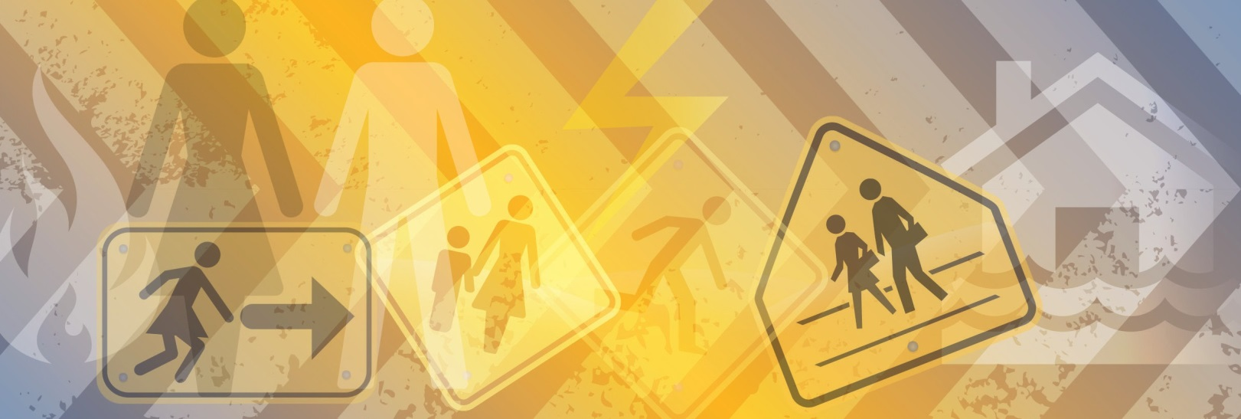
Recovering From Disaster:
Men and masculine expectations
Case study

Graham recently stayed and successfully defended the family home during a significant bushfire. During the bushfire Graham’s family and many people in his small community chose to leave early, some houses were unfortunately lost including his neighbours property. There was no loss of life. Graham’s workplace was affected by the fire and it is unclear when he will be able to return to work.
Whilst Graham successfully defended the family home the experience was extremely traumatic and he feared for his life on a number of occasions. Graham also feels guilty he could not save his neighbour’s property. Graham’s friends think he is a hero and often ask him to recall stories of the day.
Graham’s family has noticed that he is becoming increasingly withdrawn, drinking more and is quicker to anger and lash out. Graham’s wife has tried talking with him about his change in behaviour and the possible trauma of the day but Graham assures her everything is okay. Graham has also declined the offer of counselling sessions.

Research tells us
- Post Black Saturday men were observed to be suffering psychologically due to their inability to fulfil their expected roles as protectors and providers for their families, and their tendency to withhold their emotions. This was found to be linked to increased rates of violence against women¹.
- Employment is often closely linked to male identity, and loss of employment can lead to feelings of inadequacy on the part of men, who feel themselves unable to fulfil the traditional masculine role of provider for the family, leading to negative effects on health and well-being².
- Accessing help for mental health problems is much lower among men than among women in all age groups. Instead, men have a higher tendency to manage emotional and mental health issues through silence, avoidance and denial³.
- Barriers to men seeking help may include not recognising symptoms, preferring to work it out alone, not knowing the right service, not prioritising healthcare, and services not being male-friendly⁴.
- Often men see formal counselling services as better suited to women⁵.

¹ Men on Black Saturday: Risks and opportunities for change, Zara, C., & Parkinson, D. (2013)
² ³ ⁴ ⁵ ibid
Recovering from Disaster:
Men and masculine expectations

Case study

Action local government can take
Women’s Health Goulburn North East – Men and Disaster Snapshots⁶ provide a number of constructive actions local government can take:

- Ensure recovery planning and programs take into account the ways men would like to access services.
- Broaden options for gender-aware psychological and social supports to help reduce stigma and ensure that alternatives to one-on-one counselling are available.
- Promote Men’s Shed activities and similar programs to include outreach to younger men, art, music and other activities, including conversation on preparedness and recovery.
- Ensure that support services and social options operate at a range of times to allow access by those unavailable from 9am to 5pm. Support services that are located outside the local area can also be helpful particularly if men travel to other locations to work.
- Choose alcohol-free premises for events, modelling effective mental health awareness campaigns.
- Ensure comprehensive training (including family violence training) for emergency recovery workers.
- Consider non-traditional ways of connecting with male community members.

Resources available
- Examples of programs engaging men are outlined in Volume 28, Issue 2 of the Australian Journal of Emergency Management. These include:
  - Myrtleford Men’s Shed
  - Gender, masculinity and bushfire: Australia in an international context
  - The Toodyay experience: connecting with men in disaster recovery
  - Gender and disaster recovery: strategic issues and action in Australia.
- Emergency management handbook: Community recovery (ema.infoservices.com.au/collections/handbook)
- CFA: Leaving Early Bushfire Survival Planning Template (www.cfa.vic.gov.au/plan-prepare/leave-early).
- Case Study of Best Practice: Community Recovery in Buxton After Black Saturday (www.whealth.com.au/environmentaljustice/gender-disaster.html)
- Women’s Health Goulburn North East – Men and Disaster training (www.whealth.com.au/)

⁶ www.genderanddisaster.com.au/wp-content/uploads/2015/06/Doc-032-Women-and-Disaster-Snapshot-5.pdf

