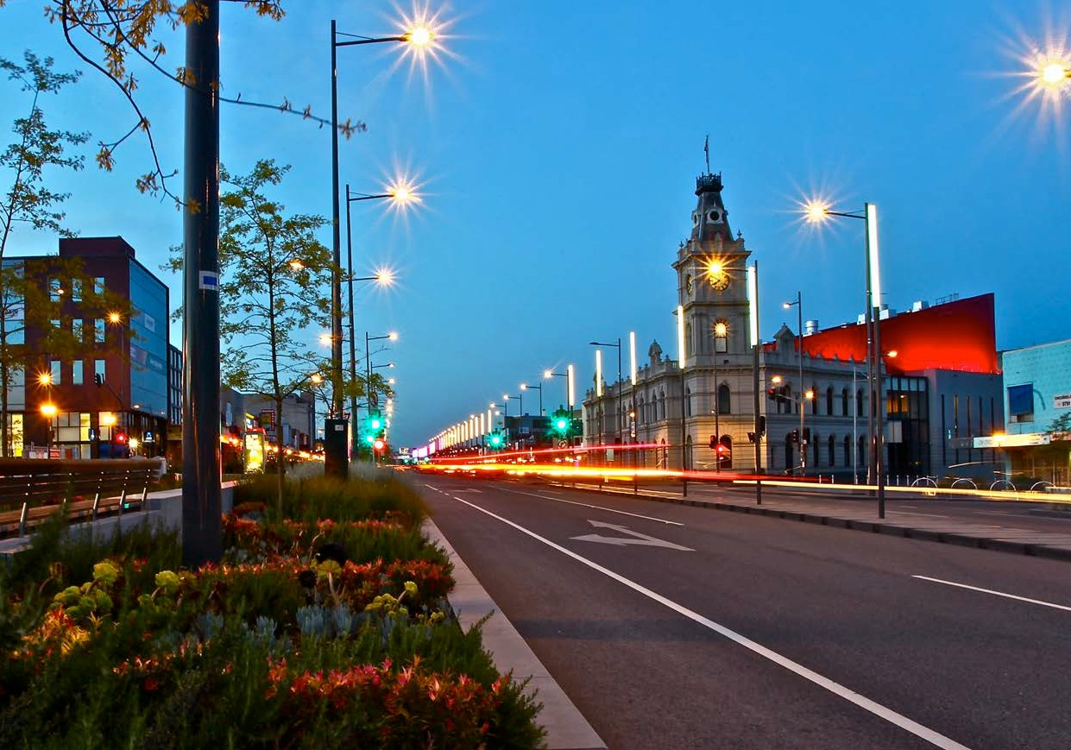

Call to Parties

OUR VISION FOR VICTORIA:
> Grow the economy
> Improve liveability
> Support stronger communities

V I C T O R I A N S T A T E E L E C T I O N 2 0 1 8

Working together for a better Victoria
Local government seeks to work with the Victorian Government to grow the economy, improve liveability and support stronger communities – while also securing a more sustainable future for councils.
Our communities face differing challenges. Rural Victoria requires adequate provision of essential services, and policies which facilitate greater economic diversity and increase populations. Communities in growth areas need additional services and infrastructure provided in a timely and proactive way. Metropolitan areas face liveability challenges as a result of the rapid rise in population and greater social stratification based on access to housing.
Councils are part of the solution. They service the needs of their local communities and are well placed to identify issues and opportunities to progress economically, socially and environmentally sustainable services and infrastructure for all Victorians.
This document sets out how councils can be a key partner to assist the Victorian Government to achieve seven inter-related goals for a better Victoria over the coming term of government:
- Share Victoria’s population growth
- Transform local service delivery
- Improve liveability
- Support resilient and cohesive communities
- Provide fair and equal opportunities for all
- Maintain and improve assets for the future
- Sustain our natural resources.

All 42 election commitments sought by local government will help to secure tangible benefits for Victorian communities across these seven core challenges facing the Victorian Government.

Delivering community outcomes
Councils are a willing partner to deliver better outcomes for Victoria’s growing and ageing population, preparing for and adapting to climate change, building resilience, ensuring economic growth and social connectedness. With the right support and resourcing from the Victorian Government, some services can be delivered more effectively at a local level.
Securing financial sustainability
Councils are progressing self-reform opportunities to ensure a financially sustainable future including collaborative procurement, shared service delivery and digital transformation.
Communities will directly benefit as service efficiency improves and costs are reduced. Opportunities exist for the State to support and resource councils to keep pace with local infrastructure and service delivery needs.

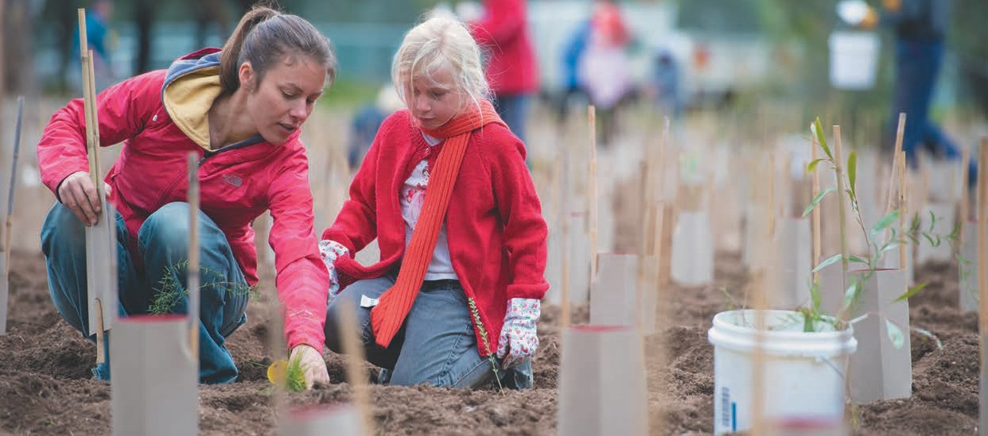
Three principles underpin the 42 commitments sought within this document:
A clear vision for local government
A more coordinated approach can be achieved if State and local government work together with sound planning and partnerships that reflect both statewide policies and local needs. This requires respectful relationships including recognition of local government’s role, and improved mechanisms for consultation and shared implementation.

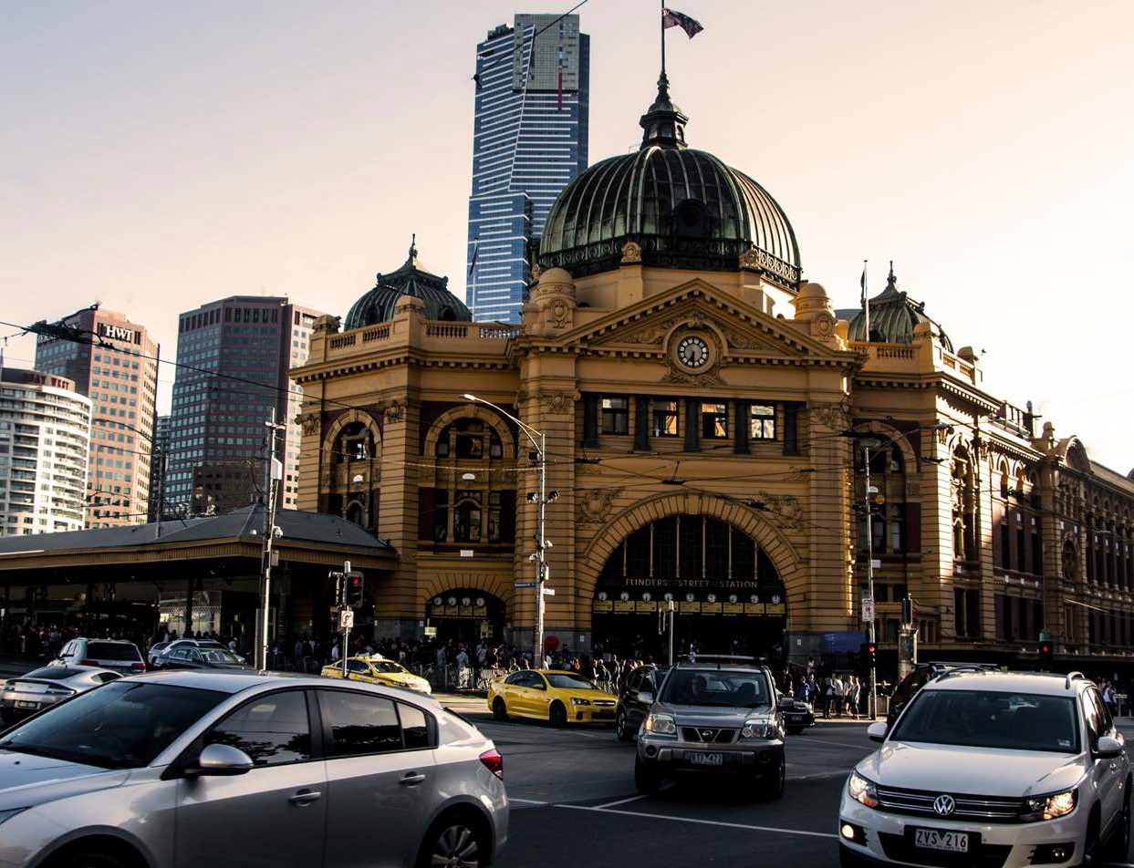
Victoria’s population is continuing to grow at historically rapid levels. A key challenge facing governments is how to make our regions more productive and ensure an appropriate level of community services and infrastructure can efficiently meet the needs of Victorians, regardless of where they live.
A more appropriate balance must be struck between Melbourne versus non-Melbourne growth to address our metropolitan housing, congestion and liveability challenges, while also building on the strengths of our rural communities to keep them growing.
Government leadership is overdue to drive the strategic policy that will guide responses to our population challenges – overall growth, population ageing, and contracting
rural communities – and ensure equitable living standards for metropolitan and rural Victorians.

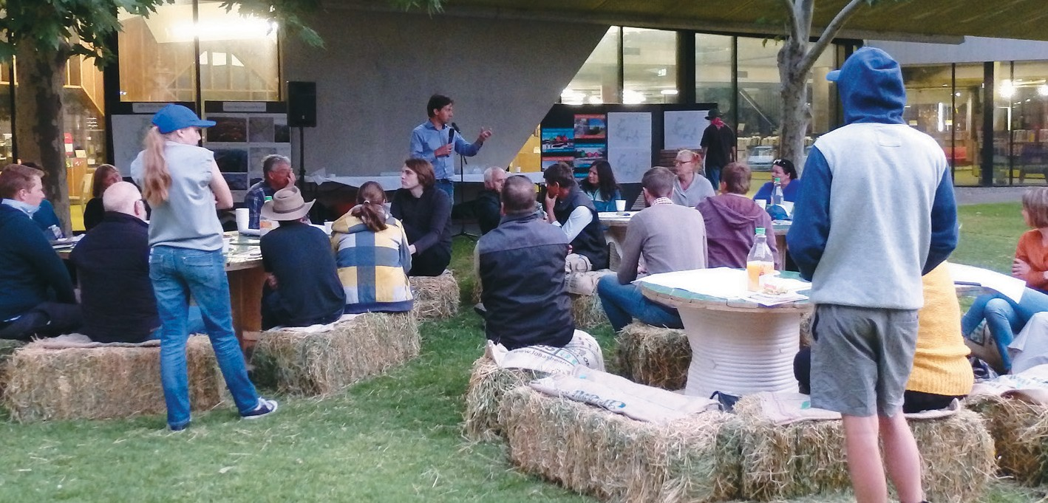
Commitments sought:

Population strategy to better manage growth and opportunities
Develop a Victorian Population Strategy 2050 to improve long-term outcomes for regions and reduce the pace of Melbourne population growth, including mechanisms to support infrastructure in rural areas, regional cities and growth areas:
  - Partner with regional councils to identify population growth strategies and local infrastructure demand; and
  - Provide funding for key infrastructure that will drive population to the regions (such as transport, telecommunications, water and sewerage connections), including a small town sewerage partnership program for councils to implement innovations such as recycled water use for public facilities and creation of wetlands to enhance urban amenity.

Provide services where communities need them
Develop a strategic plan to ensure provision of adequate health and community services and infrastructure required by people living in interface / growth areas and rural Victoria, including decentralisation of State services where appropriate.

We are operating in a changing world. Emerging issues such as the rapid pace of technological transformation has made digital connectivity an essential reform to be embraced by all levels of government.
Digital transformation is critical to every area of council business. Communities now have an expectation of 24/7 services and access to information. The MAV is working alongside councils to deliver technology projects that support more cost effective, efficient and innovative delivery of essential community services.
The population growth and technological challenges facing Victoria directly influence the ability of councils to provide complementary services and infrastructure while operating under external revenue pressures, including rate capping and abolition of local road and infrastructure funding.
The current State-imposed rate cap is now entering its third year. Councils have implemented numerous business efficiency reforms – such as internal restructures, asset sales, collaborative procurement and a reduction in fleet vehicles.
However, evidence is emerging of a worrying under-investment in capital infrastructure, and councils choosing to opt out of discretionary community services due to budget constraints. Due to these negative outcomes, the MAV emphasises its opposition to rate capping.
Under a State rate cap regime, there must be clear flexibility within the model to reflect different revenue raising capacities and council input costs to deliver services so that no communities are left behind.

Commitments sought:

Digital transformation to meet community expectations
A new funding stream to assist digital business transformation strategies in partnership with local government. Funding would help to enhance consistent services across multiple councils and align back-of-house systems to enable sharing of services and cost savings.

System reform for rural councils
Establish a fund to provide seed capital for rural councils with financial challenges to drive significant change to their operating model and internal business practices to ensure more efficient delivery of sustainable services to local communities.

Sustainable services and infrastructure investment
Work with the MAV to develop an appropriate rate cap indexation model to better reflect council input costs to deliver community services, and the revenue-raising capacity of various councils.

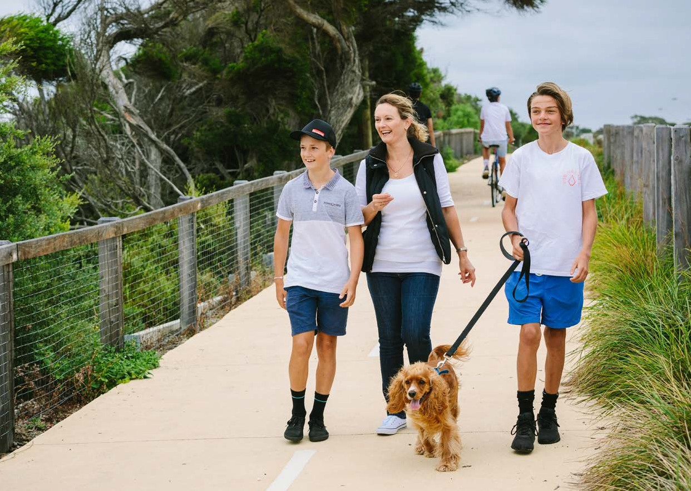
Melbourne is recognised as the world’s most liveable city. To retain this title we must address growing problems that impact on communities, business and Victoria’s economy.
Local government is a critical partner in delivering Victoria’s planning vision. Council plans and strategies are working towards solutions for communities to cope with changing populations, climate change, increased travel and congestion, depleting fossil fuels, housing affordability, biodiversity and infrastructure needs.
Councils are leading improvements to the sustainability of our built environment, and this work requires adoption at a state level to embed it into current practices. Continued expansion of renewables is also vital for Victoria, but energy development must be facilitated with appropriate controls that balance the needs of local communities.
Recent high profile incidents – both in Victoria and abroad – have highlighted the need for a stronger building regulatory system. Resourcing, role clarity, and overall compliance are system-wide problems which require timely resolution to protect communities.

Commitments sought: Planning

Champion sustainable, liveable buildings
Building on the local ESD Policy success, collaborate with local government to adopt a comprehensive Environmentally Sustainable Development planning policy in the Victoria Planning Provisions by 2019 to improve the sustainability and liveability of all buildings.

Reduce planning complexity
Fund more significant ‘smart’ reforms of the planning system – including a legislative review and digital transformation – to improve accessibility of the planning process for all parties.

Safer, more compliant building system
In response to fundamental failures, review the legislative and operational framework of the building system to clarify roles and responsibilities, funding, and improve the compliance and enforcement regime.

Provide more affordable housing options
Finalise the outcomes of the inclusionary zoning pilots and enable inclusionary zoning to be utilised more widely by councils across metropolitan Melbourne and regional centres.

Strategic decision-making for renewables
Identify strategically desirable areas for different types of renewable energy and develop guidance for councils about balancing planning objectives. Ensure independent advice is available to councils for wind farm noise conflicts by
establishing the Environment Protection Authority as the independent noise auditor.

Community infrastructure provided by councils contributes significantly to the health and lifestyle of all Victorians, as well as boosting the state’s knowledge economy with councils now investing 82 per cent of funding required for public library services.
Through improvements to transport and community infrastructure, Victoria could achieve better connected communities – both socially and through a more reliable, integrated public transport system and active transport options that address growing problems in traffic congestion.

Improve liveability _{(Continued)}

Commitments sought: Transport

Integrated transport options for all Victorians
Develop and deliver an integrated transport strategy for Victoria, as required under the Transport Integration Act 2010, including a freight plan, as well as long-term integrated transport targets for public transport, car transport and active transport; and consideration of demand-management strategies to better utilise our transport infrastructure.

Promote active transport options
Continue to provide funding to councils for bicycle and pedestrian infrastructure through continuation of the Safer System Road Funding Infrastructure Program.

Improve public transport access and connectivity
  - Increase the frequency of rural, regional and metropolitan public transport services where there are identified shortfalls, including on weekends
  - Review bus routes across Victoria and expand Smart Bus network service areas.

Get children to school safely
Provide funding to meet the current 50:50 commitment for the school crossing supervisor program; and adequately resource recommendations arising from the State Safety Around Schools review.

Commitments sought: Arts and Culture

Boost Victoria’s knowledge economy
Provide increased funding to ensure a secure and growing future for Victoria’s public libraries:
  - Recognise cost and population growth, and progressively increase operational funding over four years by $12 million pa
  - Commit $40 million over four years to extend the Living Libraries capital program.

Create more socially connected communities
Develop strategies for Victoria’s nine regions to deliver arts and culture programs in partnership with local government, and establish a new cultural facilities grants program to support all councils in the provision of art galleries, museums, theatres and arts centres.

Support resilient and cohesive communities

Local government provides facilities that contribute to the cultural and social fabric of Victorian communities, as well as facilitating more cohesive communities through multicultural and diversity programs, support and services.
Gender equity initiatives being implemented at the local level are recognised nationally and internationally for creating more inclusive communities, including through sporting facilities that directly respond to community diversity needs.
Planning for the safety, health and wellbeing of communities remains a central role for councils.
Reducing the public health costs associated with smoking, drugs, gambling, crime prevention and violence against women can be achieved by placing a stronger emphasis on preventative initiatives through state policy changes and resource support for
local priorities.
The Victorian Government is implementing a range of reforms to the state’s emergency management arrangements, with implications for local government. With a stronger emphasis on building up community resilience through a shared approach to emergency management responsibility between State agencies and local communities, councils
are working in partnership with Local Government Victoria to build their capability and capacity.
Responsibility for the cost of installing, maintaining and repairing fire plugs requires clarity; and councils seek protections for maintaining flood-mitigation infrastructure for at-risk communities.
Support is also required to ensure Victorian communities do not miss out on Commonwealth Natural Disaster Relief and Recovery Arrangements (NDRRA), with the proposed new model requiring up-front estimation of costs for reimbursement to repair essential public assets.

Support resilient and
cohesive communities _{(Continued)}

Commitments sought: Diversity and Participation

Sports facilities that respond to community diversity
Funding to develop and upgrade sporting and aquatics facilities to cater for the needs of diverse communities, including female focused sports.

Integrated settlement planning for new migrants, asylum seekers and refugees
Develop and implement mechanisms to improve settlement planning for newly arriving migrants, asylum seekers and refugees between the Commonwealth, State and local government.

Foster improved employment opportunities for Aboriginal and Torres Strait Islander people
Fund an economic development project to boost employment and career development opportunities for local Aboriginal communities, and provide partnership project funding to support councils to achieve the objectives of the Victorian Aboriginal Local Government Action Plan.

Commitments sought: Prevention of Family Violence

Prevention of family violence
Support the 10-year State reform agenda through local initiatives to help prevent family violence, by resourcing of Gender Equality Development officers in councils.

Commitments sought: Public Health and Safety

Reduce crime and improve community safety
Fund Community Safety Officers across local government to support state safety and crime prevention initiatives.

Protect vulnerable communities from gambling harms
Regulatory reform to reduce the community harm from electronic gaming machines through machine design; and a greater say for councils on where pokies are located in our communities.

Invest in our youth
Invest in youth services and programs that build civic engagement, leadership and respectful relationships, and fund rural councils to employ trained youth workers to support young people facing serious disadvantage.

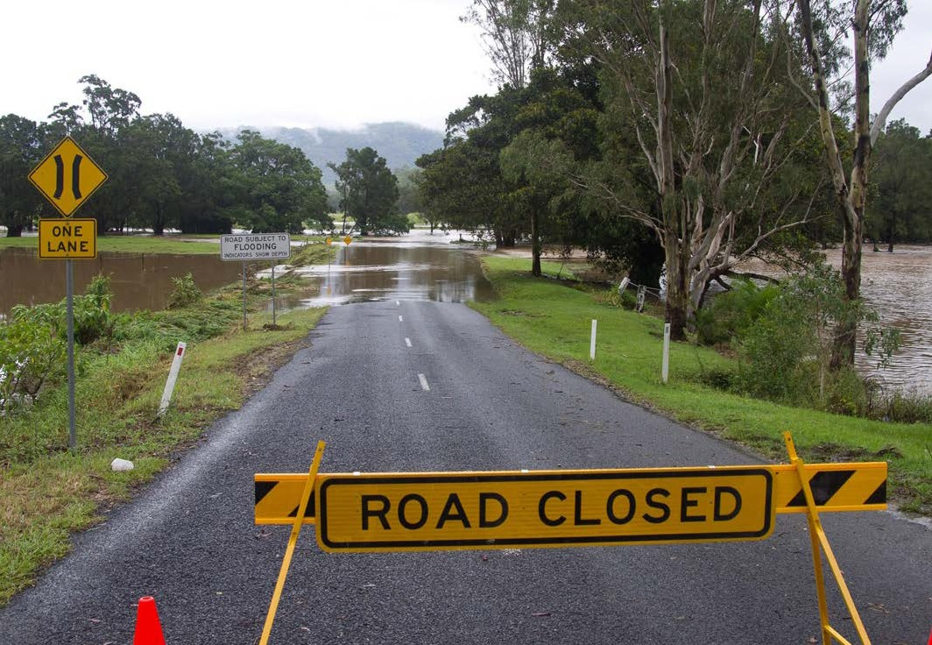

Commitments sought: Emergency Management

Support councils’ role in emergency management
Commit to funding local government to implement State legislative and policy changes, through continuing and expanding the critical Municipal Emergency Resourcing Program (MERP) beyond its current 2020 cessation.

Ensure community assets can be restored
Provide funding support to rural councils to update asset registers and ensure regular inspection programs to meet national disaster funding requirements.

Clarify responsibility for fire hydrant maintenance
Amend the Water Act to clarify that responsibility for fire plugs rests with water authorities, not local government.

Flood mitigation infrastructure for at-risk communities
Amend the Water Act to ensure appropriate management and maintenance of flood mitigation infrastructure, and provide a funding program for future council projects.

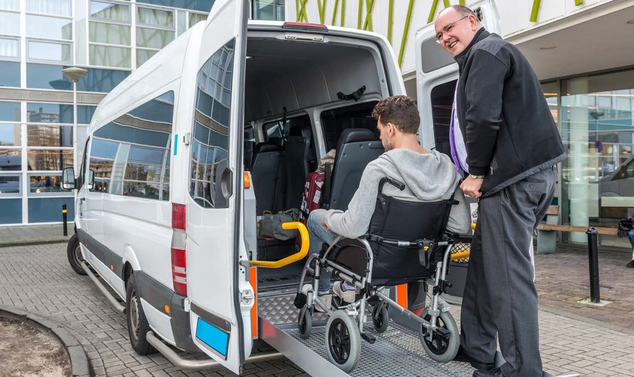
5. Provide fair and equal opportunities

Victoria is experiencing increased demand from people experiencing homelessness and additional support is needed to address the needs of these vulnerable community members. Local government is committed to working in partnership with the State and key public and private sector agencies to address this complex issue.
All community members should have fair and equitable access to universal community services, with more targeted investment required to respond to areas of disadvantage.
Local government has an integral role in all aspects of community services from newborn babies through to aged care. Councils co-design and resource services at the local level, are a critical funding partner, and provide infrastructure for services to operate from.
Aged and disability care programs are being transferred to the Commonwealth, placing at risk the strong State-local government partnership that has ensured a high quality of public sector services for care recipients. Some councils do not see themselves as future providers of disability and home care services, but an absence of alternative providers could disadvantage clients in both growth and rural communities.
Local government is committed to working with the State to enhance outcomes for all Victorian children and families. We seek the continuation of new ways of working
together to boost access to services for our growing population including kindergarten and maternal and child health programs, and improved youth services.

Commitments sought: Housing

Increase investment in public and social housing
Ensure access to housing that:
  - Meets diverse needs, is geographically distributed according to need, and is accessible to people of all abilities
  - Addresses the growing problem of homelessness.

Commitments sought: Aged and Disability

Retain the strengths of Victoria’s in-home care system
Develop a joint Victorian Government and MAV position to influence design of the Commonwealth Home Support Program for older Victorians beyond 2020.

Meet the needs of people with disabilities
  - Continue State funding for the metro and rural access programs to promote access and inclusion for all people with disabilities
  - Ensure continued funding to meet the community care and health needs of younger people with disabilities who are not eligible for the National Disability Insurance Scheme.

Safe and inclusive age-friendly communities
Build on the work of local government in developing communities based on age-friendly principles and provide new funding for initiatives to address the key issues for seniors in community transport, housing and social isolation.

Commitments sought: Children and Families

Guarantee access to early years’ service for families
  - Continue the partnership work with local government under the Early Years Compact 2017-27 to provide funding for kindergarten and Maternal and Child Health
  - Ensure continued funding for 15 hours universal kindergarten for all children
  - Develop a joint approach to funding development of Kindergarten Central Enrolment
  - Develop a 10-year facility strategy for kindergarten and MCH services, with capital funding to renovate and build infrastructure identified in the strategy.

Integrate government services for communities
  - Plan for co-location of kindergarten and early years services on new primary school sites and invest in integrated developments in new and expanding communities.
  - Optimise usage of school facilities for community capacity building, including opportunities for inclusion of parents and older people.

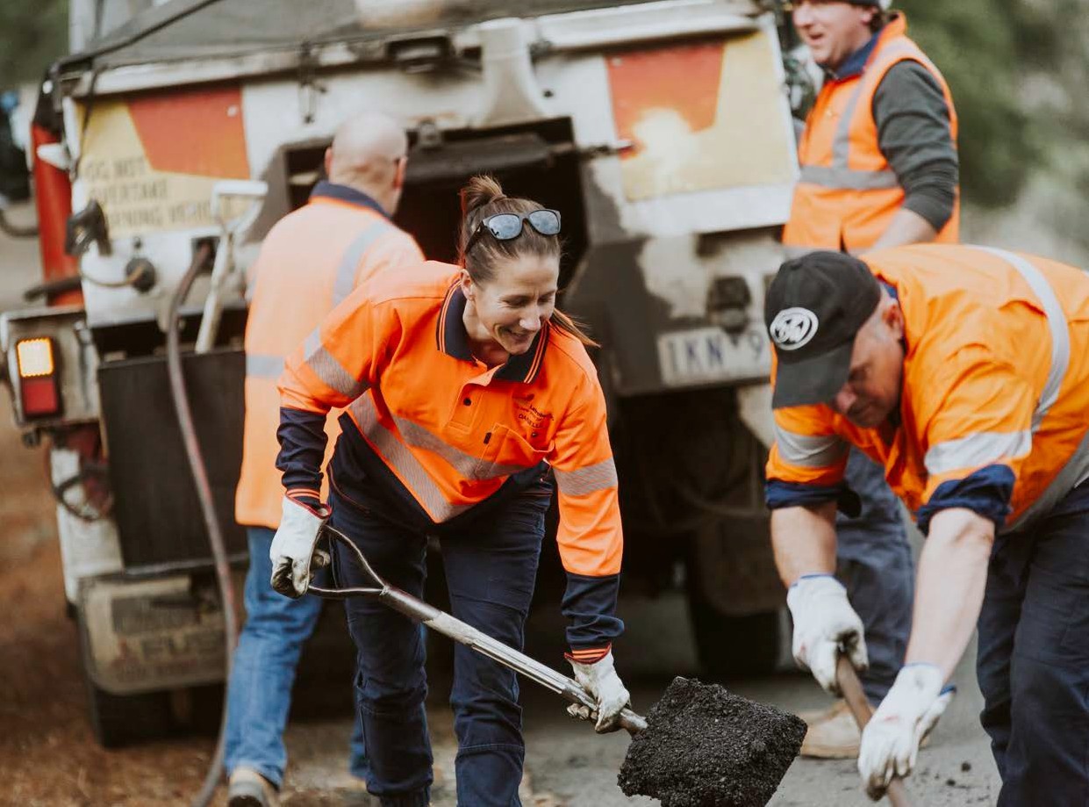
6. Maintain and improve assets for the future

Victoria’s economy relies significantly on a dependable road network to get around Victoria and move freight, including first and last mile routes to and from markets. Bigger freight vehicles are more frequently damaging local roads, and automated vehicles are presenting new challenges for governments.
Approximately 250 people die and 5,100 people are seriously injured on Victorian roads each year, costing the community $3 billion. More can be done to improve our road safety record.
Local government maintains 85 per cent of the State’s entire road network. Prior to the introduction of rate capping, many councils were working towards closing the gap in their maintenance and renewal of ageing road and bridge infrastructure. In 2013, the Victorian Auditor General projected that councils’ asset renewal gap would grow to
$2.6 billion by 2026.

Commitments sought:

Ensure a safe and reliable road network for all Victorians
  - Develop a new funding program for access by rural councils to help fund local road and bridge assets
  - Increase funding to VicRoads to address key road and traffic issues on the metropolitan and regional road networks

Improve planning for asset requirements
  - Fund every region to develop a regional freight strategy for local roads
  - VicRoads to work with councils on a consistent statewide approach, including funding support, to meet new National road data standards
  - Commence the Melbourne airport rail link during this term of government.

Safe introduction of automated vehicles
Develop a plan to manage and fund infrastructure required for the introduction of automated vehicles on the Victorian road network.

Better stormwater use for community amenity and reduced water treatment costs:
Implement a three-year $30 million statewide urban stormwater improvement program for councils to upgrade ageing stormwater assets and institute water- sensitive urban design.

The latest council budget forward projections show worrying signs of a decline in rural councils’ capital works budgets, as well as cancellation and deferral of infrastructure projects due to reduced revenue raising capacity. This will significantly impact on road safety and Victoria’s economy, and will mean higher future costs on communities to maintain the road network.
With a drying climate, increasing severe storm events and urban densification, ageing stormwater assets and management of stormwater must be prioritised to protect against urban flooding, river and bay health; improve urban greening and amenity of local parks, ovals and gardens; and minimise pollution and water treatment costs.

7. Sustain our natural resources

Human-induced climate change is a significant threat that requires urgent action by all levels of government. Local government supports the Victorian emissions reduction target of net zero emissions by 2050 and the 40 per cent renewable energy by
2025 target.
Victoria’s waste and resource recovery system is under significant strain. China’s decision to restrict the importation of certain recyclable materials brought to light the impacts of more than a decade of underinvestment in our local resource recovery
system. There’s an ongoing need for state and national investment, and policy settings that support innovation in and expansion of resource recovery. Reducing the amount of waste Victorians generate and send to landfill is a key challenge and an opportunity to target significant behaviour change. The State needs to expend landfill levy income on measures that achieve a genuine change in how waste is managed in Victoria.
Healthy and thriving biodiversity is critical to a healthy and thriving Victoria. To ensure Victorian communities can reap the multitude of benefits that access to nature brings, it is incumbent on all levels of government to increase efforts to slow and reverse the decline in the condition of Victoria’s biodiversity.
Water is vital for communities and for maintaining the health of our environment. Smarter water use in the face of population pressures and increased densification in urban centres means continuing reforms to achieve green-blue public spaces that deliver amenity and liveability for urban communities, and maximise the availability of water for the environment.

Commitments sought:

Invest in and support waste reduction and improved resource recovery
  - Invest accumulated landfill levy income and develop appropriate policy settings to support the development and expansion of our local resource recovery industry and marketplace
  - Develop and deliver a statewide waste education campaign targeting waste minimisation and improved recycling behaviour
  - Adopt targets across all of state government for the procurement of recycled material
  - Advocate for and support the development of greater product stewardship, including adoption of a container deposit scheme in Victoria.

Progress climate change adaptation
Develop a Memorandum of Understanding in partnership with local government within the first year of the new parliamentary term to clarify respective climate change adaptation roles, responsibilities and funding arrangements.

Protect our natural environment
  - Promote the contribution that a healthy biodiversity makes to Victorians’ economic, social and environmental wellbeing, and commit to the targets and fund the actions set out in `Protecting Victoria’s Environment – Biodiversity 2037’
  - Ensure water stewardship for drainage on private land through catchment oversight and advice being required to be provided to drainage committees developing drainage management plans

Eradicate roadside weeds and pests
Commit to ongoing funding from the 2019-20 State Budget onwards for roadside weed and pest management; and improved State pest and weed management on Crown land.

Partner with councils to deliver priority water initiatives for their communities
Optimise use, management and access to water to improve liveability and amenity by:
  - Maintaining Integrated Water Management Forums to facilitate catchment-scale partnerships
  - Resourcing a stormwater community engagement program to educate residents and businesses on improving waterways health and limiting stormwater run-off
  - $2 million program over two years for innovations in on-site domestic wastewater management including funding of backlog issues in priority areas, giving councils better regulatory powers, and a community education program to better manage waste systems.

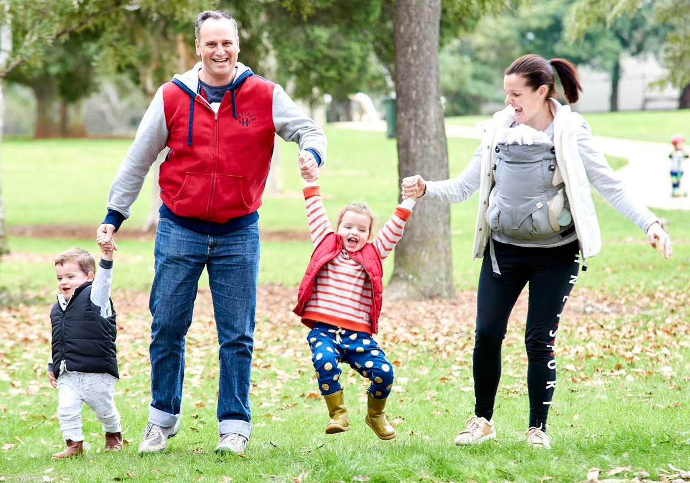

Picture: Ballam Park, courtesy of Frankston City Council

Municipal Association of Victoria Level 12, 60 Collins Street, Melbourne
GPO Box 4326, Melbourne 3001
Phone: 03 9667 5555
Fax: 03 9667 5550
Email: inquiries@mav.asn.au mav.asn.au

V I C T O R I A N S T A T E E L E C T I O N 2 0 1 8

