Victorian Maternal and Child Health Service Statewide consent form

Insert council logo here
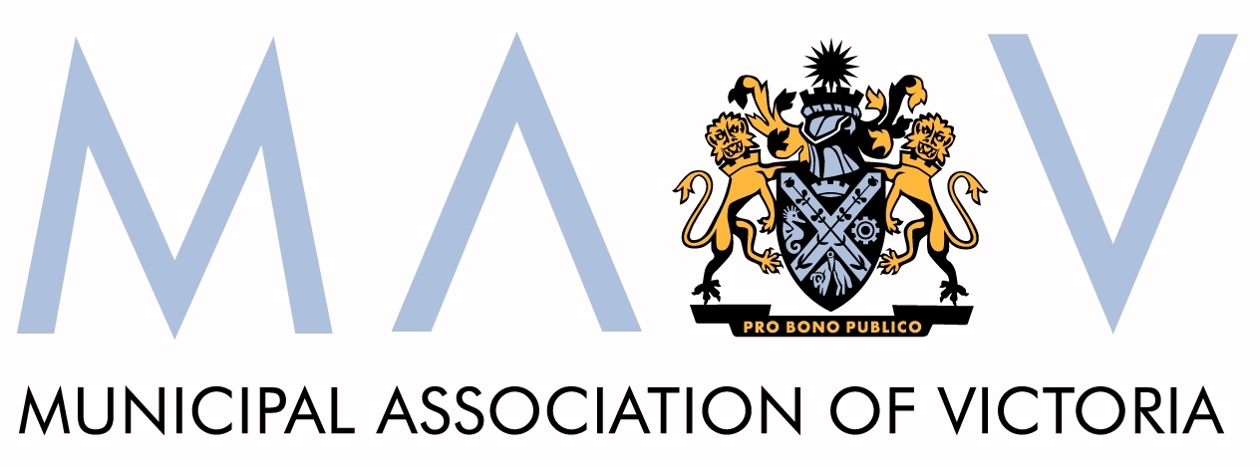

Child’s name Date of Birth____/____/20____

Please complete either the written or verbal consent section.

Written consent from parent/guardian
The Maternal and Child Health nurse has discussed with me how and why certain information about my child and family may be collected and stored. I understand that this information will be handled in accordance with the Health Records Act 2001 (Vic) and only shared with my consent or where required by law.

First Name: | Last Name:
Signed: | Relationship:
Date: / / 20 | Contact number:

Verbal consent from parent/guardian
I have discussed with the client how and why certain information may be collected and stored. I am satisfied that this has been understood and that informed consent has been given for the information to be handled in accordance with the Health Records Act 2001(Vic) and only shared with consent or where required by law.

Discussed with:
First Name: | Last Name:
Relationship: | Contact number:

Translator/support, if present or involved (e.g. language, visual or literacy challenges)
Name: | Contact Number:

Written or verbal consent was obtained and witnessed by:
First Name: | Last Name:
Signed: | Council:
Date: / / 20 | Contact number:

Please complete:

This family have been given information about privacy & consent:
- "What happens to information about you and your family?"
- “About Maternal & Child Health Service Consent.”
- Any additional resources as necessary.
This family will be given a copy of this completed form.

