Melbourne Urban Stormwater Institutional Arrangements (MUSIA) Review
Background
The 60 ha catchment boundary convention, which was established by the Metropolitan Board of Works in 1927, is currently used to determine responsibility for catchment related stormwater and drainage assets within metropolitan Melbourne. The original resolution defined regional drains with an area greater than 150 acres [60.7 hectares], and greater than 800 feet [243.8 metres]’ to be designed, constructed and managed by the MMBW (now Melbourne Water). Small catchments are the responsibility of local councils.
While there are no prescribed responsibilities for councils to manage stormwater, sections 198-201 of the Local Government Act provide authority for councils to manage public drainage. In practice, all councils provide drainage infrastructure and services for stormwater.
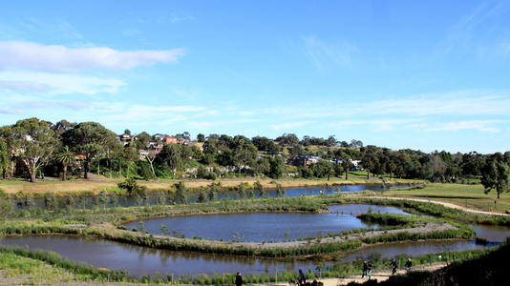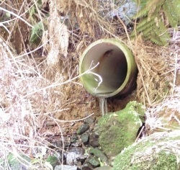
The current arrangements have evolved as a convention and do not assign clear roles, responsibilities and resourcing for stormwater drainage assets and services between councils and Melbourne Water. Therefore, this review was instigated as Action 14a of the Victorian Floodplain Management Strategy (VFMS) (2016).
An increasingly dry and volatile climate along with population growth and densification resulting in the reduction in permeable surfaces across Melbourne present significant challenges for managing increased urban flood risk, liveability and waterway health concerns. Increasingly, councils and Melbourne Water have recognised that these issues cannot be adequately addressed under the existing arrangements, and may be better managed at a catchment scale.
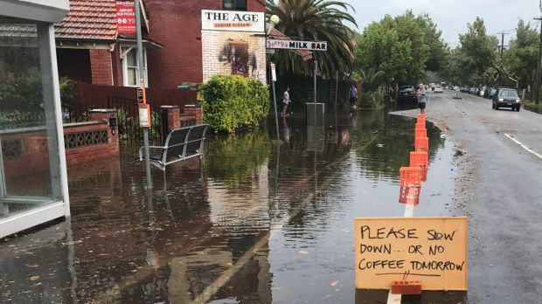 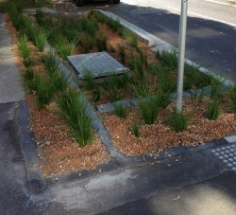
Image 1 source: The Age. Images 2-4 source: Clearwater.
What we are doing
The Department of Environment Land Water and Planning are leading the MUSIA review between Melbourne Water and the 38 Melbourne metropolitan councils within the Melbourne Water region. The MAV is facilitating and supporting the 38 councils through the review with the provision of a local government working group and a project officer.

Project operating principles
These are the agreed principles advised to the MAV and Melbourne Water in a letter from DELWP.
- Social and environmental outcomes for floodplain management which are cost-effective to implement will be key criteria used to assess proposals through the review
- Input and agreement from local government and Melbourne Water is essential to the project’s success
- MAV will represent the 38 affected councils in any negotiations that may be required
- Mutual respect for the values of partner organisations
- Transparency about the process and timelines for stakeholders to be provided during the review
- Communication approaches will be agreed and then followed between parties
- There will be time for engagement with a diverse and complex local government sector.
If new responsibilities emerge for local government as a result of the review, the Victorian State Local Government Agreement will be utilised to reach agreement with councils.
Project governance
Authorisers: Heads of Melbourne Water and MAV to sign-off on any new agreements
Steering Committee: Senior staff from DELWP, Melbourne Water and MAV.
Project working group: Officer level staff from DELWP, Melbourne Water and MAV.
Local Government working group: Convened by the MAV, and includes representatives from the 38 Melbourne metropolitan councils within the Melbourne Water region.

Partnerships
The MAV is working in close partnership with DELWP and Melbourne Water throughout this review. The MAV also participates in related committees and working groups to link this work with other initiatives across the water sector.
- Port Phillip and Westernport Flood Management Strategy Implementation Advisory Committee
- Water Sector Adaptation Action Plan program steering committee (observer)

Related research
- The Productivity commission’s National Water Reform final report
- Infrastructure Australia’s Reforming urban water paper.
Related websites
- The MAV’s members only website allows access to materials from the Local Government Working Group under the stormwater management page.
- DELWP’s MUSIA project page provides a project overview and resources from the early project workshops.
- The Victorian Floodplain Management Strategy 2016 instigated this review through action 14a and the strategy provides additional context around Victorian flood concerns.
MAV Contact
For project updates and information, please contact
Rosemary Hancock
Manager Water and Public Health
MAV
T: 9667 5520
E:rhancock@mav.asn.au

