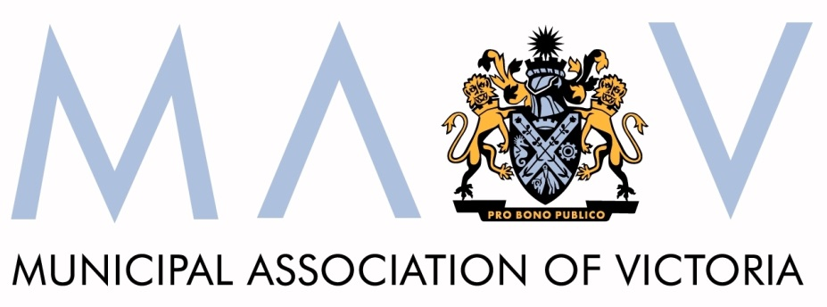

Sustainability Fund – Priority Statement

Submission

December 2015

© Copyright Municipal Association of Victoria, 2015.

The Municipal Association of Victoria (MAV) is the owner of the copyright in this publication.

No part of this publication may be reproduced, stored or transmitted in any form or by any means without the prior permission in writing from the Municipal Association of Victoria.

All requests to reproduce, store or transmit material contained in the publication should be addressed to Claire Dunn on 9667 5555.

The MAV does not guarantee the accuracy of this document's contents if retrieved from sources other than its official websites or directly from a MAV employee.

Table of contents
Recommendations 4
1 Introduction 5
2 Councils’ interest in the Sustainability Fund 5
3 The draft Priority Statement 6
3.1 Investment of landfill levies 6
1.1.1. Waste and Resource Recovery 7
1.1.2. Climate Change Adaptation and Mitigation 8

Recommendations
- The State to provide detailed and publicly available annual reporting of all Sustainability Fund income and expenditure

- The State to ensure that all Sustainability Fund income from a given year is expended within the next two years, and that the accrued savings currently in the Fund are also expended within two years

- At least 75 per cent of Sustainability Fund expenditure to be directed toward measures that foster environmentally sustainable uses of resources and best practice in waste management

- Expenditure on non-waste and resource recovery related initiatives not to exceed 25 per cent of overall Sustainability Fund expenditure

- The State to commit to returning “as of right” at least five per cent of the landfill levy paid by each council to councils each year to invest in programs and initiatives that align with the Priority Statement strategic objectives. This “as of right” funding would be in addition to funds made available via State grants programs.

Introduction
The Municipal Association of Victoria (MAV) welcomes the opportunity to provide the Department of Environment, Land, Water and Planning (DELWP) with a submission in response to the draft Sustainability Fund Priority Statement.
The MAV is the statutory peak body for local government in Victoria. Formed in 1879, we have a long and proud tradition of supporting councils to provide good government to their communities.

While this paper aims to broadly reflect the views of local government in Victoria, it does not purport to reflect the exact views of individual councils. In addition to providing feedback to inform this submission, we anticipate that several councils will make their own submissions to DELWP.

Councils’ interest in the Sustainability Fund
As a key partner in environmental management and one of the primary collectors of landfill levies, councils take great interest in the State’s management of the Sustainability Fund. Indeed the State’s handling of landfill levy funds has been the subject of at least twelve MAV State Council resolutions since May 2010.
The MAV and councils have repeatedly called on successive State governments to reinvest greater quantities of landfill levy funds in waste management and resource recovery initiatives and to openly and transparently report landfill levy income and expenditure.
At the October 2015 MAV State Council meeting, it was resolved that the MAV should:
- seek information from the Minister detailing the amount of landfill levy revenue that has been collected by the Victorian Government since its inception and the amount of that revenue that has been returned to local government
- write to the Premier and Minister requesting that revenue derived from the landfill levy, currently held in the Sustainability Fund, be used to fund future infrastructure and programs identified in the new metropolitan and regional waste and resource recovery infrastructure plans (currently under development)
- seek information from the Minister regarding the proposed plans and timelines to disburse accrued landfill levy funds and the projects that are likely to be funded
- ask the Victorian Government to explain the lack of reinvestment of landfill levy funds in local government waste and resource recovery infrastructure and programs

We again call on the State to reinvest greater quantities of landfill levy funds in waste management and resource recovery and to provide detailed annual reporting of Sustainability Fund income and expenditure.

The draft Priority Statement
Councils agree that a healthy environment is critical to our current and future social and economic wellbeing and that everyone - government, business, communities and individuals- has a role to play in keeping our environment healthy.

Investment of landfill levies

The draft Priority Statement notes that landfill levies help lower the impact on the environment in two ways:
- By encouraging people to find alternative, more innovative ways to dispose of their waste than landfill; and

- By providing funds to support Victorian communities and businesses to reduce negative impacts on the environment and adapt to the future impacts of climate change through innovation and stimulating viable industries, creating jobs for Victorians.
We note that the success of landfill levies in helping achieve these objectives is contingent on sufficient funds being reinvested into initiatives that provide the community with alternative waste disposal options and that support innovative and viable industries.
Currently the Sustainability Fund is failing to fulfil its intended purpose because the collected funds are not being reinvested in the community. Instead the monies are being held on to by the State, with the current balance of the Sustainability Fund close to half a billion dollars.
It is no exaggeration to say one of the local government sector’s greatest disappointments is that the State has not used accrued landfill levy funds to better support councils and communities to achieve positive environmental outcomes, particularly in relation to waste management and resource recovery.
Councils, and the communities they represent, are frustrated that they collect and pass on to the State millions of dollars each year but see so little money reinvested back in to local communities.
We therefore call on the State to ensure that all Sustainability Fund income from a given year is expended within the next two years, and that the accrued savings currently in the Fund are also expended within two years.
It is incumbent on the State to use the Sustainability Fund for its promised purpose, namely to secure positive environmental outcomes for Victoria.

The draft Priority Statement identifies the following strategic priorities for future investment of Sustainability Fund savings, with preference to be given to initiatives that also foster employment, new technology and innovation, resource efficiency or ongoing behavior change:
Legislated purpose: | Fostering environmentally sustainable uses of resources and best practices in waste management to advance the social and economic development of Victoria | Fostering community action or innovation in relation to the reduction of greenhouse gas substance emissions [mitigation] or adaptation or adjustment to climate change in Victoria
Strategic priorities: | Investment will prioritise :  - making alternatives to landfill more viable and cost competitive through the stimulation, creation and expansion of viable markets for recycled and recovered materials;  - facilitating a network of best practice waste and resource recovery infrastructure which minimises public health and environmental impacts and maximises resource recovery opportunities;  - providing equity in access to, and reducing impacts of, waste and resource recovery services on communities; and  - modernising the management of legacy contamination or pollution.  Investment will be guided by Victorian government policies, including the Statewide Waste and Resource Recovery Infrastructure Plan, Regional Waste and Resource Recovery Implementation Plans and other relevant strategies. | Investment will prioritise:  - supporting individuals, communities and industry to transition to a low carbon economy;  - supporting Victorians to adapt to the impacts of climate change, particularly those most vulnerable and least able to do so; and  - assisting Victoria's ecosystems and native species to be more resilient to climate change and/or support mitigation outcomes.  Investment will be guided by Victorian government policies, including the Victorian Climate Change Adaptation Plan, Energy Efficiency and Productivity Statement, Biodiversity Strategy and other relevant strategies.

Waste and Resource Recovery

The MAV has long advocated for landfill levy funds to be expended on measures that achieve a genuine step change in how Victoria manages its waste and captures resources. As such we support at least 75 per cent of Sustainability Fund expenditure to be directed toward measures that foster environmentally sustainable uses of resources and best practice in waste management (the first legislated purpose above).
Given the benefits of adopting a regional approach to waste and resource recovery, we support accrued funds being used to fund future infrastructure and programs identified as priorities in the Waste and Resource Recovery Groups’ regional waste and resource recovery implementation plans.
We also support landfill levy funds being used to assist with the very costly task of rehabilitating landfills to EPA standards. For rural and regional councils in particular, the task of rehabilitating multiple legacy closed landfills to the satisfaction of the EPA is extremely difficult, if not financially impossible.

There are a number of rural municipalities that have well in excess of 15 closed landfills scattered among small towns where there is potentially limited environmental protections in place and limited resources to rectify this. Many councils do not have the resources or capacity to keep up with the knowledge and practice advances made in the waste industry. We support the Victorian Auditor-General’s 2014 recommendation that the EPA work with DELWP and waste portfolio partners to develop options for the landfill levy to be used for the timely rehabilitation of high-risk landfills.
The often limited and inequitable reinvestment of landfill levy funds into the communities from which the funds have been collected is a significant frustration for councils. We therefore call on the State to commit to returning “as of right” at least five per cent of the landfill levy paid by each council to councils each year to invest in programs and initiatives that align with the Priority Statement strategic objectives. This would provide communities with some assurance that the levies they pay will benefit their local area. Recognising that five per cent is only a very small proportion of the total funds collected, it is essential that this “as of right” funding be in addition to funds made available via State grants programs.

Climate Change Adaptation and Mitigation

The second legislated purposed proposed in the draft Priority Statement is for Sustainability Fund savings to be used to fund climate change mitigation and adaptation action and innovation, including assisting Victoria's ecosystems and native species to be more resilient to climate change.
Councils actively undertake and support various climate change mitigation and adaptation activities and are supportive of a portion of Sustainability Fund savings being used to assist innovation and action in this space. That said, noting that Sustainability Fund savings are derived solely from landfill levies, it is our view that expenditure on non-waste and resource recovery related initiatives should not exceed 25 per cent of overall expenditure of Sustainability Fund income. It is incumbent on the State to make its own genuine investment in climate change adaptation and mitigation action.
Waste management and resource recovery initiatives that rehabilitate landfills and divert waste from landfill achieve a number of environmental benefits for communities, not least significant reductions in greenhouse gas emissions. As such, waste and resource recovery should remain the primary focus of Sustainability Fund expenditure.

