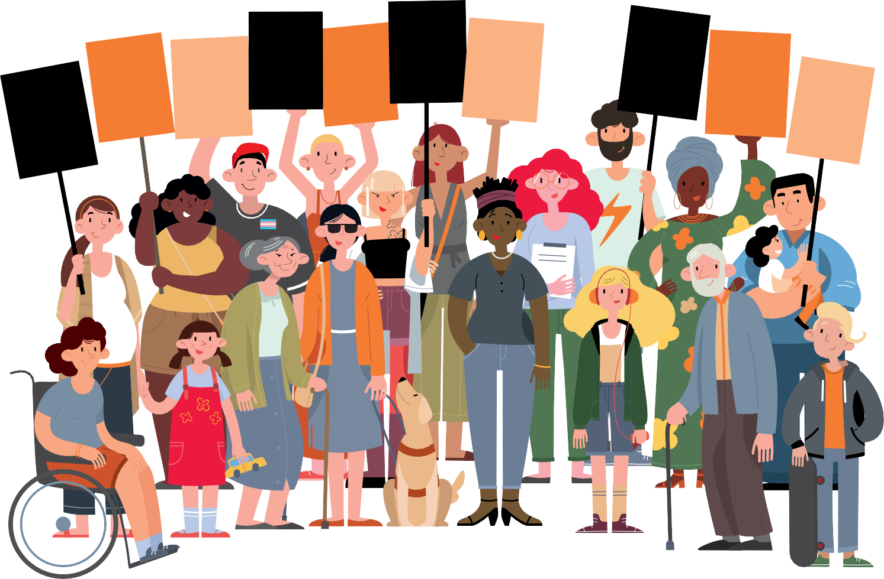16 Days of Activism toolkit
Respect
Women: Call It Out

P

Coinciding with the United Nation’s:

16 Days of Activism against Gender-Based Violence
This toolkit has been created to help councils and
other organisations participate in Respect Victoria’s
Respect Women: ‘Call It Out’ 16 Days initiative from
25 November - 10 December

If you or someone you know is experiencing family violence,

help is available.
If you believe someone is in immediate danger call Triple Zero (000) and ask for the police.

Safe Steps (1800 015 188) safesteps.org.au

Safe Steps is Victoria’s 24/7 family violence support service.

For a more comprehensive list of support services see page 28 of this toolkit.

Acknowledgements
We acknowledge the traditional custodians of the land on which we work and we pay our respects to their elders, past, present and emerging. We acknowledge that sovereignty of this land was never ceded and we are committed to honouring Australian Aboriginal
and Torres Strait Islander peoples in our work.

The Municipal Association of Victoria (MAV) has been funded by Respect Victoria to help councils and other organisations across Victoria participate in the Respect Women: ‘Call It Out’ 2020 initiative coinciding with the UN’s 16 Days of Activism against Gender-Based Violence. This resource is an updated version of the toolkit developed by the Domestic Violence Resource Centre Victoria in 2019 in partnership with the MAV and Respect Victoria.

1.

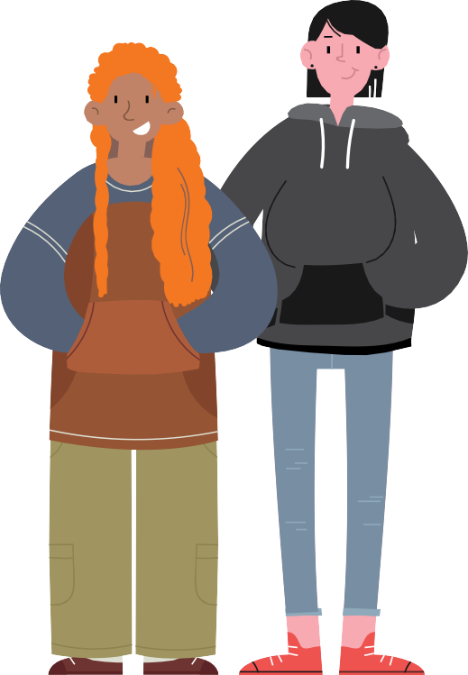Contents
Tools to help ‘call it out’
20
Conversation starters
22
Dealing with resistance and backlash
23
Responding to disclosures
25
Beyond the 16 Days
27
Support services
28
Respect Women: Call It Out 16 Days toolkit
2.

Acknowledgments 1
About this toolkit 3
Coronavirus (COVID-19) 5
Key Terms 6
About the Respect Women: ‘Call It Out’ campaign 8
About the 16 Days of Activism 9
Campaign Collateral 10
16 ways to get involved 12
Booklists: Read and share books 14
Key facts and statistics about gender equality 17
Problematic attitudes that need to be called out 19

About this toolkit

This toolkit provides information about the Respect Women: Call It Out initiative coinciding with the United Nation’s (UN) 16 Days of Activism against Gender-Based Violence.

The toolkit features information and resources for organisations to use during the 16 Days and beyond as well as ‘conversation starters’ to stimulate community discussion about the prevention of gender-based violence.

Many sections within this toolkit can be used on their own, as posters or pull-out resources.

The resources within this toolkit have been designed so that they are suitable for use in Victoria in response to the coronavirus (COVID-19) pandemic and changing restrictions.

Respect Victoria is an independent Statutory Authority dedicated to the primary prevention of all forms of family violence and violence against women.

Respect Victoria’s Respect Women: ‘Call It Out’ campaign encourages individuals, communities and organisations to ‘call it out’ and intervene when they witness sexism and gender inequality – drivers that can lead to family violence and violence against women.

“Gender-based violence needs to stop, and everyone has a role

to play”

The UN’s 16 Days of Activism against Gender-Based Violence is a global campaign that takes place annually between
25 November and 10 December.

In Australia, on average, 1 woman is murdered by a current or former partner each week, and 1 in 2 women have experienced sexual harassment. Violence against women and their children costs Australia $22 billion each year.

A note on gender-based violence
‘Gender-based violence’ includes all forms of violence against people based on their gender, or violence that affects people of a particular gender disproportionately. It is most frequently used to describe men’s violence against women.

Throughout this toolkit, the term
‘gender- based violence’ will refer to men’s violence against women. Violence in this domain is where the strongest evidence base exists and is consistent with the historic
and current focus of the UN’s global campaign.

Gender-based violence causes severe harm to families and communities. Campaigns like this one highlight the need for us to prevent all forms of gender-based violence and family violence experienced within our society.
Importantly, members of LGBTIQ communities face discrimination and violence on the basis of sex, sexuality and/or gender identity at alarming rates.

Respect Women: Call It Out 16 Days toolkit
3.

Diversity and inclusion
It is vital that this campaign and others like it are inclusive of the diversity that exists within our communities. As such, we encourage you to collaborate with representatives from LGBTIQ communities as you prepare for your 16 Days of Activism. To find out more visit the Research & Resources page on Rainbow Health Victoria’s website.

The International Day of People with Disabilities is recognised on 3 December, which coincides with the 16 Days of Activism. We strongly encourage you to collaborate with organisations led by people with disabilities to ensure your activities are inclusive and raise awareness of the rights and agency of people with disabilities. To find out more, visit the Women with Disabilities Victoria website.

This campaign should seek to work with Aboriginal and Torres Strait Islander peoples and culturally diverse communities, including refugee and migrant communities, using community language and culture as part of a strengths-based approach to addressing gender-based violence.

To find out more, please visit the Prevention of Family Violence page on Djirra’s website and the Resources page on Multicultural Centre for Women’s Health website.

“It is vital that this campaign and others like it are inclusive of the diversity that exists within our communities”

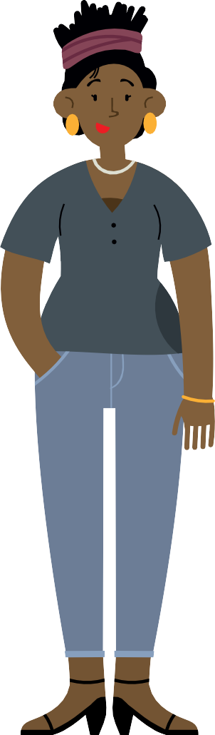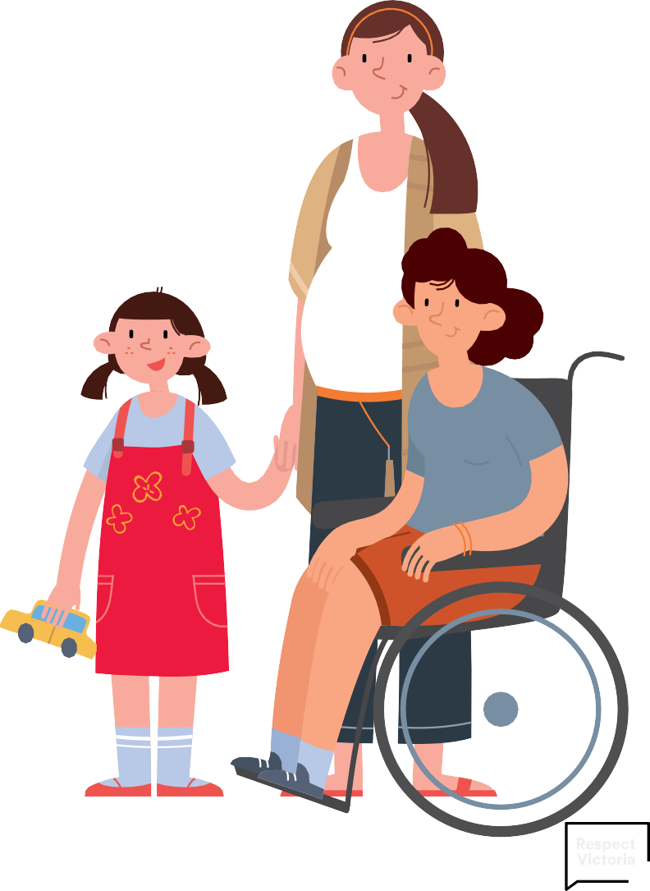

Respect Women: Call It Out 16 Days toolkit
4.

Coronavirus (COVID-19)

The coronavirus (COVID-19) pandemic has exacerbated gender inequality and increased the risk of gender-based violence. Find out what your organisation can do to address gender inequality in response and recovery.

The impact of coronavirus (COVID-19)
The pandemic has changed how we live. The
impact restrictions and physical distancing have on individuals, families, and communities varies. There is no doubt however, that the impact of the pandemic is highly gendered.
Data shows that women have been hit hardest, with higher unemployment rates, greater risk of exposure in low paid jobs, greater caring responsibilities and significantly poorer
mental health outcomes than men.

Family violence services have also reported increased demand during the pandemic.
Intimate partner and family violence increase during disaster and emergencies, both in prevalence and severity (Parkinson 2014)1 Data released by the Crime Statistics Agency in September this year shows that Victoria is facing its highest reported rates of family violence in history, with a 6.7% increase in reports to police over the past year.2
The reported increase in violence has been compounded by reduced access to services and support during social isolation.

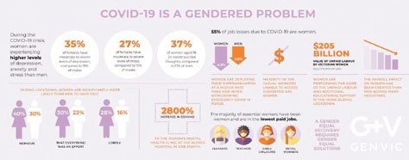
Violence doesn’t happen because we’re staying home, however. Family violence and violence against women are driven by
inequality, discrimination and marginalisation. That means that response to and recovery from the pandemic must address
gender inequality and other forms of discrimination. If we “build back better” a more inclusive and equal Victoria, we can help everyone live free from violence.

Your organisation can help “build back better” by implementing a coronavirus (COVID-19) recovery plan that addresses the disproportionate impact of the pandemic on women. There are a range of resources and tools to help you do this, including:
- Guiding principles for primary prevention in the context of COVID-19 (Respect Victoria)
- Addressing systemic and structural discrimination for primary prevention of family violence in the context of COVID-19:
A resource for advocacy (Respect Victoria)
- Applying a Gender Lens to COVID-19 Response and Recovery (Women’s Health in the North)
- Towards a Gender-Equal Recovery: COVID-19 Fact sheets (Gender Equity Victoria).

Complying with restrictions
Ensure you comply with the current Victorian Government Chief Health Officer’s directions when organising activities or events for the
16 Days. Please note, the restrictions could be different between regional Victoria and metropolitan Melbourne.
Visit the Department of Health and Human Services (DHHS) website for the most
up-to-date information on the coronavirus (COVID-19) pandemic.

GenVic, https://www.genvic.org.au/resources/covid-19-resources/ 2020
Respect Women: Call It Out 16 Days toolkit
5.
1 Parkinson, D. (2014). Women’s experience of violence in the aftermath of the Black Saturday bushfires (doctoral dissertation, Monash University) 2 https://www.theage.com.au/national/victoria/record-family-violence-offences-and-covid-fines-drive-crime-rate-surge-20200924-p55yqz.html

Key terms
Respect Women: Call It Out 16 Days toolkit
6.
These terms are used throughout this toolkit, with definitions listed below.

Active bystanding
Refers to the act of ‘calling out’ sexist and/or disrespectful language or behaviour, either in the moment or following an incident.

Backlash
Describes extreme, aggressive or organised forms of resistance to preventing violence against women. Resistance can range from denial to passive attempts to maintain the status quo. Examples include men’s rights groups inciting misogyny or online trolls abusing social commentators.

Bystander
Describes a person who is present or witnesses an event or incident but is not actively involved in it.

Bystander action
Refers to ‘how’ a bystander calls out, or engages others in responding to incidences of violence, sexism, harassment or discrimination. It also refers to action to address the attitudes, behaviours, norms, polices and structures that contribute to violence against women.
Examples include calling out inappropriate behaviour, changing the topic, eye rolling, enlisting support, referring to organisational policies, or changing discriminatory workplace policies and practices. These actions can be taken in the moment or following an incident.

Disclosure
Occurs when someone tells another person about violence they have experienced, perpetrated or witnessed. Undertaking prevention of violence against women activities can lead to an increase in disclosures as people learn more about harmful attitudes and behaviours and think about their own lives.
In some cases, it is because the activity has created a safe space for people to discuss their experiences.

Domestic violence
Is sometimes interchanged with family violence. Victorian legislation and policy documentation use the term family violence as it is more inclusive of diverse family units and kinship networks. As noted below ‘family violence’ encompasses more than just violence occurring in a domestic situation.

Family violence
Involves patterns of coercive, controlling and abusive behaviours inflicted on victim survivors resulting in fear for their own or someone else’s safety and wellbeing. Family violence can take many forms including coercive control, physical, sexual,
psychological, emotional and spiritual violence. It also includes financial/economic abuse and technology facilitated abuse. Family violence can occur within a diverse range of family units including:
- Intimate partners (current or former): married or de facto couples with or without children
- Other family members; including siblings, step-parents, extended kinship connections
- Adolescent or adult children and their parents
- Older people and their adult children, relatives or carers
- People with disabilities and their relatives or carers.

Gender-based violence
Describes violence rooted in gender-based power, inequality and discrimination.
Gender-based violence causes or can cause physical, sexual, psychological or financial harm. It can occur in the home, at work, online or in public. People of all genders can experience gender-based violence, including transgender and/or non-binary people.
Gender-based violence is sometimes used interchangeably with ‘violence against women’ because of the disproportionate number of women and girls who experience violence
(UN Women).

Gender equality
Respect Women: Call It Out 16 Days toolkit
7.
Is the outcome reached through addressing gender inequities. Gender equality does not result from erasing gender difference, it occurs when people’s rights, responsibilities, and opportunities are upheld and are not dependent on their gender or the sex they were assigned at birth.

Perpetrator
Is the term most commonly used in Victoria to describe people–mainly men–who use family violence, or commit sexual violence against women. ‘Offender’ or ‘sexual violence offender’ are used to describe perpetrators of violence in clinical or legal contexts.

Primary prevention
Is a public health approach that addresses the drivers of a problem to prevent it from occurring in the first place. It is geared towards education, upskilling individuals, communities and organisations to identify the issue, generating systems and practices to stifle the issue’s ‘progress’.

Prevention of/Preventing violence against women (PVAW)
These terms are often used interchangeably and are generally understood to mean the primary prevention of violence against women. While there is an established evidence base around the drivers of violence against women, our understanding of what drives other forms of family violence is still emerging.

Resistance
Is an active pushing back against initiatives to prevent violence against women and promote gender equality. Examples include denial of the problem, refusing to make a change or dismantling a change initiative.

Respect
The act of understanding and appreciating every person for who they are. All people deserve to be treated with respect, as a basic human right.

Sexism
Is a form of discrimination and refers to the language, attitudes, behaviours and conditions that create, support or reinforce gender inequality. Sexism can take many forms from inappropriate jokes or comments and discrimination to sexual harassment and assault. Sexism can occur in a range of settings either at the hands of an individual perpetrator or embedded within organisations that reinforce sexist behaviour through organisational culture and hierarchy.

Sexual harassment
Refers to unwelcome sexual behaviour that could make a person feel offended, humiliated or intimidated. Sexual harassment
can be a single incident or repeated behaviour. It can be physical, verbal or written. It doesn’t matter what the intention is: sexual harassment is against the law. The Equal Opportunity Act 2010 makes sexual harassment illegal in certain areas of public life including at work, school and in shops. For more information, please visit the Victorian Equal Opportunity & Human Rights Commission website.

Victim survivor
Describes people, including children and young people, who have experienced or are experiencing family or gender-based violence. The term acknowledges the strength and resilience shown by people who lived, or are
currently living with, violence. People who have experienced violence have different preferences about how they would like to be identified and may choose to use victim or survivor separately, or another term altogether.

Violence Against Women
Violence against women is any act of gender-based violence that causes or could cause physical, sexual, psychological or financial harm or suffering to women. This includes threat of harm or coercion and can
occur in public or in private life. While violence against women often occurs in a family or relationship context, violence against women is broader than what is covered by the term family violence as it includes, for example, harassment at work or sexual assault by a stranger, colleague or acquaintance.

IT

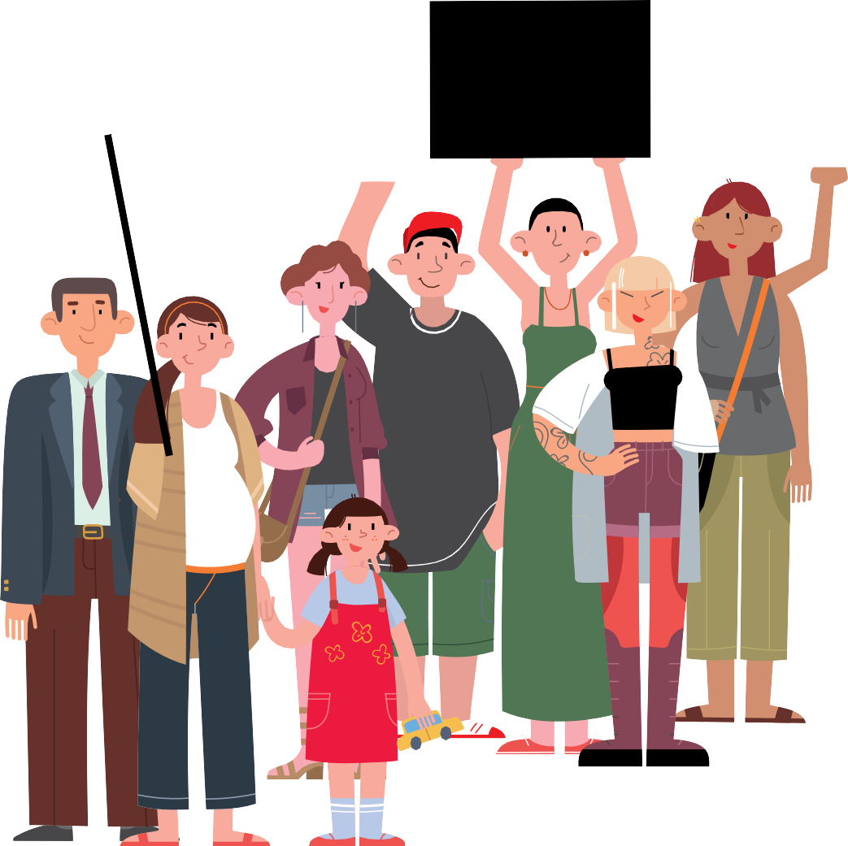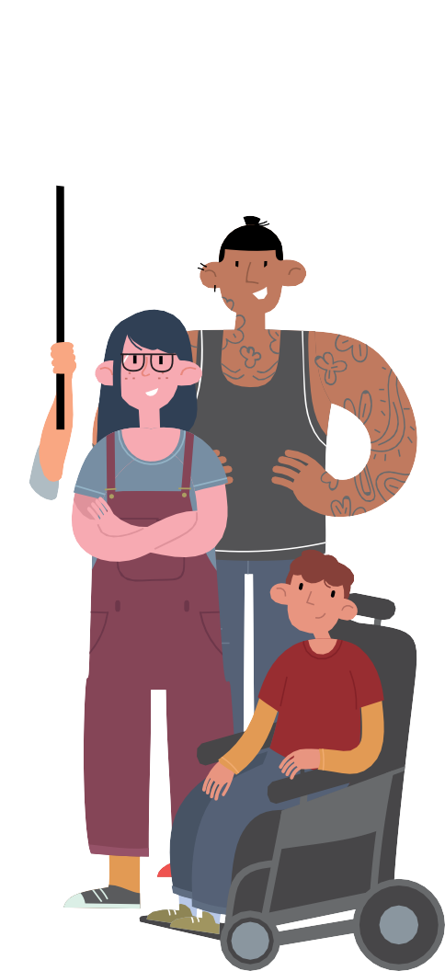About the
Respect Women: Call It Out 16 Days toolkit
8.
Respect Women: ‘Call It Out’ campaign

Respect Victoria’s Respect Women:

‘Call It Out’ campaign encourages Victorians to call out sexism, sexual harassment and disrespect towards women.

This campaign aims to support the Victorian community in understanding what respect means, what it looks like, and how to put it into practice in their everyday lives. We have an opportunity to support our communities to understand what gender equality looks like and how striving for equality can prevent

violence against women. When gender equality exists, we all benefit.
Gender inequality involves devaluing or disrespecting women or women’s contributions. Research has consistently found that these forms of disrespect increase the likelihood of violence against women.
Respect Victoria wants to inspire action and to encourage members of the public to embrace the types of behaviours and actions that represent and personify ‘respect’.

About the UN initiative: 16 Days of Activism against Gender-Based Violence

The 16 Days of Activism against

Gender-Based Violence originated from a petition that was circulated during the 1991 United Nations World Conference on Human Rights.

This petition called on the conference committee to comprehensively address women’s human rights, and recognise gender-based violence as a human rights issue. Almost three decades on, the 16 Days of Activism against Gender-Based Violence is a widely recognised global campaign that signifies action towards ending violence against women and girls around the world.

The 16 Days Campaign begins on the International Day for the Elimination of Violence Against Women (25 November) and ends on International Human Rights Day (10 December). The dates for the campaign were chosen to link violence against women and human rights. During this time, organisations and individuals from around the world raise awareness about women’s rights being human rights, and that violence against women is a fundamental violation of those human rights.

Respect Victoria’s “Respect Women: Call It Out” campaign seeks to align with the timing of 16 Days of Activism against Gender-Based Violence as recognition that this is an important period of the year to be actively focusing on violence against women.
More details on the activist origins of the 16 Days of Activism can be found here.

The 16 Days of Activism against Gender-Based Violence is a global initiative galvanising individuals, communities and organisations to address gender inequalities and eradicate violence against women and girls around the world.

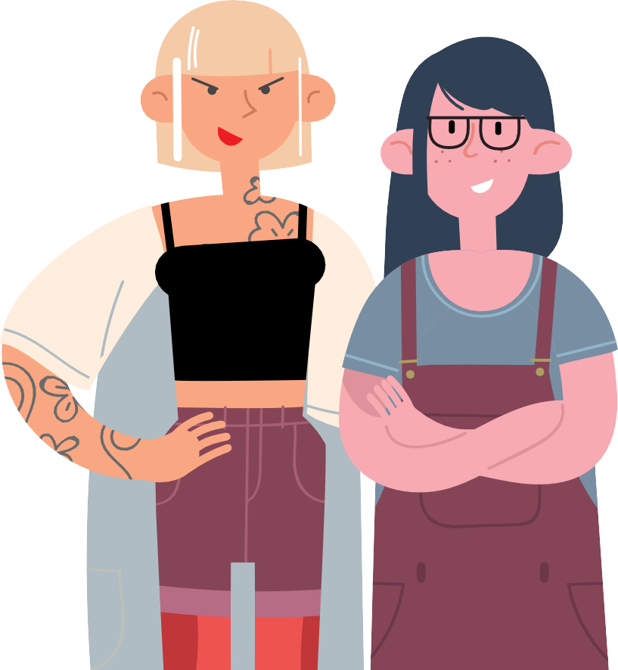

Respect Women: Call It Out 16 Days toolkit
9.

Campaign collateral

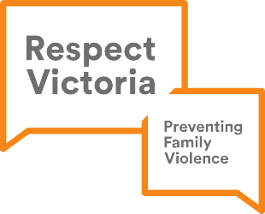
Respect Women: Call It Out 16 Days toolkit
10.

A selection of collateral and materials has been developed for councils and organisations to use during the 16 Days initiative and beyond (as appropriate).

Below is a list of digital collateral ready to- download here. On each item, there is a blank space for you to drop in your organisational logo(s) in Photoshop.

Additional information that is specific to the ‘Respect Women: Call It Out’ campaign messaging will be provided by Respect Victoria at a later date. This will include social media tiles and posters.

Logos
Please note: The Respect Women: Call It Out logo is current and should still be used in 2020, along with the Respect Victoria logo. In terms of hierarchy, your council/organisation’s logo should come first, then Respect Victoria’s logo, then your partner organisation’s logo.

Respect Women: Call It Out logo

Respect Victoria logo

Sticker
This is designed to be printed as 7cm wide x 9cm high.

Bookmark This is designed to be printed as
4.5cm wide x 15cm high.

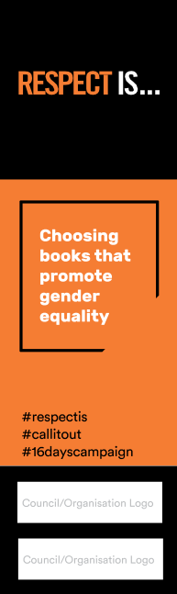
Front Back

Selfie Frame Respect Is...Cards
#16dayscampaign #respectis #callitout

Council/Organisation Logo

This is a virtual selfie frame. It is designed for you to drop an image (photo) of you/someone/ people into the frame and share on social media or online.
You may wish to use the

Virtual Background
Respect Women: Call It Out 16 Days toolkit
11.
#16dayscampaign #respectis #callitout
Council/Organisation Logo

This is designed to be used as a virtual background on Zoom and other online meeting platforms.

Email Signature Banner
treating everyone as an equal
#16dayscampaign #respectis #callitout

Council/Organisation Logo

This is designed to be used by your organisation in your email signatures.
‘TO ME / TO US, RESPECT IS...’ cards to hold up in your photos, describing what respect is to you/them (in your/their own words). Words can be either hand written or typed in using Photoshop. e.g. “To me, respect is... listening to what other people have to say.”

Please note: if you are developing your own ‘Respect Is...’ key messages (as opposed to personal statements), please make sure these are approved by the MAV prior to distribution, to ensure they align to the campaign’s intent (email: 16dayscampaign@mav.asn.au to seek approval). MAV will keep a register of these key messages along with any collateral developed by councils/NGOs.

Hashtags include #respectis #callitout #16dayscampaign

16 ways to get involved
Respect Women: Call It Out 16 Days toolkit
12.

Here are just a few ideas. Many of these ideas can also be used beyond the 16 Days of Activism to encourage year- round action for gender equality and prevention of

gender-based violence.

Ways for organisations to take action

Sign up to the virtual Walk Against Family Violence on 25 November hosted by Safe Steps with support from Respect Victoria
The inaugural ‘Walk Against Violence’ was held in 2008, on the first day of the 16 Days of Activism initiative. For more than a decade this major event has taken place in Melbourne’s CBD. Each year, the walk has gained momentum, drawling larger crowds and increased interest from the community.

The walk launches the 16 Days of Activism suite of activities and community initiatives, encouraging Victorians to stand up and speak out against family violence.

The landscape for 2020 has changed significantly due to coronavirus (COVID-19) restrictions relating to community gatherings. With this in mind, the aim for 2020 is to widen accessibility, encouraging Victorians to stage their own ‘neighbourhood walk’ by themselves or in small groups adhering to government approved gathering sizes. Walkers will be encouraged to register for the walk (as an individual or as part of a team) and wear orange to raise awareness of family violence.

Councils can sign up to order a limited number of orange masks to distribute to their constituents.

Host an online event: start conversations about preventing gender-based

violence
Organise an online morning tea, panel discussion, book club or exhibition. Use the conversation starter kit on page 22 of the

toolkit to support a conversation about respect, gender-based violence, everyday sexism and how to call it out.

Get active on social media
Social media can be used to drive behaviour change. During the pandemic, its popularity has skyrocketed, with people using this technology to stay connected. We encourage individuals and organisations to share the social media tiles in toolkit part 2 to
promote respect and bystander action. Use the problematic attitudes fact sheet on page 19 to support your messages. See page 23 for tips on dealing with online resistance and backlash. Ask your Councillors, Presidents or Chairs to support the initiative through social media.
Use the selfie frame provided in this toolkit.

Invite faith and diverse community leaders to actively participate
Faith-based and multicultural community leaders can play a vital role in bringing about change. Invite your local leaders to work on a joint activity and use resources in community languages.

Share books that challenge traditional gender stereotypes
Record people reading books, or parts of books, aloud and share the videos. Use the book lists provided on page 14-16 to create library displays, promote to book clubs and distribute among colleagues, family and friends. Print the bookmark template included in this toolkit and distribute to local libraries.

Elevate the voices of Aboriginal and Torres Strait Islander women, CALD, refugee and migrant women
Invite Aboriginal and Torres Strait Islander women and culturally and linguistically diverse (CALD) women, including refugee and migrant women, to share their stories, achievements and initiatives in print, video and on social media.

- Share learning about gender diversity Encourage colleagues to learn about what gender diversity means, and how to
support transgender and non- binary people.
The Trans101 gender diversity crash course is
a great place to start. Host an online workshop to discuss.

Add the Respect Women: ‘Call It Out’ logo to your email signature.
Use the digital signature banner in this toolkit and the virtual background in your Zoom meetings.

Wear orange and get your colleagues to wear orange too!
Orange symbolises a brighter future and a world free from violence against women and girls. Take a photo of you and your colleagues in orange using the virtual selfie frame and share. Consider printing orange t-shirts or distribute orange face masks.

Start a conversation or run training on bystander action, including online bystander action
Use VicHealth’s active bystander resources available on their website.

- Make the link with Healthier Masculinities Healthier masculinities are characterised by equality and respect, non-violence, reflection and self-awareness, emotional expression and vulnerability, and accountability. Use the VicHealth Healthier Masculinities framework to inform your initiative.

Run a competition
Organise a ‘challenging gender stereotypes’ art competition or a competition relating to what respect looks like in the context of gender equality and prevention of
violence against women.
- Display posters/banner in your workspace and around your community Print and display posters/banners in your workplace and on community notice boards. If restrictions permit, ask to put up posters in libraries, neighbourhood houses, schools, community halls, sporting clubs and other settings within your municipality or organisation encouraging people to
‘call out’ disrespectful behaviour.

Partner with local businesses
If restrictions permit, ask local cafes to put stickers or printed sleeves on their coffee cups during the 16 Days. Ask local businesses including medical centres, supermarkets, chemists and petrol stations to display posters.

- Ensure your events and materials are accessible to people with disabilities Women with disabilities are twice as likely as women without disabilities to experience violence throughout their lives but they are often missed from the conversation.
Find out more on the Women with Disabilities Victoria website.

Learn more about gender- based violence and bystander action
Explore the supporting resources section of the 16 Days website for additional resources such as DVRCV’s A-Z of preventing violence against women posters.

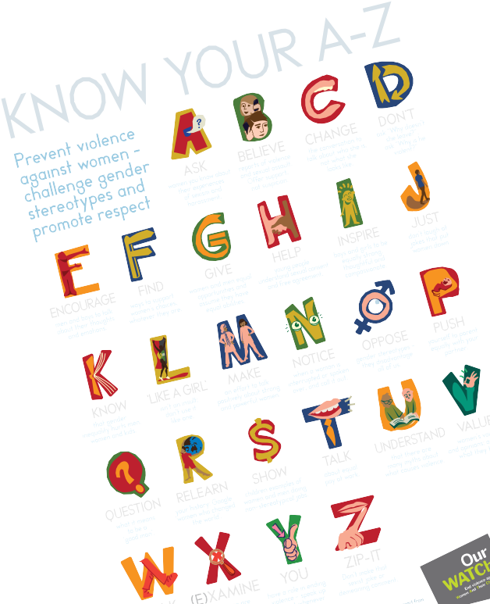Respect Women: Call It Out 16 Days toolkit
Investig gender
ate
influences canwear
ant‒
understand People that!
ttheyw
remember
between wha
Helppeopletionxism’and event
theconnecayse twomen an
‘everyd ains anisetesgender he
eag Org omo y tt
violenc thatpr equalit respec non-
and
positive Valueandgirls s
oicesof ystudent
Normalise abouty ate v binar
discussions xualit elebr
sse c
women’ andandyinour
ents nderst ommunitsit y
forgirls erdiver

13.

Booklists: Read and share books

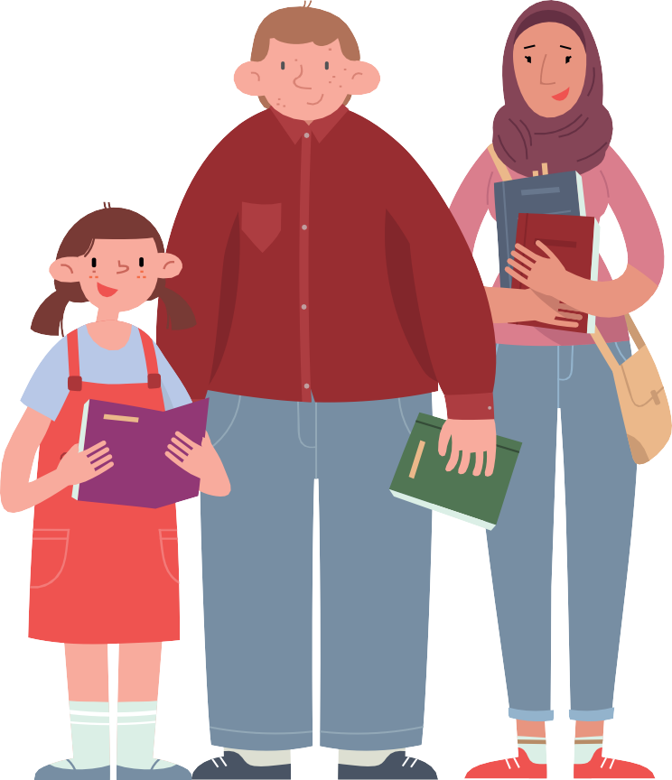Children’s books
- My Princess Boy by Cheryl Kilodavis
- The Night Pirates by Peter Harris
- No Difference Between Us by Jayneen Saunders
- Not All Princesses Dress in Pink by Jane Yolen and Heidi Stemple
- One Busy Day by Lola Schaefer
- Pearl Fairweather Pirate Captain
by Jayneen Sanders
- Piggybook by Anthony Browne
- Princess Smartypants by Babette Cole
Respect Women: Call It Out 16 Days toolkit
14.
Help parents to choose books with their children that promote boys and girls as equals. Here are some great examples.
- Ada Twist by Andrea Beaty
- Amazing Babes by Eliza Sarlos and Grace Lee
- Axle Annie by Robin Pulver
- Be Who You Are by Todd Parr
- Bold Australian Girl by Jess Black
- Cactus Annie by Melanie Williamson
- Crusher is Coming by Bob Graham
- Easy as Pie by Cari Best
- Fly by Jess McGeachin
- Every-day Dress-up by Selina Alko
- Giraffes Can’t Dance by Giles Andreae and Guy Parker-Rees
- Hunting for Dragons by Bruce Whatley
- I am Enough by Grace Byers
- I Could Be, You Could Be by Karen Owen
- Jacob’s New Dress by Sarah and Ian Hoffman
- Made by Raffi by Craig Pomranz
- Introducing Teddy by Jessica Walton

- Roadworks & Demolition (series) by Sally Sutton
- Rosie Revere, Engineer by Andrea Beaty
- Squishy Taylor (series) by Ailsa Wild
- Ruby’s Wish by Shirin Yim Bridges
- Some Boys by Nelly Thomas
- Some Girls by Nelly Thomas
- The Different Dragon by Jennifer Bryan
- The Underwater Fancy-Dress Parade by Davina Bell
- The Paper Bag Princess by Robert Munsch
- Tina and Tom’s Time Travelling Toilet
by Chris ‘Roy’ Taylor and James A Crabtree
- Tough Guys (Have Feelings Too) by Keith Negley
- Two Mates by Melanie Prewett
- Who Am I? I Am Me! by Jayneen Sanders
- Zephyr Takes Flight by Steve Light

Booklists: Read and share books

Young adult
What we read has a strong influence on what we think. Provide young adults with guidance towards literature that challenges stereotypes and gives characters non- traditional roles.
Here are some great examples.
  - A Court of Thorns and Roses by Sarah J. Mass
  - A Great and Terrible Beauty by Libba Bray
  - A Thousand Nights by E.K. Johnston
  - I Am J by CrisBeam
  - And I Darken by Kiersten White
  - Code Name Verity by Elizabeth Wein
  - Gabi, a Girl in Pieces by Isabel Quintero
  - Harry Potter (series) by J.K. Rowling
  - Homecoming by Cynthia Voight
  - How to Make Friends with the Dark
by Kathleen Glasgow
  - I’ll give you the sun by Jandy Nelson
  - Ink and Ashes by Valynne E. Maetani
  - Luna by Julie Anne Peters
  - Lydia by Natasha Farrant
  - Not That Kind of Girl by Siobhan Vivian
  - Only Ever Yours by Louise O’Neill
  - Out of Darkness by Ashley Hope Pérez
  - Rebel of the Sands by Alwyn Hamilton
  - Remix by Non Pratt
  - The Boy in the Dress by David Walliams
  - The Curious Tale of the Lady of Caraboo
by Catherine Johnson
  - The Hunger Games Trilogy by Suzanne Collins

- The Lie Tree by Frances Hardinge
- The Love and Lies of Rukhsana Ali
by Sabina Khan
- The Perks of Being a Wallflower
by Stephen Chbosky
- The Ruby in the Smoke by Phillip Pullman
- The Servant by Fatima Sharafeddine
- The Sky Is Everywhere by Jandy Nelson
- The Tracey Fragments by Maureen Medved
- Unbecoming by Jenny Downham
- Wandering Son (series) by Shimura Takako

Respect Women: Call It Out 16 Days toolkit
15.

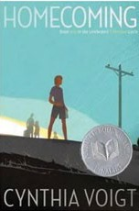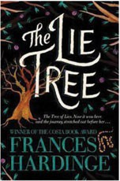

Booklists: Read and share books

Adult fiction and non-fiction
Help visitors and borrowers to choose books that will help them think about gender and gender equality differently. Here are some great examples.
  - Alone atop the Hill by Alice Dunnigan
  - Attack of the 50 Ft. Women: How Gender Equality Can Save The World! by Catherine Mayer (2017)
  - A Room of One’s Own by Virginia Wolfe (1929)
  - Bossypants by Tina Fey (2011)
  - Brotopia: Breaking up the Boys’ Club of Silicon Valley by Emily Chang (2018)
  - Carrie Pilby by Caren Lissner (2003)
  - Dead Beckoning by Christina Engela (2016)
  - The Argonauts by Maggie Nelson (2015)
  - The Bluest Eye by Toni Morrison (1970)
  - Feminism is for Everybody: Passionate Politics
by Bell Hooks (2000)
  - Girl Up by Lauren Bates (2016)
  - Here Lies Arthur by Philip Reeve (2007)
  - Hidden Figures by Margot Lee Shetterly (2016)
  - I Am Malala: The Story of the Girl Who Stood Up for Education and Was Shot by the Taliban
by Malala Yousafzai and Christina Lamb (2013)
  - Juliet Takes a Breath by Gabby Rivera (2016)
  - Kindred by Octavia E. Butler (1979)
  - Men Explain Things to Me by Rebecca Solnit (2015)
  - Middlesex by Jeffrey Eugenides (2002)
  - Milk and Honey by Rupi Kaur (2014)
  - My Life on the Road by Gloria Steinem (2015)

- Not That Bad by Roxane Gay (2018)
- Invisible Women: Data Bias in a World Designed for Men by Caroline Criado Perez (2019)
- Pachinko by Min Jin Lee (2017)
- Stealing the Show: How Women Are Revolutionizing Television by Joy Press (2018)
- The Argonauts by Maggie Nelson (2015)
- The Bluest Eye by Toni Morrison (1970)
- The Great Believers by Rebecca Makkai (2018)
- The Handmaid’s Tale by Margaret Atwood (1985)
- The Help by Kathryn Stockett (2009)
- The Secret Life of Bees by Sue Monk Kidd (2003)
- The Surface Breaks by Louise O’Neill (2018)
- The Testaments by Margaret Atwood (2019)
- The Time Has Come: Why Men Must Join the Gender Equality Revolution by Michael Kaufman (2019)
- The Wife Drought by Annabel Crabb (2015)
- We: A Manifesto for Women Everywhere by Gillian Anderson and Jennifer Nadel (2017)

Respect Women: Call It Out 16 Days toolkit
16.

Key Facts and statistics about gender equality

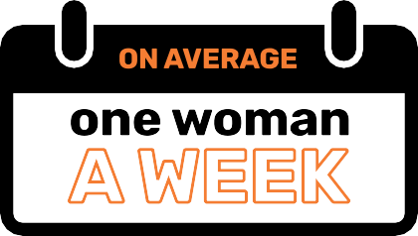
is murdered by her current or former partner.

Source: Australian Institute of Criminology, (2017), Homicide in Australia 2012-13 to 2013-14
of the women who experienced physical or sexual violence it was the ﬁrst time their partner had been violent.
2.2%
4.2%
11.6%
experienced sexual violence
experienced physical violence
experienced emotionally abusive and coercive behaviour
of the women who experienced coercive control said this was the ﬁrst time their partner had been emotionally abusive
or controlling.
Source: Australian Institute of Criminology, The prevalence of domestic violence among women during the COVID-19 pandemic
from a current or former partner during the first 3 months of the COVID-19 pandemic.
COVID-19 In a survey of 15,000 women
5
3
women
women

women have experienced sexual harassment during their lifetime.
2
women
4
men
5
women
20
men
Source: Australian Bureau of Statistics, (2017), Personal safety, Australia, 2016. ABS cat no.4906.0
93%
men have experienced sexual harassment during their lifetime.
Source: Australian Bureau of Statistics, (2017), Personal safety, Australia, 2016. ABS cat no.4906.0

have experienced sexual violence since the age of 15.
Source: Australian Bureau of Statistics, (2017), Personal safety, Australia, 2016. ABS cat no.4906.0

have experienced sexual violence since the age of 15.
Source: Australian Bureau of Statistics, (2017), Personal safety, Australia, 2016. ABS cat no.4906.0

of all victims of violence, whether women or men, experience violence from a male perpetrator.
Source: Australian Bureau of Statistics, (2017), Personal safety, Australia, 2016. ABS cat no.4906.0S

have experienced violence by an intimate partner since the age of 15.
4
w
omen
13
men
Source: Australian Bureau of Statistics, (2017), Personal safety, Australia, 2016. ABS cat no.4906.0

have experienced violence by an intimate partner since the age of 15.
Source: Australian Bureau of Statistics, (2017), Personal safety, Australia, 2016. ABS cat no.4906.0
of Victorian women have experienced bullying, harassment or violence in their workplace.

Source: Victorian Trades Hall Council, (2017), Stop Gendered Violence at Work

Respect Women: Call It Out 16 Days toolkit
17.

of trans women
of trans men
reported harassment or abuse in the previous 12 months.
Source: The Australian Research Centre in Sex, Health & Society, LaTrobe University, (2015), A Closer Look at Private Lives 2.

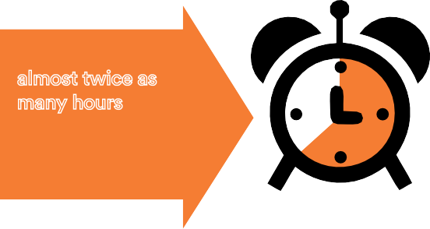Key Facts and statistics about gender equality
Respect Women: Call It Out 16 Days toolkit
18.
Women spend almost twice as many hours each day performing unpaid care work compared to men
64.4%
17.1%
OF CEOS
26.8%
OF DIRECTORS
Women made up 90% of adults who sought specialist homelessness services due to family and domestic violence in 2018-19.
Family and domestic violence is the main reason
women and their children leave their homes
90%

IN THE PRIVATE SECTOR WOMEN REPRESENT
Source: Workplace Gender Equality Agency, (2018), WGEA Data Explorer
Source: Australian Institute of Health and Welfare, (2019), Specialist homelessness services annual report 2018–19

It is estimated that violence
against women and their children
cost the
A
ustralian
economy
in 2015-16
of the total work day for women
36.1%
of the total work
day for men
Source: KPMG, (2016), The Cost of Violence Against Women and their Children in Australia
Source: Workplace Gender Equality Agency, (2016), Unpaid care work and the labour market
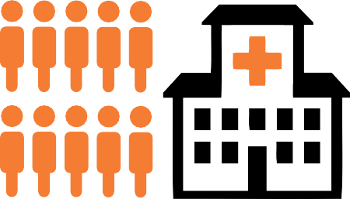
Almost 10 women a day are hospitalised for assault injuries perpetrated by a spouse or domestic partner.

Source: Australian Institute of Health and Welfare (AIHW) 2019.

The full-time average weekly wage for women is
14% LESS than for men. On average, women need to work
AN ADDITIONAL 59 DAYS
to earn the same annual income as men
Source: Workplace Gender Equality Agency, (2020), Australia’s Gender Pay Gap statistics
10women
Family, domestic and sexual violence in Australia: Continuing the national story. Cat. no FDV 3. Canberra: AIHW. During this year, 3600 women hospitalised for assault injuries identified a spouse or domestic partner as the perpetrator.

have experienced violence from a partner, ex-partner or family member. These numbers are even higher for intersex, transgender and gender diverse people.
Source: The Australian Research Centre in Sex, Health & Society, La Trobe University, (2015), A Closer Look at Private Lives 2

Problematic attitudes that need to be called out
Australians believe that woman prefer a man to be
in charge of the relationship

This belief reflects and maintains the broader harmful social expectation that men should always be in charge. It
undermines women’s independence and ability to make decisions in both public and private life.
Australians believe that woman make up false reports of sexual assaults in order
to punish men
This unfounded belief is the very reason that victim survivors are afraid to seek help, and the majority either delay or never report sexual assault. Evidence shows that only 5% of sexual assault allegations are false.
2 in 5
Australians believe many woman exaggerate
how unequally women are treated in Australia
Unfortunately, we are still working towards gender equality in Australia. We have a gender pay gap, men hold the majority of leadership positions and women still undertake the vast majority of unpaid caring work.
It is everyone’s job to address language, attitudes and behaviours that endorse violence and disrespect towards women.

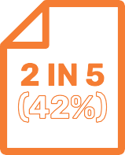
Below are examples of problematic attitudes and ways councils and other organisations can respond to these views. These have been taken from findings from the 2017 National Community Attitudes towards Violence against Women Survey.
1 IN 5

Australians believe violence is a normal reaction to daily stress and frustration
There are many healthy ways to respond to stress and
frustration – using violence is not one. Do not excuse people who choose to use violence.

(24%) Australians see no harm in telling sexist jokes
Sexist jokes reflect and reinforce sexist attitudes, and are harmful. They excuse and perpetuate the gender stereotyping and discrimination against women that underpins violence.
1 IN 3
Australians think it’s natural for a man to want to appear in control of his partner in front of his male friends
Controlling behaviour is a key factor in abusive relationships. By deeming women as less equal than men, disrespect and violence against women will continue.
Australians believe that women can often make a man so angry that he hits her when he didn’t mean to
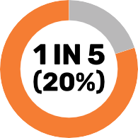
Using violence against women is a choice, not an instinct. Don’t excuse people who choose to use violence.

49 %
Respect Women: Call It Out 16 Days toolkit
19.

Less than half of Australians recognise that levels of fear from domestic violence are worse for women.

Australians believe that women who ﬂirt all the time are somewhat to blame if their partner gets jealous and hits them
Jealousy, control and abuse are not a normal part of romantic relationships, and in no way excuse violence against women.
Don’t excuse people who choose to use violence.
32%
of Australians believe a female victim is partly responsible for the abuse if she does not leave
Leaving an abusive relationship is hard and can be dangerous. Common barriers include: concerns for the safety and wellbeing of children; lack of housing and income; social isolation and lack of knowledge of support options. Instead of asking ‘why doesn’t she leave’, ask ‘why does he use violence’.
However the evidence shows that women are more likely than men to report experiencing fear as a result of violence.

Tools to help ‘call it out’

This section provides councils and other organisations with pointers to stimulate conversations among their workforce and communities. This information will help build capacity among all Victorians in understanding the issues and how to respond to them.

How to “call it out”
‘Call it out’ is a broad term for
responding in some way to behaviours that may be deemed sexist, disrespectful, abusive or constitute sexual harassment.

Inappropriate behaviour can be ‘called out’ by saying something or using body language to indicate disapproval in the moment.
Bystanders can also say or do something later, after the incident (see ‘ways to #callitout’ on the next page). You should use your judgement about the best way to respond, to show that the comment or behaviour is not okay. If the behaviour is directed at a particular person, your response may be primarily to support
them (see number 5 and 10 on the following page).

‘Calling it out’ does not mean physically intervening when you witness violence and does not include hostile or aggressive responses.
If you believe someone is in immediate danger call 000 and ask for the police. It is important that when you react to inappropriate behavior directed toward women, you do not put yourself or the
person who is being targeted at risk. Before responding, you should assess safety and risk of escalation. It is also important to stay within your comfort zone and be pragmatic about your level of skill or confidence. As with any bystander intervention, your safety is paramount.
Different types of bystander action

There are a range of ways you can respond to sexism, harassment and disrespect towards women, depending on the context and your level of confidence. These can

be grouped into four categories:

  - Diffuse Make light-hearted comments or give disapproving looks

  - Check in See if the target is okay

  - Call it out Declare the statement or behaviour offensive and explain why it is harmful

  - Report Access incident reporting systems or report to management where applicable.

See VicHealth’s Take action: Empowering bystanders to act on sexist and sexually harassing behaviours for more information.

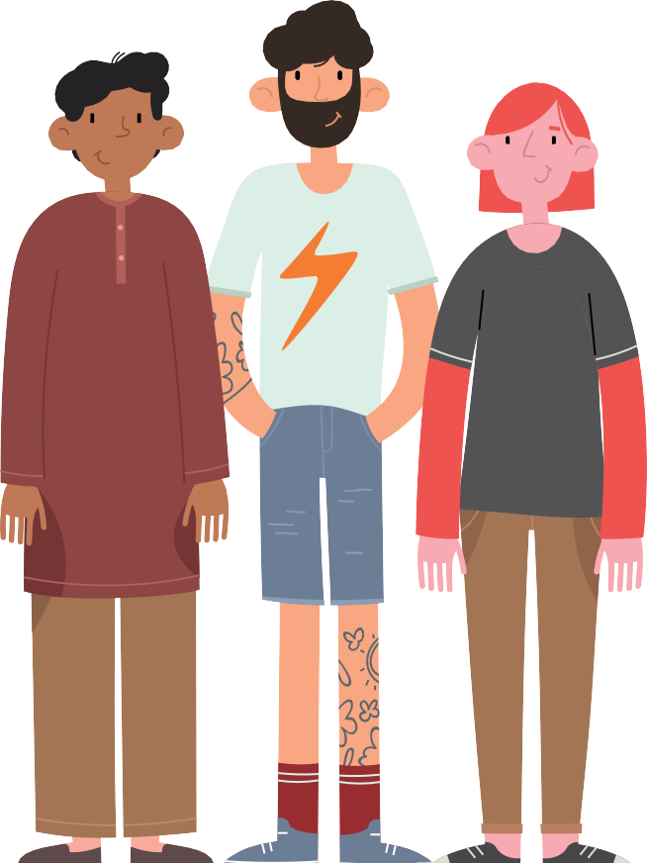Respect Women: Call It Out 16 Days toolkit

20.

16 ways to #callitout
Respect Women: Call It Out 16 Days toolkit
21.
What to do when you hear or see sexist, disrespectful or sexually harassing behaviour

- Don’t laugh at sexist jokes.
- Give a disapproving look to show a behaviour or statement is not okay. Shake your head or roll your eyes.
- Leave a pointed and uncomfortable silence.
- Make a light-hearted comment: “What century are you living in?”
- Check in with the person affected: “I heard what he just said – are you okay?”
- Privately let them know the behaviour is not okay: “The joke you made in yesterday’s meeting was not funny, and actually not okay.”
- Calmly disagree and state that the comment is wrong or unacceptable: “I know you probably didn’t mean it, but I found what you said to be offensive.”
- Speak up and educate by explaining why you disagree: “Actually evidence shows the vast majority of women do not make up false claims of sexual assault” (you could use the Key Facts in this toolkit).
- Challenge the logic: “That’s not my experience.” or “What makes you think that?”
- Stand up for the person affected: “Michelle was saying something, and you cut her off again.”
- Make eye contact with the person affected - let them know you’re an ally.
- Show your emotion: “It actually makes me sad/ uncomfortable when you say that.”
- Support others when they call it out: “I agree, that’s not funny.”
- Appeal to their better self: “Come on, you’re better than that.”
- Report the behaviour to management, or via incident reporting systems if available.
- Disrupt or distract the situation to redirect focus from the incident to something else.

For more examples of how to #callitout visit:
- Respect Victoria Respect Women:
Call It Out campaigns
- Our Watch Doing Nothing Does Harm campaign Our Watch No excuse for abuse campaign
- Michael Flood Challenging Everyday
Sexism Workshop Notes
What should be called out?
In order to call out sexism and disrespect towards women, people must first be able to recognise it. Here are a few everyday examples of sexism, disrespect and harassment
that should be ‘called out’:

- Using ‘like a girl’ as an insult: “Stop whingeing, you sound like a girl!”
- Sexist jokes at the pub: “I’d give her an 8 out of 10!”
- The stereotype that men and boys don’t cry
- Comments that transgender women are “not real women”
- Sitting back while female colleagues clean the work kitchen or get the coffees
- Stereotypes about skills: “I need a bloke’s brain for this”
- Belittling women: “Given what your husband does, do you really need to work?”
- Comments made about a person’s suitability
for a role based on their gender:“I think it’s weird for a guy to be a child care worker”
- Leering or staring
- Sharing inappropriate images with co-workers
- Fathers being congratulated for doing basic parenting tasks: “Great job babysitting the kids!”
- Sexism and racism disguised as a compliment: “She’s pretty... for an Aboriginal girl.”
- When your mate puts his partner down
- Cat-calling / wolf-whistling
- Comments about women being “too emotional”
- The stereotype that Asian women are submissive and therefore make “better wives” and “know how to look after men”
- Sexually suggestive comments or jokes: “I know just what you need to release some stress!”
- Leering or staring
“come on, you’re better than that”

Conversation starters

Gender-based violence, sexism, harassment and disrespect towards women can be difficult topics to bring up in conversation, especially in relationships, communities and settings where attitudes and beliefs about traditional gender roles may be strongly held.

It is, however, important that we do start talking about these issues, or we will never be able to solve them.

Below are some questions to help you start an informal conversation with colleagues, family, friends and community members about gender- based violence, sexism and disrespect towards women. These conversations can be challenging and may bring up a range of difficult issues and emotions for people. Consider this before you start a conversation and make sure you feel safe, supported and prepared.

  - “Why are women overwhelmingly the victims of family violence?
  - “How do men and women experience violence differently?”
  - “Have you thought about who does the chores in your house? Why do you think labour is divided this way?”
  - “Who are your female role models? Do you think they experienced discrimination because of their gender?”

  - “Do you think the media treats women fairly? Does the media blame victims of sexual harassment?”
> “How can men be engaged as allies to help prevent sexism and harassment towards women?”
  - “Do you know what sexism is?” (Use definition and examples of sexism on page 7 in this toolkit to demonstrate).
  - “Do you think there is a problem with sexism / gender inequality in our community?”
  - “Have you thought about what you could do when you hear sexist comments? I know it can feel hard, but there are lots of ways to respond.” For ideas on ways to respond look at page 21.

Conversations about gender inequality can lead to resistance or backlash from some people. See page 23 of the toolkit for tips on how to manage this.

“It is important that we start talking about these issues, or we will never be able to solve them”

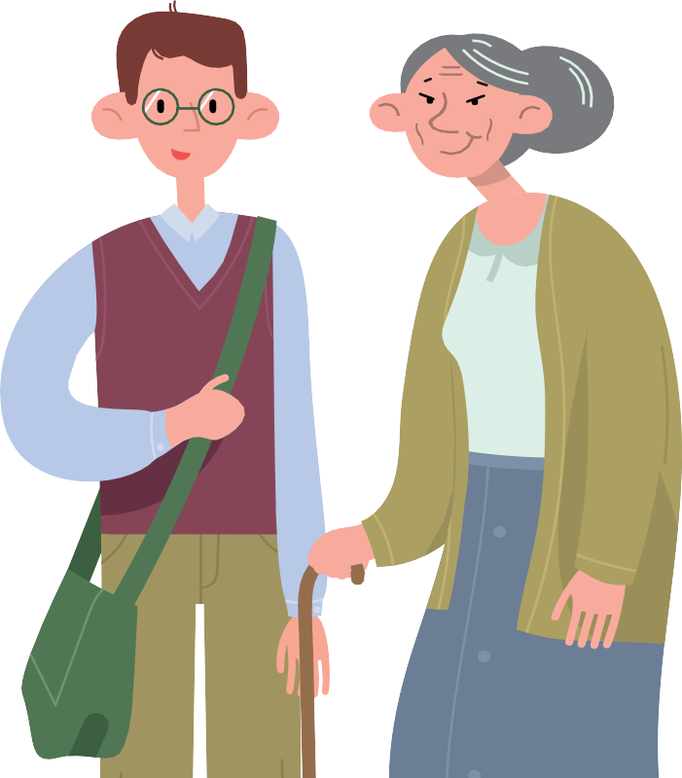Respect Women: Call It Out 16 Days toolkit

22.

Dealing with resistance and backlash

When you bring up gender equality messages, it is likely that you will face resistance or even backlash. It is an uncomfortable experience for most people when their long-held beliefs are challenged – and, naturally they want to resist.
Respect Women: Call It Out 16 Days toolkit
23.

Preparing for potential resistance and coming up with responses in advance will help you communicate better on the spot and may help you open more conversations with the community.
One way to do this is to develop a response register that can be used to guide responses in person, over the phone or online.

You’re just cherry-picking data to say that women are the victims
We acknowledge that both women and men can experience violence, but the nature of this
violence differs in terms of its severity and impacts. Data comes from sources such as the Crime Statistics Agency and the Personal Safety Survey undertaken by the Australian Bureau of
Statistics.

As uncomfortable as it may be, the data consistently shows that women disproportionately experience intimate partner violence and
non-partner sexual assault, and are more likely to be hospitalised, injured, express fear or be killed by a current or former partner. To address the violence experienced by women, we must recognise its gendered nature. We look forward to a future with very different data that shows all forms and rates of violence being eliminated!

Jokes are harmless - speaking disrespectfully does not mean the man is abusive
Speaking disrespectfully does not necessarily mean someone is abusive, but people who are abusive often speak disrespectfully. The evidence tells us that the most consistent predictor for support of violence against women by men is their agreement with sexist and disrespectful attitudes towards women. Sexist jokes reflect and reinforce sexist attitudes.
There are many jokes we can make that aren’t sexist and disrespectful – why not challenge ourselves to be creative with our humour and not fall back on old stereotypes!

Sexism and disrespect do not cause violence against women. It is caused by poverty, unemployment and stress
Poverty, unemployment, or stress alone do not drive violence against women. Women experience poverty, stress and unemployment at equal or often higher rates than men. However,
93% of violence is committed by men, not women. Violence against women happens regardless of income, class or unemployment status. While we recognise those factors may increase the likelihood or severity of violence against women, they only play a role when people hold beliefs and attitudes that are sexist and disrespectful.

Violence is really only an issue within some community groups like migrant communities or Aboriginal & Torres Strait Islander communities Family violence occurs among all types of families, regardless of income, profession, religion, ethnicity, or educational level.
Why must one gender be more respected than the others? Respect everyone regardless of gender, not just women!
We agree – everyone should be respected regardless of their gender. Unfortunately though, women experience casual and structural sexism on a daily basis and are not respected in the same way as many men are. To create a society where there is no disrespect and no violence we need to look honestly at what the evidence is telling us.

“Women are more likely than men to be hospitalised, injured, express fear or be killed by a current or former partner”

Sexism only seems to work one way these days Sexism is prejudice or discrimination based on sex or gender. Although sexism can be directed at men, women have been and remain the predominant targets of sexism. Sexism toward women must be viewed differently to sexism toward men because
it is based on systematic inequalities and historic oppression. Sexism and similarly inflexible beliefs and attitudes toward sex and gender roles (sexism) are the most consistent predictor of attitudes and behaviours that lead to violence against women.

Why is gender equality and family violence/gender-based violence a council issue? Shouldn’t you just stick to roads, rates and rubbish?
Family violence and violence against women is a serious and prevalent issue affecting the health and wellbeing of many people living within
our municipality. The role of council is to address issues that are relevant to our community and we are legislatively required to work to prevent family violence (Public Health and Wellbeing Act 2008). The reach of local government across the community is unrivalled and we are in a unique position where we can embed gender equality across multiple community settings and services. We believe that we can lead the societal change needed to achieve gender equality and subsequently prevent violence against women through the services we deliver, our organisational structure and operations, and most importantly through leadership in the community.

What happens inside a family is their business, no one else’s
Family violence is no longer considered a private matter and is being addressed as a serious public health and criminal justice issue. If you know of someone who is being abused, express your concern and encourage them to seek help.

Safe Steps is Victoria’s 24/7 family violence support service.
Safe Steps (1800 015 188) safesteps.org.au

Continue to build your response register
Use the Women’s Health West, Speaking publicly about preventing men’s violence against women: Curly questions and language considerations tool and Our Watch’s Practice Guidance: Dealing with backlash tool.

For more information on how to prepare for and respond to resistance and backlash to gender
equality initiatives view VicHealth’s (En)countering resistance: Strategies to respond to resistance to gender equality initiatives.

Consider using the key facts and statistics provided in this tool kit to strengthen your response.

Dealing with resistance and backlash online
To respond to destructive comments or trolling on social media, here are some ideas on how you can start your response:

- Hi (insert name), we hear you; you’re not on board with this initiative and that’s OK ...
- Hi (insert name), we’re sorry to hear you say this. From our research we know that ...
- Hi (insert name), we do appreciate other view points, however, if you continue to be disrespectful to others, we will remove you from the page.
- Hi (insert name), please be clear any further
de-railing of the conversation with disrespect or hatred will not be tolerated.
- Hi (insert name), thanks for sharing your feedback, we do appreciate other viewpoints however, this is a space for ... and will continue to serve that function.

It is important for social media moderators to strike a balance between allowing audiences to
self-moderate and intervening when comments are offensive and de-rail constructive conversation.
Having clear moderation guide lines will support you to effectively manage resistance on online forums.

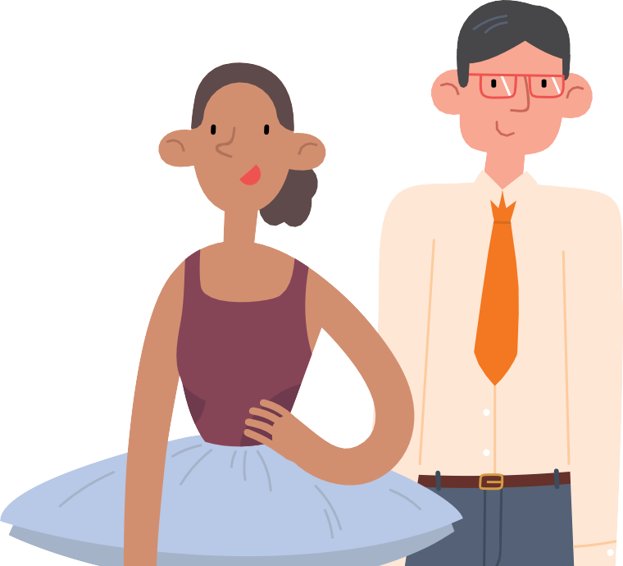Respect Women: Call It Out 16 Days toolkit

24.

Responding to disclosures

When you open up conversations about gender equality, respectful relationships and violence against women, there’s a good chance that someone may disclose that they have experienced or witnessed violence.
For this reason, it is important you know how to respond. This section provides information to support you to respond to disclosures effectively.

Do
  - Listen,without interruption or judgement, giving the victim survivor time to share their experience
  - Believe what the victim/survivor is saying to you
  - Affirm the victim/survivor has done the right thing in disclosing their experience
  - Affirm the victim/survivor is brave in being able to come forward
  - Emphasise that they are not to blame for their experience
  - Respect the victim/survivor’s decisions – even if you don’t agree with them
  - Be honest and open about your skills and knowledge and the types of support you can provide
  - Provide information about specialist support services (listed on the back page). Encourage them to seek out additional personal and professional support
  - Keep the conversation confidential. The only exception is if you believe the person’s safety is at immediate risk (call 000), or you become aware that a child’s safety is at risk. In some cases, for example if you are a professional such as a teacher or doctor, it may be mandatory for you to report this to relevant
authorities.
“What has happened is not okay and is not your fault”

Don’t
- Try to find out details
- Try to fix the situation for them
- Suggest the situation is somewhat their fault – don’t ask questions like ‘why do you put up with it?’ or ‘how can you still stay with him?’
- Give advice or tell them what to do – it will reduce their confidence to make their own decisions
- Judge or criticise their choice – even if you don’t agree with it
- Criticise the perpetrator – it may only make the victim/survivor want to defend the perpetrator. Focus on criticising the abusive behaviour and let them know that no one should abuse them
- Provide counselling – if you are not a counsellor or do not have specialist training in responding to family violence, be honest and open about that.
Instead you can provide information about referral pathways which are listed at the back of this toolkit.

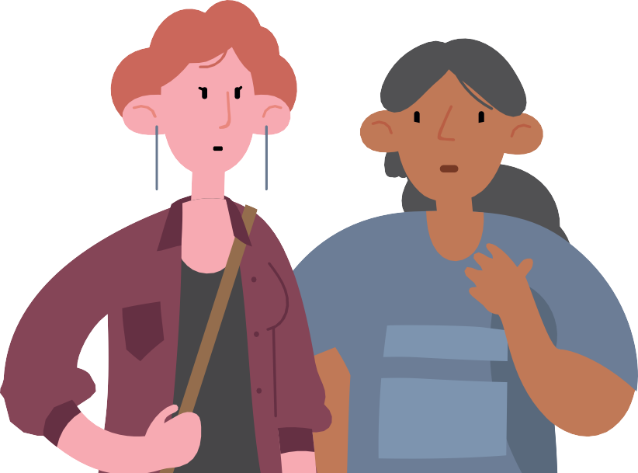Respect Women: Call It Out 16 Days toolkit

25.

Responding to disclosures

Examples of things you could say
Respect Women: Call It Out 16 Days toolkit
26.
These are some ideas. It is important you only say what you believe and use your own words:

- What has happened is not okay and is not your fault
- I’m glad you have told me
- No one should have to experience what you have been through
- Do you feel safe at the moment?
- I don’t have specialist knowledge in helping people with experiences like yours, but I can give you the contact details of people who do
- It’s up to you to choose what to do with this information, but I can give you the contact details of a specialist whom you can talk to if you need.

Self-Care
Self-care is a priority and necessity – not a luxury. If you find yourself feeling down, depleted or irritable you may need to take some time out.
There are lots of ways you can do this.

- Reach out to someone. This could be a family member, trusted friend or colleague, your manager, a counsellor or an other support person. You could also speak to your GP about seeing a counsellor or, if available to you, access your employee assistance program (EAP). For
after- hours support, Safe Steps, Victoria’s family violence support service, is available 24 hours a day for professionals to discuss the personal impact of working with people who have experienced violence
- Find a way to escape physically and/or mentally e.g. reading, days off, holidays, walks, seeing friends
- Rest – have some time with no goals e.g. taking naps, watching clouds, lying on the beach
- Play – have fun and do things that make you laugh e.g. playing with children and pets, creative activities, watching a favourite comedy.

The three most important things you can do when responding to disclosure:

- Listen without interruption or judgement
- Believe and validate their experience
- Provide information about referral pathways

Beyond the 16 Days
Respect Women: Call It Out 16 Days toolkit
27.
Efforts to prevent violence against women, such as this year’s 16 Days initiative, are more likely to be effective and to achieve lasting change when they are part of a broader suite of activities to promote gender equality and prevent violence against women.

To increase the likelihood that you will achieve positive and lasting change, consider the following:

Get leadership on board
Leadership involvement and support is essential for getting traction on gender equality initiatives. When leadership is on board, bystander action can more easily be embedded
into organisational policies, code of conduct and performance management. Having strong leadership on preventing violence against women helps to create an authorising environment in which bystander action is encouraged and supported. Our Watch has advice on how to secure support from leadership.

Make sure your organisation has an effective reporting and resolution process. If not, develop one!
Having an effective reporting and resolution process supports people to easily and safely take action against sexism, disrespect and sexual harassment. VicHealth and Our Watch have useful suggestions to support your workplace to respond appropriately to violence against women and sexual harassment.

Ensure your organisation has an equal opportunity, sexual harassment, or gender equity policy
Policies provide a blueprint for the kind of workplace culture you want to achieve. To encourage bystander action, you will need policies that let staff and other stakeholders know what behaviours are inappropriate, what action can be taken, and how privacy will be protected. This information does not have to be contained
in a standalone bystander action policy, but can be included in other policies aimed at building
a safe and respectful workplace, such as an equal opportunity or sexual harassment policy. Policies

should be accessible, accompanied by complaint and grievance procedures, and communicated to all staff. Take a look at the promising practice
portal and council produced resources on the MAV website.

Attend, deliver or organise gender equality or bystander action trainings/workshops.
For information on a range of gender equality training and professional development workshops for individuals and workplaces visit:

- The Domestic Violence Resource Centre Victoria
- Subscribe to receive the MAV gender equality and prevention of violence against women fortnightly e-news update
- Sign up to the Partners in Prevention Network
- Women’s Health Victoria
- No To Violence
- Your regional Women’s Health Service.

Roll out light touch messaging about bystander action throughout the year
Consider doing this through a series of simple emails. These emails should:
- Be clear about what constitutes sexism, harassment and disrespect
- Provide suggestions on how bystanders could respond.

For more information on how to do this view VicHealth’s, Take action: Empowering bystanders to act on sexist and sexually harassing behaviours in universities.
Develop a code of conduct
A code of conduct is an important guide for employees when thinking about how they are expected to behave in the workplace.
Use of tools and resources beyond the 16 Days The tools and resources provided in this toolkit have been deliberately designed to be useful beyond the 16 Days of Activism against
Gender-Based Violence 2020. We encourage councils, organisations, and community members to continue to use these resources to support bystander action, prevent violence against women and promote gender equality.

During the 16 Days
Ensure support services are visible

Ensure the following support services are visible when running the Respect Women: ‘Call It Out’ 16 Days initiative.

At a minimum, the Safe Steps phone number should be included, and where possible add the following sentence “If you believe someone is in immediate danger, call 000 and ask for the police. If you or someone you know is experiencing family violence, help is available.”

SAFE STEPS 1800 015 188
A confidential and supportive family violence response line for Victoria. Phone services available 24/7. safesteps.org.au
ORANGE DOOR
Family violence support and safety hubs. To find your nearest location, visit the website: orangedoor.vic.gov.au
DJIRRA
Djirra is a culturally safe place where culture is celebrated, and practical support is available. Call 1800 105 303 or visit the Djirra Aboriginal Family Violence Prevention and Legal Services website: djirra.org.au

INTOUCH MULTICULTURAL CENTRE AGAINST FAMILY VIOLENCE
A specialist family violence service that works with multicultural women, their families and their Communities. Call 1800 755 988 or visit the InTouch website: intouch.org.au

1800 RESPECT
1800 737 732
The national sexual assault, domestic and family violence counselling service. Phone and online services available 24/7.
1800respect.org.au

“If you or someone you know is experiencing family violence, help is available”

KIDS HELPLINE
1800 55 1800
Kids Helpline is a counselling service for Australian children and young people aged
between 5 and 25 years. Phone and online services available 24/7. kidshelpline.com.au
RAINBOW DOOR
Rainbow Door is a free specialist LGBTIQ+ helpline providing information, support and referral to all LGBTIQ+ Victorians, their friends and family during the COVID-19 pandemic and beyond. Call
1800 729 367 or visit the Rainbow Door website.
MEN’S REFERRAL SERVICE
1300 766 491
Men’s Referral Service provides anonymous and confidential telephone counselling, information and referrals to men, to help them take action to stop using violent and controlling behaviour. ntv.org.au
MENS LINE
1300 78 99 78
Professional support and information service for Australian men. Phone and online services available 24/7. mensline.org.au
SENIORS RIGHTS VICTORIA
1300 368 821
Seniors Rights Victoria (SRV) provides information and advice to help prevent elder abuse and safeguard the rights of older people. seniorsrights.org.au

Respect Women: Call It Out 16 Days toolkit

28.

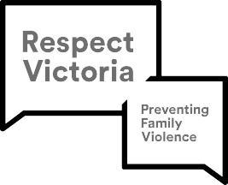

For more information relating to this toolkit, councils and other NGO funded recipients can contact MAV by emailing
16dayscampaign@mav.asn.au

Other organisations and Victorian Government departments can contact Respect Victoria by emailing contact@respectvictoria.vic.gov.au

