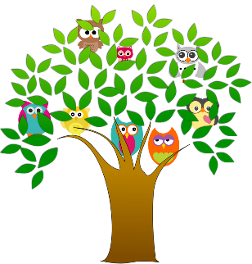
Your Victorian Maternal and Child Health Service What happens to information about you, your child and family?

Insert council logo here
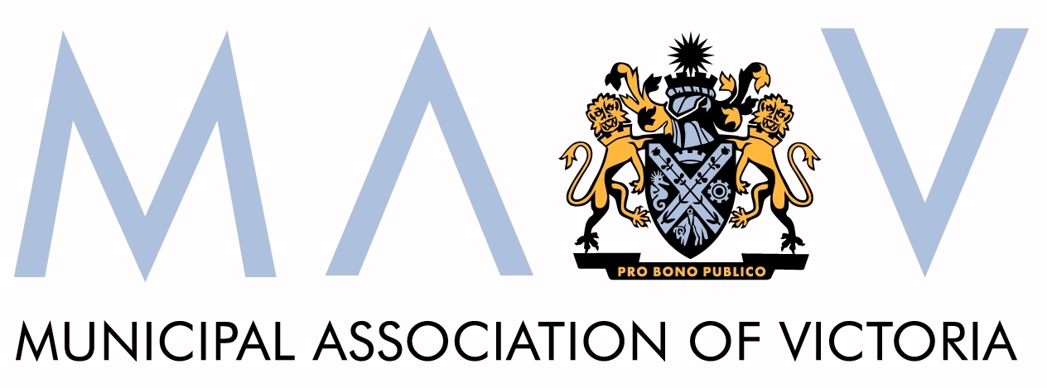

Who are we?
The Victorian Maternal and Child Health (MCH) Service is a statewide service that provides support for your child’s health, learning and development from birth until they go to school. The service also provides support to you and your family and referrals to other services.

What information do we collect?
Your name and contact details are a part of your child’s electronic health record. Other details about you, your child and family that are important to this service and the information about the services you receive, are recorded each time you visit.

Why do we collect this information?
The information we collect helps us to keep up-to-date information about you, your child and your family’s needs so we can help support you all in the best way we can.

Who else sees your information?
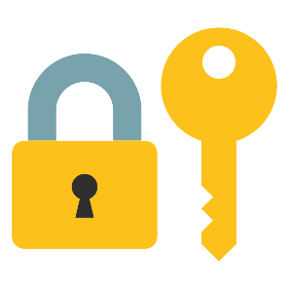
Your information can only be seen by the professionals in this service who are involved with you, your child and family. Information that does not identify you, your child or your family will be collected for training and planning towards a better service for everyone. We cannot share any information with anyone unless you agree or otherwise only in accordance with privacy law.

Do you have a say in what happens to your family’s information?
Yes. We rely on the information you share with us to help provide the right service for you, your child and family. If you decide not to share some information or limit access to your child’s electronic child health record, this is your right, but it may affect our ability to provide you with the best possible services. Talk to your Maternal and Child Health nurse if you wish to change or cancel your consent.

How will this information be protected?
We are committed to protecting the security and confidentiality of your child’s electronic health record. This information is protected under the Health Records Act 2001 (Vic). We treat all information we receive confidentially and we must store it safely and securely.

Can you access this information?
Yes, you have a right to request access to your child’s electronic health record and you can ask for information in it to be corrected if necessary. If you would like to do this, please ask the Maternal and Child Health nurse or go to the Victorian State Government Health Records Act link below for more information.

Any other questions?
Please talk to your Maternal and Child Health nurse if you have any other questions or concerns.

For further information:
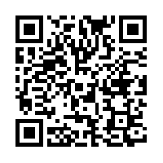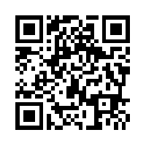

- Health Records: https://www2.health.vic.gov.au/about/legislation/health-records-act

- Freedom of Information: https://www2.health.vic.gov.au/foi

