MARAM Alignment Tool
for Councils
(Multi-Agency Risk Assessment and Management Framework)

Updated December 2021

Adapted from DFFH MARAM organisation self-audit tool (2020) on the MARAM practice guides and resources webpage

MARAM Alignment Tool for Councils
(Multi-Agency Risk Assessment and Management Framework)
Contents
SECTION 1 - MARAM Legislative and practice context 5
MARAM Guidance available to assist completing the audit tool
MAV MARAM Support page
MAV MARAM & Information Sharing Policy Guidance for Councils
State Department MARAM website
MARAM Framework one page
MARAM Framework summary
MARAM practice guide: chapter summaries
MARAM Framework
MARAM victim survivor focused practice guides
Background of the MARAM Framework 6
Objectives of the MARAM Framework 6
MARAM legislative principles 6
MARAM Pillars 1 - 4 7
Structured Professional Judgement Model 8
MARAM allocation of roles and responsibilities9
Screening and Identification - Responsibilities 1,2, 5,6, 9,10 9
Intermediate Risk Assessment: (additional) Responsibilities 3, 4 9
Comprehensive Risk Assessment: (additional) Responsibilities 7, 8 9
MARAM Responsibilities: Decision Guide for Organisational Leaders 10
Information Sharing Entities (ISEs) 11
Risk Assessment Entities (RAEs) 11
List of ISEs 11
Section 2 -MARAM AlignmenT tool 12
Integrating the MARAM framework and tools into policies and practice 12
Assessment of alignment progress, examples and resources 12
Recommendations in using the tool 13
Assessing progress 13
Reviewing implementation activities 14

Pillar 1: A Shared Understanding of Family Violence15

Key reading | Introduction to Pillar 1 | Framework Requirement

Milestone 1A: Foundational knowledge for a shared understanding OF FV 16
Milestone 1B: Training in foundational knowledge 17
Milestone 1C: Workplace environment 19
Pillar 2: Consistent and collaborative practice 20
Key reading | Introduction to Pillar 2 | Framework Requirement
Milestone 2A: screening and Identification of family violence 21
Milestone 2B: Management of family violence risk 23
Milestone 2C: Secondary consultations and referrals 25
Milestone 2D: Information sharing 26
Pillar 3: responsibilities for risk assessment and management 29
Key reading | Introduction to Pillar 3 | Framework Requirement
Milestone 3A: Mapping MARAM responsibilities 30
Milestone 3B: Staff communications on responsibilities 31
Milestone 3C: Staff training on responsibilities 32
Pillar 4: Systems, outcomes and continuous improvement 33
Key reading | Introduction to Pillar 4 | Framework Requirement
Milestone 4A: Collect and collate data 34
Milestone 4B: Establish external partnerships 35
Milestone 4C: Organisational culture change 36
Completion details 38
Glossary and definitions 39

SECTION 1 - MARAM Legislative and practice context
The MARAM Alignment Tool supports councils in their responsibilities to align their prescribed services with the MARAM (Multi-Agency Risk Assessment and Management) framework. The tool can be used by council managers, senior leadership and prescribed service workers to understand, identify and assess relevant family violence policies and practice to come under alignment with MARAM, and can form the basis of a project plan.

Section One briefly outlines MARAM's key legislative context, ten core principles and four pillars, as well as the organisational roles and responsibilities.

Section Two provides the alignment self-audit tool which is structured to reflect MARAM's four foundational pillars, with considerations for service mapping and review with general examples, and links to MARAM guides and tools. The self-audit tool can be tailored and adapted to suit the organisation’s purpose (i.e. by adding in examples or references to specific council policies).

MARAM Guidance available to assist completing the audit tool
MAV MARAM Support page
FVISS Ministerial Guidelines
CISS Ministerial Guidelines
MAV MARAM & Information Sharing Policy Guidance for Councils
State Department MARAM website
MARAM Framework on a page (2 pages) (under MARAM Framework)
MARAM Framework summary (10 pages)

For a deeper dive into the MARAM reforms:
MARAM practice guide: chapter summaries (42 pages) (under Practice guide resources and tools in Organisational focused resources)
MARAM Framework (58 pages)
MARAM victim survivor focused practice guides (2020) (400 pages) – cant find a page just direct link
DFFH/DH Information Sharing Scheme eLearn modules

Background of The MARAM Framework
The Victorian Government established MARAM in response to Recommendation One of the Royal Commission into Family Violence 2016 (“the Royal Commission”) to guide organisations, services and professionals in the sector response for the identification, assessment and management of family violence risk.

- The Royal Commission identified gaps and structural barriers in the integrated service system’s ability to work together to support adult and child victim survivors of family violence and hold perpetrators accountable.
- The first recommendation of the Royal Commission was that the existing Common Risk Assessment Framework (CRAF), developed in 2007, be updated and the new framework embedded into legislation. The Multi-Agency Risk Assessment and Management (MARAM) Framework is legislated under Part 11 of the Family Violence Protection Act 2008.
- More than 1,600 stakeholders from the public, private and non-government sector contributed to the development of MARAM.
- MARAM sets out a system-wide approach and shared responsibility to guide professionals across the integrated service system to identify, assess and manage family violence risk with a shared understanding of family violence, and that can be utilised with the the Family Violence Information Sharing Scheme, and the Child Information Scheme, (for more information, see MAV's MARAM and Information Sharing policy guidance available for councils). Practitioners hold different responsibilities under MARAM based on their role within a given organisation or service, and councils may have more than one service that is prescribed under MARAM.
- MARAM is framed as a maturity model, in acknowledgement of different organisations beginning at different starting points for MARAM alignment.
- MARAM is supported bya comprehensive suite of resources including practice tools and guidance for practitioners.

Objectives of the MARAM Framework:
The MARAM objectives are set out on page 5 of the framework as follows:
- Increase the safety of people experiencing family violence
- Ensure the broad range of experiences across the spectrum of seriousness and presentations of risk are represented, including for Aboriginal and diverse communities, children, young people and older people, across identities, and family and relationships types
- Keep perpetrators in view and hold them accountable for their actions and behaviours
- Guide alignment with the Framework for use across a broader range of organisations and sectors who will have responsibilities to identify, assess and respond to family violence risk
- Ensure consistent use of the Framework across these organisations and sectors.

MARAM legislative principles
MARAM principles guide prescribed framework organisations according to their role and function within the broader service system whenever family violence is present:

- Family violence involves a spectrum of seriousness of risk and presentations, and is unacceptable in any form, across any community or culture.
- Professionals should work collaboratively to provide coordinated and effective risk assessment and management responses in a timely manner, including early intervention.
- Professionals should be aware of the drivers of family violence, predominantly gender inequality, and the intersectionality with other forms of structural inequality and discrimination.
- The agency, dignity and intrinsic empowerment of victim survivors must be respected by partnering with them as active decision-makers in risk assessment and management.
- Children impacted by family violence must be recognised as victim survivors in their own right.
- Services provided to child victim survivors should acknowledge their unique experiences, vulnerabilities and needs, including the effects of trauma and cumulative harm arising from family violence.
- Services and responses provided to people from Aboriginal communities should be culturally responsive and safe, recognising Aboriginal understanding of family violence and rights to self-determination and self-management, and take account of their experiences of colonisation, systemic violence and discrimination and recognise the ongoing and present day impacts of historical events, policies and practices.
- Services and responses provided to diverse communities and older people should be accessible, culturally responsive and safe, client-centred, inclusive and non-discriminatory.
- Perpetrators should be guided to acknowledge and take responsibility to end violent,controlling and coercive behaviour, and service responses to perpetrators should be collaborative and coordinated through a system-wide approach that collectively and systematically creates opportunities for perpetrator accountability.
- Family violence used by adolescents is a distinct form of family violence and requires a different response to family violence used by adults, because of their age and the possibility that they are also victim survivors of family violence.

MARAM Pillars 1 - 4
The MARAM establishes framework requirements for services and organisations to align to under MARAM's four pillars. Each pillar is set at the organisation level and reflects a Framework requirement to guide and support MARAM alignment.

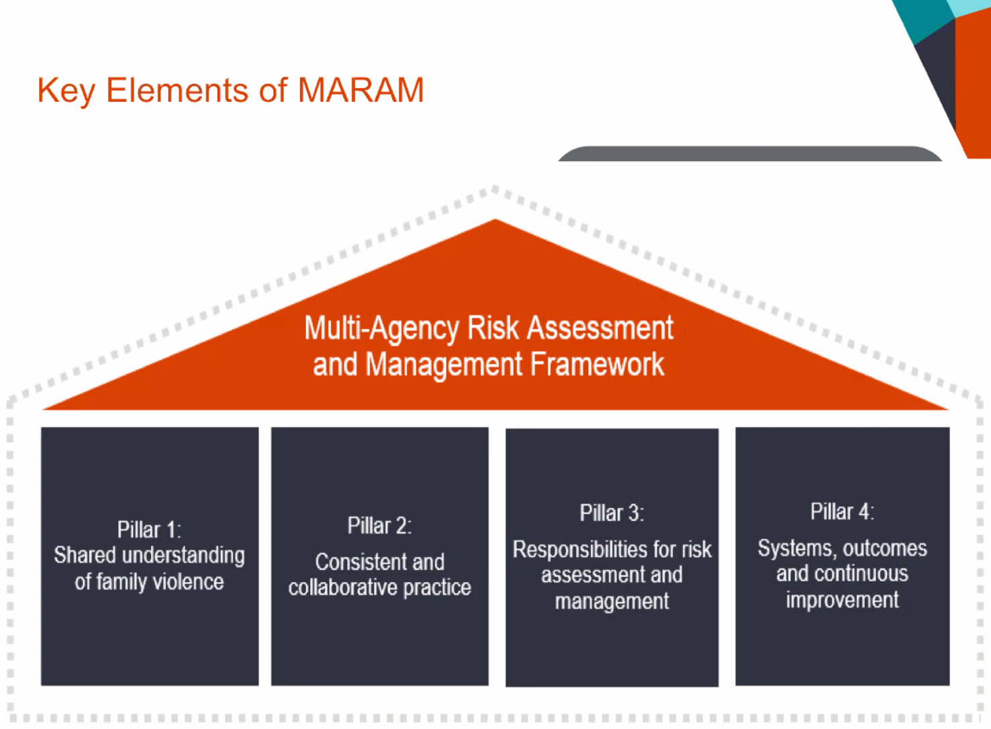

Pillar 1 - A shared understanding of family violence
Services practice a shared, evidence-based understanding of family violence, and of the responsibilities of the professionals involved.
This includes recognition of the cumulative and dynamic effects of intersectional risk indicators of family violence for children, older people, LGBTIQ, people with disability and diverse communities across identities, family and relationship types. Perpetrators are held in view and accountable by organisations and across the service system.

Pillar 2 - Consistent and collaborative practice
Prescribed council services must provide consistent, effective and safe responses for people experiencing family violence.
Pillar Two outlines MARAM's best-practice for the screening, identification, assessment and management of family violence risk through application of consistent MARAM tools across sectors, and collaborative and proactive partnerships.
MARAM practice is victim survivor led, supported through a structured professional judgement model informed by MARAM's FV evidence-based risk factors.

Pillar 3 - Responsibilities for risk assessment and management
Prescribes roles and responsibilities of family violence risk identification, assessment and management practices for prescribed services, the broader service system, to align with.

Pillar 4 - Systems, outcomes and continuous improvement
Establishes responsibilities under MARAM for leadership, governance, and professional roles to lead continuous improvement in MARAM and Information Sharing practice through data collection and reporting, and increase collaboration with other services.

Structured Professional Judgement Model
The Structured Professional Judgement model is designed to assess for the seriousness of risk or likelihood of family violence harm, death, serious injury or disability. It underpins work with adult, child and young people as distinct victim survivors.

There are four components of the model for identifying and assessing FV risk:
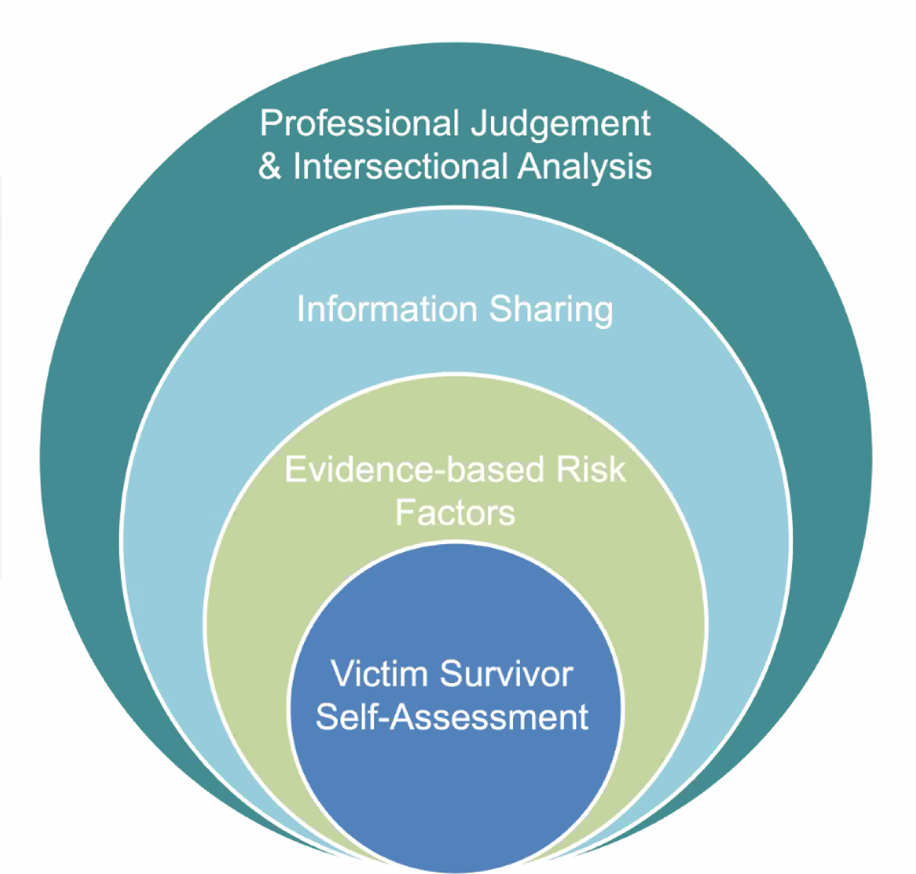

The components of the Structured Professional Judgement model are to be applied and revisited in a continuous cycle working with the victim survivor in collaboration with other prescribed services to stay up to date with the changing situation of risk top ensure appropriate intervention is achieved.

MARAM allocation of roles and responsibilities
MARAM outlines three levels of risk assessment and management response:
    - Screening and Identification
    - Brief and intermediate risk assessment / management
    - Comprehensive assessment / management

Prescribed council services are prescribed under the Screening and Identification level, however council services can choose to nominate relevant workers to upskill in the Intermediate and Comprehensive level, and should liaise with Family Safety Victoria and DHS to determine appropriateness.

Ten MARAM responsibilities are allocated cumulatively through the three levels, as outlined below:

Screening and Identification -Responsibilities 1,2, 5,6, 9,10
Services include:
- MCH and Early Years council services, including supported playgroups
- General health professionals
- Selected school staff

  - RESPONSIBILITY One: Respectful, sensitive & safe engagement
  - RESP Two: Identification of family violence risk
        - Observable signs of trauma
        - Screening and Identification Tool
        - Response options and safety planning
  - RESP Five: Seek secondary consultation for comprehensive risk assessment, risk management and referrals
  - RESP Six: Contribute to information sharing with prescribed services
  - RESP Nine: Contribute to coordinated risk management
  - RESP Ten: Collaborate for ongoing risk assessment and risk management.

Intermediate Risk Assessment: (additional) Responsibilities 3,4
Services include:
- Councils offering Homelessness services
- AOD services
- Mental health services
- Family Service services

In addition to Screening and Identification Responsibilities, the Intermediate Risk Assessment also includes:

- RESP Three: Intermediate risk assessment
      - Intermediate Assessment Tools, with guidance
  - RESP Four: Intermediate risk management
      - Safety Plan templates
Comprehensive Risk Assessment: (additional) Responsibilities 7,8
Comprehensive services include:
- Orange Door
- Specialist Family Violence workers
- Child Services

The Comprehensive level of MARAM incorporates responsibilities at the Screening and Identification and Intermediate levels, and also includes:

  - RESP Seven: Comprehensive risk assessment
        - Adult Comprehensive Assessment Tools, with guidance
  - RESP Eight: Comprehensive Risk Management
        - Comprehensive Safety Plan Template

MARAM Responsibilities: Decision Guide for Organisational Leaders
Councils can utilise the MARAM Responsibilities – Decision Guide for Organisational Leaders to identify their unique make up of services and employees with responsibilities under MARAM.

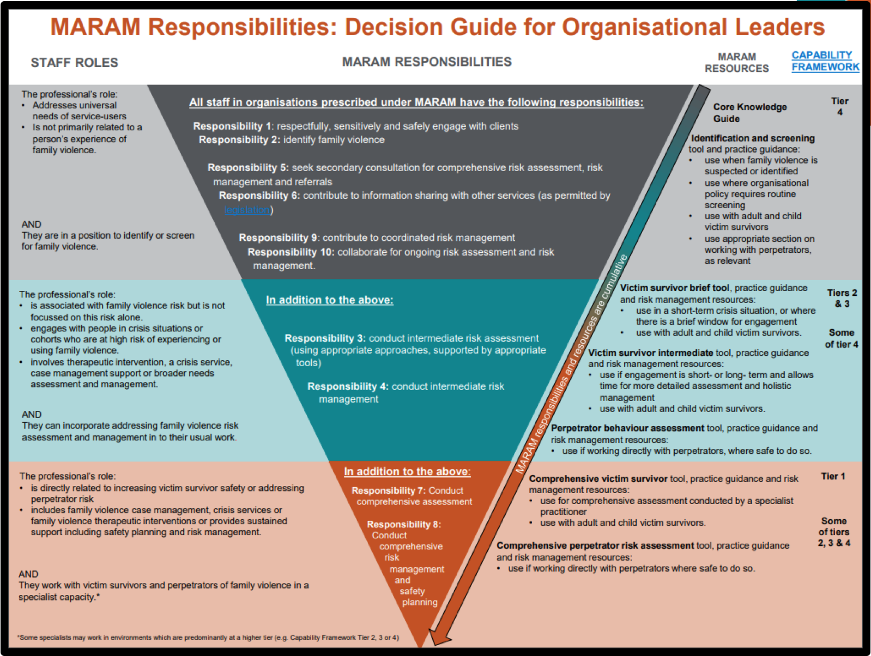

Roles and responsibilities under MARAM are clearly defined; professionals have different levels of responsibilities within organisations as part of an integrated systems response.
- Moving from left to right, the tool identifies and describes key roles to come under MARAM alignment, their corresponding responsibilities and supporting tools.
- Service context is important in determining roles; the tool can be used to facilitate organisational discussion to identify where roles fit, and support staff in understanding and proactively contributing to the development of their roles within a MARAM context.
- Not all roles are required to do all responsibilities, however everyone’s role is vital in an effective integrated system.

Information Sharing Entities (ISEs)
ISEs are prescribed organisations and services of the Information Sharing reforms and include specialist and universal services. Each ISE is prescribed under MARAM, FVISS and CISS according to their role in family violence and child health and wellbeing risk assessment and management.

ISEs can request, collect, use and disclose relevant information with other ISEs for a protection purpose to inform the assessment and management of family violence and child wellbeing and safety risk according to how they are prescribed. ISEs can also share assessment purpose information with RAEs, (see Risk Assessment Entities below).

Risk Assessment Entities (RAEs)
Risk Assessment Entities, or RAEs, are a sub-set of ISEs which have extended capability in seeking, gathering and assessing potential family violence risk information for alleged perpetrators.

List of ISEs
https://www.vic.gov.au/ciss-and-fviss-who-can-share-information

Section 2 -MARAM Alignment tool
Integrating the MARAM framework and tools into policies and practice

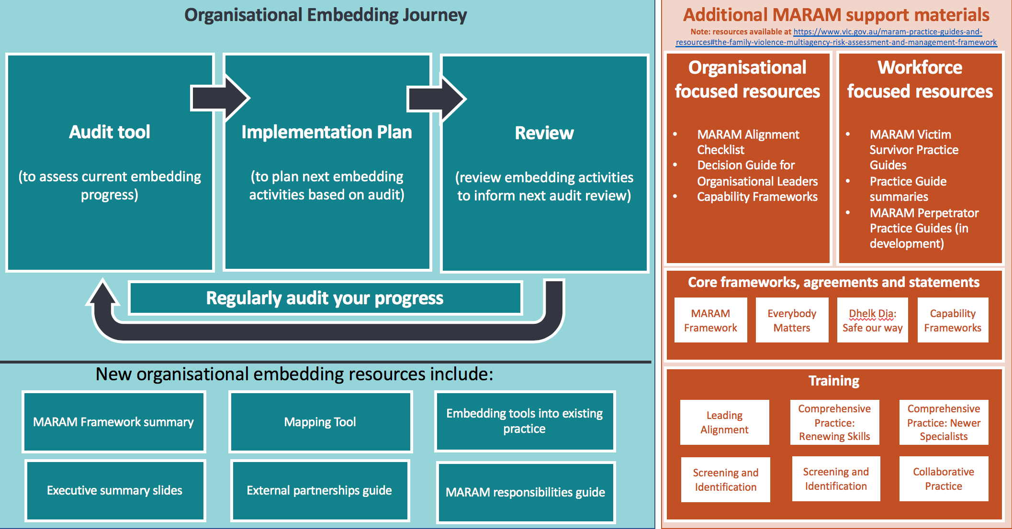
Assessment of alignment progress, examples and resources
The MARAM Alignment tool is organised by MARAM's four pillars:
- Pillar 1: A shared understanding of Family Violence
- Pillar 2: Consistent and collaborative practice
- Pillar 3: Responsibilities for risk assessment and management
- Pillar 4: Systems and continuous improvement
Under each pillar are general milestones with examples and resources for councils to consider and use as prompts to undertake an audit for MARAM alignment progress.
A checkbox and notes field can be used to add detail of each standard, activity or action, and next steps required to be captured.

Example: Assessment of Progress and Notes fields
Assessment  Significant ☐  Good ☐  Some ☐  Minimal ☐  None ☐ | Notes

A list of supportive resources in the right-hand column of each table references relevant MARAM support, and pages and sections of the MARAM practice guides as they relate to each example.
Councils can consider each milestone and corresponding examples to determine if and how it applies to their services as they continue along their alignment journey. The examples provided are not exhaustive and councils will need to identify all applicable service policies and processes that need to come under alignment with MARAM.
Example | Resources
Policies to be updated to include a Shared Understanding of Family Violence (Pillar 1)  - Family violence is defined in accordance tos5 Family Violence Protection Act 2008 (FVPA) and the MARAM Framework  - Aboriginal definition of family violence  [Resource 1; Resource 2, pp.12, 20–23] | - Family Violence Protection Act 2008 (FVPA), s. 5  - MARAM Framework

For some councils there may be complexities in aligning multiple relevant program areas that concern family violence with different beginning points for alignment, and different capacities of each service area to work through alignment. Councils may consider completing separate audit tools, and determining which program areas to undertake MARAM alignment.

Recommendations in using the tool
- Identify which council services to come under MARAM alignment. Refer to the Decision Guide for Organisational Leaders above for further detail.
- Identify and nominate key positions, including project leads and committee membership, within each prescribed service area with knowledge of applicable policies, processes and procedures to form an implementation plan for MARAM alignment. Ensure that project committees are familiar with key MARAM concepts.
- An implementation plan template is available for guidance:
- Form a representative committee to oversee and assess alignment progress to ensure accurate and comprehensive reflection on the council's current alignment progress.
- Utilising the tool, highlight key milestone examples within that could apply to prescribed services under MARAM. Consider any existing reviews relevant to MARAM alignment that can be used to inform the overall assessment of progress.
- As alignment is undertaken, make an assessment score for each section and ensure that notes elaborate upon why the score was given.

Assessing progress
There are five levels of progress for each milestone. Assessment of progress can be measured by using the descriptive qualification on the below scale. MARAM is understood as a maturity model in that alignment is a continuous process and will take time. Progress should be reviewed to assess for further improvements under each milestone.
Assessment Scale
Significant progress | Comprehensive policies, procedures, practice guidance and tools and has made effective actions to meet the milestone statement.  Policies, procedures, practice guidance and tools that demonstrate successful implementation in staff understanding and use, and client outcomes.  Planned regular reviews of policies, procedures, practice guidance and tools.
Good progress | Policies, procedures, practice guidance or tools are completed for use, however there is room for further work to be undertaken to improve best practice, including support to ensure consistent application of MARAM by staff members.
Some progress | Some policies, procedures, practice guidance or tools are completed, or in a usable iteration.  Staff members are undertaking activities for alignment to understand the changes made in aligning to MARAM in the course of their work.
Minimal progress | Undertaken minimal steps towards updating policies, procedures, practice guidance and tools which demonstrate the milestone statement.  Policies, procedures, practice guidance and tools are under development, with some directive to be minimally followed. Change management activities are beginning to be initiated and communicated.
No progress | No action taken that demonstrates the milestone statement.  Policies, procedures, practice guidance and tools unidentified.

Reviewing implementation activities
An implementation review guide is available to download.
Councils are encouraged to review implementation regularly (annually or after each implementation cycle) and use the results to inform future MARAM implementation efforts through data collection and analysis, qualitative surveys and case file reviews.

Pillar 1: A Shared Understanding of Family Violence

Key reading
- MARAM Framework, pp. 19–37, (58 pages)
- MARAM foundation knowledge guide, (67 pages)
- MARAM Framework summary, (10 pages)
___________
Introduction to Pillar 1
Pillar 1 establishes the basis for a shared understanding of family violence across framework organisations as a basis for a systems approach in the response to family violence.
It contains foundational information about the prevalence and impact of family violence across ages and communities and which when incorporated in policies, procedures, practice guidance and tools.

Framework requirement
Framework organisations demonstrate an evidence-based, shared understanding of family violence risk and impact.
A shared understanding promotes an effective, integrated service response to family violence and comprises:
- spectrum of family violence types
- all evidence-based risk factors used to support determination of seriousness of risk
- complexity of experiences across the community.

Milestone 1A: Foundational knowledge for a shared understandingOF FAMILY VIOLENCE
Policies, practice guidance and procedures relevant to family violence include information on the spectrum of family violence types, the evidence-based risk factors and the complexity of experiences across ages and communities.
Assessment  Significant ☐  Good ☐  Some ☐  Minimal ☐  None ☐ | Notes

Example | Resources
- Council policies define Family violence in line with s. 5 of the Family Violence Protection Act 2008 (FVPA) and the MARAM Framework, in addition with the Aboriginal definition of family violence  [Resource 1; Resource 2, pp.12, 20–23]  - Foundational family violence understanding is reflected in prescribed services policies, practice guidance and procedures and is accessible to, and known by staff.  [Resource 3]  - Family violence policies outline MARAM's evidence-based risk factors  [Resource 2, pp. 27–31]  - Family violence policies reference and specifically discuss the intersection between family violence and systemic discrimination, particularly addressing self-determination for Aboriginal communities, and reflect an intersectional understanding of the different ways that family violence is experienced across diverse community groups including:  - Aboriginal communities,  - LGBTIQ communities,  - multicultural communities  - multi-faith  - rural and remote communities  - people with disabilities  - older people (elder abuse)  [Resource 2, pp. 33–37; Resource 3, pp. 32–34, 38–56; Resource 4, pp. 20–21, 26–32; Resource 5, pp. 15–18]  - Children are recognised as victim survivors in their own right with specific guidance around response requirements in all relevant prescribed service policies  [Resource 2, p. 11 principles 5 and 6, pp. 24–25]  - Relevant policies outline perpetrator behaviour and focus on keeping the perpetrator in view and accountable.  [Resource 2, pp. 31–33]  - Adolescents using family violence are distinguished from perpetrators in all policies with specific response requirements outlined  [Resource 2, p. 33; Resource 3, pp. 60–-61] | - Family Violence Protection Act 2008 (FVPA), s. 5  - MARAM Framework  - MARAM foundation knowledge guide  - DhelkDja: Safe our way  - Everybody Matters: inclusion and equity statement

Milestone 1B: Training in foundational knowledge
Staff induction and training highlight the spectrum of family violence types, underlying drivers, the evidence-based risk factors, and the complexities of experiences across communities.
Assessment  Significant ☐  Good ☐  Some ☐  Minimal ☐  None ☐ | Notes

Example | Resources
- Staff induction for prescribed council services covers:  - foundational family violence knowledge, specifically the different types of family violence and the drivers of family violence  [Resource 1, pp. 20–26]  - MARAM evidence-based risk factors  [Resource 1,pp. 27–31]  - Intersectional understanding of the barriers to accessing support across the community  [Resource 1,pp. 33–37]  - observable signs of trauma  [Resource 3, pp. 102–105 Appendix 1]  - All existing and new employees are inducted with cultural and diversity awareness training  - All existing and new employees receive Aboriginal cultural training  - All existing and new employees are trained on intersectionality and the systemic barriers across the family violence service system  [Resource 1,pp. 33–37; Resource 2, pp. 32–34 and 38–56] | - MARAM Framework  - MARAM foundation knowledge guide  - MARAM practice guide: Responsibility 2– Appendix 1

Milestone 1C: Workplace environment
The workplace is a welcoming and safe environment, accessible for the whole community and culturally safe for Aboriginal and diverse communities.
Assessment  Significant ☐  Good ☐  Some ☐  Minimal ☐  None ☐ | Notes

Example | Resources
- Displaying welcoming images, signs and symbols in reception and meeting areas including:  - Rainbow Pride flag  - Aboriginal and Torres Strait Islander flags  - interpreting symbol  - wheelchair symbol  - Services are accessible by all service users including those with disabilities  - Staff recruitment reflects diversity  - Physical, visible cues to staff and community service users of prescribed council services able to help in the response to family violence  - Family violence resources reflect the diversity of the local community (ie: available in local languages) and varying types of family violence  - Play areas for children and young people are appropriately resourced as a safe and welcoming environment (where applicable)  - There are safe, welcoming and private spaces to meet with service users to conduct risk assessments  - Staff profiles include other languages spoken  [For all examples, see Resource 1, pp. 30–37; Resource 2, pp. 72–79] | - MARAM foundation knowledge guide  - MARAM practice guide: Responsibility 1

Pillar 2: Consistent and collaborative practice

Key reading
- MARAM Framework (pp. 19 to 37, 18 pages)
- MARAM practice guides: chapter summaries (42 pages) (under Practice guide resources and tools)
- MARAM Framework summary (10 pages)

___________________
Introduction to Pillar 2
Alignment with Pillar 2 aims to achieve a common approach to family violence risk screening, identification, assessment and management to enable a consistent response across prescribed framework organisations.
Prescribed council services only require the Screening and Identification tool for practice, however it is useful to be aware of the brief assessment tool, the intermediate assessment tool and the comprehensive assessment tool and how these fit into the broader sector response.
These tools can be adopted in full or adapted into existing tools, ensuring retention of the evidence-based factors as a minimum requirement.
To assist alignment with Pillar 2 there are MARAM tools available:
- MAV website
- VIC Gov MARAM resources website (see appendices to the MARAM practice guides):

Framework requirement
Council services prescribed under MARAM employ a collaborative approach with other Framework organisations in the screening, identification, assessment and management of family violence risk, including sharing information relevant to family violence risk assessment and management.
Seriousness of risk is assessed through a structured professional judgement model; which comprises a victim’s self-assessed level of risk, fear and safety, assessment against evidence-based risk factors, and information sharing to inform assessment and professional judgement.
MARAM and information sharing tools are available to provide consistent guidance to:
- keep victim survivors safe and manage ongoing risk
- keep perpetrators in view, accountable for their actions and behaviours, and assists them to change their behaviour
- reinforce a shared understanding of family violence and risk
- strengthen formal and informal collaborative arrangements.

Milestone 2A: screening and Identification of family violence
Screening and Identification takes place through observation and engagement with service users to identify indicators of family violence at an early stage.
Assessment  Significant ☐  Good ☐  Some ☐  Minimal ☐  None ☐ | Notes

Example | Resources
- Policy that clarifies prescribed service staff responsibilities to identify and screen for family violence  [Resource 1, p. 46; Resource 4a; Resource 6]  - The MARAM Screening and Identification tool is embedded into existing service tools and processes. An example is where MCH have integrated the tool into CDIS  [Resource 4b]  - Guidance to prescribed service staff members on how to engage in a respectful, sensitive and safe way when undertaking Screening and Identification for family violence  [Resource 3]  - Procedures for relevant staff members on how to identify family violence using MARAM risk indicators, and how to undertake screening (or refer to a staff member for screening, or information share), such as MAV's MCH MARAM Practice Guidance  [Resource 4 including appendices; Resource 7]  - Screening and Identification procedures and practice guidance available for and used by staff members, including how to use the Screening and Identification tool, which can be incorporated into existing procedures. An example is where the Screening and Identification tool has been adapted into MCH existing CDIS processes, and MAV's MCH MARAM Practice Guidance.  [Resource 4a, appendices 2; Resource 4b; Resource 5; Resource 7]  - Procedure and practice guidance for staff members on using structured professional judgement model to assess level of risk  [Resource 2, pp. 30–31; Resource 4, p. 92]  - Procedure of response options to identified family violence based on assessed level of risk, including proactive information sharing  [Resource 4, p. 118]  - Procedure and tool for completion of a safety plan and support planning where family violence is identified by screening  [Resource 4, p. 118]  - Appropriate supervision and support to staff members undertaking screening and identification of family violence  - Internal identification of FV: Staff experiencing family violence have support, including support for if abuse is occurring internally  In respect of perpetrators of family violence:  - Guidance on what to do when a service user is suspected of being a perpetrator including invitations to collude  [Resource 2, pp. 57–62; Resource 3, p. 81; see also Milestone 2D on secondary consultations - Men’s Behavioural Change Programs] | - MARAM Framework  - MARAM foundation knowledge guide  - MARAM practice guide: Responsibility 1  - a) MARAM practice guide: Responsibility 2  b) MARAM Screening and Identification Tool  - Embedding tools into existing practice guide  - MARAM responsibilities guide  - MAV MCH MARAM Practice Guidance

Milestone 2B: Management of family violence risk
Assessment  Significant ☐  Good ☐  Some ☐  Minimal ☐  None ☐ | Notes

Example | Resources
- Risk management procedure and practice guidance is available for staff members to undertake emergency risk management and safety planning if the victim survivor requires immediate protection, with separate safety plans made for each child  [Resource 2; Resource 3]  - Safety Plan tools are available Practice Guidance for:  - adults  [Resource 2, pp. 227–28]  - children and young people  [Resource 2,pp. 229–32]  - adolescents using family violence  [Resource 2,pp. 233–34]  MCH staff are able to utilise safety plan incorporated into CDIS.  [Resource 4; Resource 5; Resource 6]  - Risk management procedures utilise information sharing for proactively sharing risk-relevant information, making referrals and secondary consultations  (for information sharing see Milestone 2E and for referrals and secondary consultations see Milestone 2D)  - Risk management actions for the adult victim survivor also consider the potential impact upon children as victim survivors, as well as child well-being and any therapeutic responses required  (MARAM Principles 5 and 6)  - Appropriate supervision and support to staff members undertaking risk management  Children safety:  - Policies on reporting concerns for children including mandatory reporting under the Children, Youth and Families Act 2005 as well as referrals under Child FIRST and information sharing under both the FVIS and CIS Schemes  [Resource 2, p. 229]  When directly engaging with children:  - Staff members have received appropriate training  - Children and young people are directly informed of decisions made and actions being taken in an age appropriate way  [Resource 2, pp. 229–33]  - The observable signs of trauma in children and young people are included in training materials and resources  [Resource 7]  - A safe space to engage directly with child and young people victim survivors and age appropriate resources  [Resource 8, pp. 82–88] | [Note: Resource 2 is for universal services and Resource 3 is for specialist family violence practitioners]  - MARAM Framework  - MARAM practice guide: responsibility 4  - MARAM practice guide: responsibility 8  - MARAM practice guide: responsibility 4 – Appendix 9 (safety plan template)  - MARAM practice guide: responsibility 8 – Appendix 14 and Appendix 15 (comprehensive safety plan and tools)  - Embedding tools into existing practice guide  - MARAM practice guide: responsibility 2 – Appendix 1  - MARAM practice guide: responsibility 1  - MARAM responsibilities guide

Milestone 2c: Secondary consultations and referrals
Staff are able to respond to family violence through seeking and providing secondary consultations (internally and externally), and making referrals.
Assessment  Significant ☐  Good ☐  Some ☐  Minimal ☐  None ☐ | Notes

Example | Resources
- Policy which clarifies staff responsibility to seek secondary consultations and make referrals  [Resource 1, p. 46; Resource 2; Resource 4]  - Procedures and practice guidance promote the importance of secondary consultations, who and when to seek secondary consultations and make referrals, how this assists risk assessment and risk management of family violence  [Resource 1, pp. 251–53]  - Practice guidance on effective engagement in making referrals, and respecting the victim-survivor’s choice in respect of referrals  [Resource 1, p. 255–60]  - Consent forms are in place and signed before making referrals and seeking identified secondary consultations, or secondary consultations are de-identified where there is no consent.  [Resource 1, p. 260; Resource 2, p. 246]  - Records are kept of secondary consultations and referrals  [Resource 1, p. 260; Resource 2, p.244–45]  - Developed strong relationships with local services and resource lists for staff members (see Milestone 4B)  [Resource 5]  - Flow chart showing where to seek supervision and secondary consultations internally in respect of family violence matters | - MARAM Framework  - MARAM practice guide: responsibility 5  - MARAM practice guide: responsibility 4  - MARAM responsibilities guide  - External partnerships guide

Milestone 2d: Information sharing
Staff proactively share risk relevant information, make information sharing requests and respond to information sharing in a timely manner.
Assessment  Significant ☐  Good ☐  Some ☐  Minimal ☐  None ☐ | Notes

Example | Resources
- Prescribed services understand their roles and responsibilities in information sharing under FVISS and CISS with all relevant policies updated to reflect the interaction of FVISS and CISS with existing legislative responsibilities for sharing information.  [Resource 4; Resource 8; Resource 9; Resource 13; Resource 14]  - Policy which clarifies staff responsibility to share and receive information  [Resource 1, p. 46; Resource 2; Resource 3]  - Information Sharing templates available for staff for  - Making a request  - Responding to a request  - Proactively sharing  [Resource 17]  - Procedure and practice guidance promote the importance of proactive information sharing to FV risk assessment and management  [Resource 3, p. 264]  - Staff have access to resources on effective engagement for how to raise information sharing with victim survivors,to ask for consent and sought viewswhere applicable  [Resource 6; Resource 7]  - Checklists in place for staff members to use  [Resource 15]  - Consent forms are in place and signed (where required) before sharing information  [Resource 11]  - Resource available for service users explaining the purpose of information sharing under the FVISS and their rights  [Resource 12]  - Record keeping procedures for information sharing are compliant, safe and secure and systems in place for staff use  [Resource 5; Resource 10]  - Where applicable: policies and procedures are in place for CIP requests | - MARAM Framework  - MARAM responsibilities guide  - MARAM practice guide: responsibility 6  - Organisational readiness checklist (under Section 3 of this webpage)  - Tips for information sharing record keeping (FVISS & CISS) (under Section 8 of this webpage)  - Tips for conversations with adult victim survivors about consenting to information sharing (FVIS Scheme) (under Section 6 of this webpage)  - Tips for a conversation with a child or parent about information sharing (FVIS and CIS Scheme)  - FVIS ministerial guidelines  - CISS ministerial guidelines  - FVIS example record keeping form (under Section 8 of this webpage)  - Example information sharing consent form – FVIS (adult victim survivor) (under Section 6 of this webpage)  - Your information and your safety factsheet – FVIS (under Section 4 of this webpage)  - FVISS Guidance- sharing information (FVIS Scheme) (under Section 6 of this webpage)  - FVISS Guidance- requesting information (FVIS Scheme) (under Section 5 of this webpage)  - Information Sharing Checklist when making a request (FVIS Scheme) (under Section 5 of this webpage)  - Checklist when responding to a request (FVIS Scheme) (under Section 6 of this webpage)  - MAV MCH Information Sharing Templates

Pillar 3: responsibilities for risk assessment and management

Key reading
- MARAM Framework (pp. 45 to 47)
- MARAM practice guides: chapter summaries (42 pages) (under Practice guides and resources tools of this webpage)
- MARAM Framework summary (10 pages)
- MARAM responsibilities guide (16 pages)

___________________
Introduction to Pillar 3
Pillar 3 lists 10 responsibilities under MARAM for understanding and identifying family violence, risk assessment and management of family violence and collaborative practice.
Council's are required to understand what responsibilities apply to their MARAM prescribed services and to equip their workforces with the necessary tools, resources, training and support to successfully manage them.
Mapping responsibilities will look different for different councils to successfully align their different structures and community needs. Councils with multiple prescribed program areas may find the MARAM responsibilities apply differently in each working context. Project workers and council management can refer to the key reading to understand the intent behind each MARAM responsibility to properly inform the mapping exercise.

Framework requirement
Prescribed council services understand their responsibilities in risk assessment and management practice and how these relate to the operation of Part 5A of the Family Violence Protection Act 2008, and assign responsibilities of service in accordance with the 10 MARAM responsibilities.

Milestone 3A: Mapping MARAM responsibilities
Understand roles and responsibilities in family violence risk assessment and management practice and how these apply across the organisation.
Assessment  Significant ☐  Good ☐  Some ☐  Minimal ☐  None ☐ | Notes

Example | Resources
- Governance structures have been identified or established to oversee alignment  - Council leadership and prescribed service managers have read and understand the MARAM Framework and the MARAM practice guides and summaries  [Resource 1; Resource 2; Resource 3]  - Executives understand the MARAM Framework and support prescribed council services in their legislative requirements for alignment  [Resource 4]  - Mapped workforce’s roles and responsibilities under the Screening and Identification level for MARAM with leadership groups and in consultation and collaboration with staff  [Resource 5]  - Identify and update policies, procedures, practice guidance and tools needed to fulfil the responsibilities  [Resource 7]  - Map procedures for how service users receive a family violence response from prescribed council services across staff  - Regularly review the mapping of the MARAM responsibilities to determine any opportunities to increase staff capabilities (i.e. to raise staff capability from Responsibility 2 to Responsibility 3 and 4) | - MARAM Framework  - MARAM practice guides (under Practice guide resources and tools)  - MARAM practice guides: chapter summaries (under Practice guide resources and tools)  - Executive briefing slides (under Organisational focussed resources, dot point 7)  - MARAM responsibilities mapping tool (under Organisational focussed resources, dot point 8)  - MARAM responsibilities guide  - MARAM policy and procedure example table

Milestone 3B: Staff communications on responsibilities
All staff are aware of their roles and responsibilities under MARAM
Assessment  Significant ☐  Good ☐  Some ☐  Minimal ☐  None ☐ | Notes

Example | Resources
- Effective communication to prescribed service staff of their roles and responsibilities at the screening and identification level  - Hold staff consultations and internal information sessions on responsibilities  - Update position descriptions using responsibilities guidance  [Resource 2]  - Update / create organisational chart setting out MARAM responsibilities and reporting lines  - Allocate staff to be change champions to encourage collaboration and consultation | - MARAM responsibilities mapping tool (under Organisational focussed resources, dot point 8)  - MARAM responsibilities guide

Milestone 3C: Staff training on responsibilities
Staff receive training and feel confident working with service users to implement their roles and responsibilities under MARAM.
Assessment  Significant ☐  Good ☐  Some ☐  Minimal ☐  None ☐ | Notes

Example | Resources
- Staff are trained and up to date in MARAM and Information Sharing Scheme procedures, with procedures practice guidance available and accessible, and included in organisational inductions.  [Resource 3]  - Formalise a plan and schedule for relevant staff to receive MARAM training to practise their MARAM responsibilities, including leaders attending MARAM Leading Alignment training  [Resource 1, Resource 2]  - Identify opportunities for internal professional development and training, such as info sessions, communities of practice, case reviews or case studies and tailored materials relevant to the workforce  - Provide informal training opportunities such as reflective practice, team discussions, closing feedback loops, joint training with close external partners, lunch and learns, peer to peer networks and communities of practice  - Explore and map additional training requirements across the workforce which will support MARAM practice such as intersectional and cultural awareness training, working with children, asking demographic identity questions, using interpreters etc. | - Overview of MARAM training modules (under Overview of MARAM Training)  - MARAM training decision tree (DOESN’T EXIST)  - DFFH/DH Information Sharing Scheme eLearn modules

Pillar 4: Systems, outcomes and continuous improvement

Key reading
- MARAM Framework (pp.48 to 53; 6 pages)

___________________
Introduction to Pillar 4
Pillar 4 outlines the requirements as well as the benefits to Framework organisations in aligning to MARAM, and participating in data collection and evaluation of family violence response. It outlines how organisational leaders can contribute to the implementation of MARAM, to continuous improvement and an understanding of the evidence base over time.
It should be noted that Pillar 4 reiterates that alignment to MARAM requires a significant culture change and systemic reform which will take time. The collection of data and evaluation is part of this ongoing process.

Framework requirement
Framework organisations:
- establish or utilise relevant governance and advisory structures to implement the Framework
- collect consistent information about the evidence-based family violence risk factors, through tools aligned to [the evidence-based risk factors] and of service users’ individual experience of the forms of family violence
- undertake activities to change organisational culture and practice to promote continuous improvement in risk assessment and management practice, information sharing and enhanced collaboration with other services

Milestone 4A: Collect and collate data
Councils work toward collecting and collating data regarding the evidence-based risk factors and service-users’ individual experience of family violence.
Assessment  Significant ☐  Good ☐  Some ☐  Minimal ☐  None ☐ | Notes

Example | Resources
- Collect data on individual files related to service users’ individual experience  - Gather information at an organisational level to under service users’ individual experiences and the organisation’s role in the wider service system  - Data is collected and analysed to better inform services response to family violence, key achievements and where to focus the organisation’s efforts for improvement. Data is safely and securely stored.  - Process to review data to reflect service user type and who may be missing – not accessing and why not | - MARAM practice guide: responsibility 3, appendix 5 (pp. 146–147 for demographic questions)  <https://www.vic.gov.au/sites/default/files/2020-05/APPENDIX%205.docx>  - Implementation review guide  - Victorian family violence data collection framework

Milestone 4B: Establish external partnerships
Partnerships established with local relevant services and agencies to collaborate and coordinate within the Framework.
Assessment  Significant ☐  Good ☐  Some ☐  Minimal ☐  None ☐ | Notes

Example | Resources
- Referral and secondary consultation procedures in place that prioritise intake of requests and timely responses sothat collaborative practice may lead to an increase in family violence referrals, consultations and information-sharing requests  - Aligning MARAM practices collaboratively with key partners for the purposes ofinformation sharing, secondary consultations and referrals, emergency risk management and safety planning and taking steps to establish connections and partnerships. This includes organisations thatwould support service users with intersecting needs, as identified in the MARAM Framework  - An up-to-date resource list thatdetails local and national partners relevant for information sharing, secondary consultations and referrals  - Participation in inter-agency and network meetings as an active member of community networks and communities of practice on family violence (contact your local PSA for details) | - MARAM practice guide: responsibility 5  - MARAM practice guide: responsibility 6  - MARAM practice guide: responsibility 9  - MARAM practice guide: responsibility 10  - External partnerships guide  - Family violence regional integration factsheet (The Lookout website)  - List of Principal Strategic Advisors (The Lookout website)

Milestone 4C: Organisational culture change
Council's prescribed services undertake change activities to provide continuous improvement inscreening and identificationfor family violence risk, and enhance information sharing and collaboration with other services.
Assessment  Significant ☐  Good ☐  Some ☐  Minimal ☐  None ☐ | Notes

Example | Resources
- Regularly undertake an implementation review to inform further MARAM alignment activities  [Resource 8]  - A public, organisational vision statement and objectives includes family violence information for service users and a commitment to supporting the Victorian Government’s 10-year plan to end family violence  [Resource 1]  - Creating a supportive and psychologically safe environment for staff members who are responding to family violence  - Provide a comprehensive family violence leave policy for those experiencing family violence and choosing to use family violence  [Resource 2]  - A comprehensive equal opportunities policy which is effective in practice through staff employment and engagement  - Embed an intersectional lens into our family violence response  [Resource 3, pp. 127-128; Resource 4, p. 254; Resource 5, pp. 296–297; Resource 6, pp. 359–60]  - Providing additional training (contacting local PSAs for recommendations on appropriate training available to staff members which supports MARAM implementation including:  - trauma-informed practice  - cultural awareness  - intersectionality  - collaborative practice  - relevant local issues (i.e. pertaining to local Aboriginal or CALD communities)  - mental health awareness including, for specialist practitioners, seeking a capacity assessment  - child safe practices  [Resource 7] | - Ending family violence: Victoria’s plan for change  - Supporting staff: family violence leave policy considerations  - MARAM practice guide: responsibility 3  - MARAM practice guide: responsibility 5  - MARAM practice guide: responsibility 7  - MARAM practice guide: responsibility 8  - List of Principal Strategic Advisors (The Lookout website)  - Implementation review guide

Completion details

Completed by
Name | Position

Council Service under review | Date completed | Date of next review

Glossary and definitions
Aboriginal definition of family violence | DhelkDja defines family violence as ‘An issue focused around a wide range of physical, emotional, sexual, social, spiritual, cultural, psychological and economic abuses that occur within families, intimate relationships, extended families, kinship networks and communities. It extends to one-on-one fighting, abuse of Indigenous community workers as well as self-harm, injury and suicide’
Adolescent who uses family violence | A young person who chooses to use coercive and controlling techniques and violence against family members, including intimate partners. Adolescents who use family violence often coexist as victims of family violence and therapeutic responses should be explored.
Child | Has the meaning set out in section 4 of the FVPA, being a person who is under the age of 18 years (which includes infants and adolescents).
Child Information Sharing Scheme (CISS) | CISS enables authorised organisations and services to share information to promote the wellbeing or safety of children. Find more information on child information sharing.
Culturally safe responses | To practice in a culturally safe way means to carry out practice in collaboration with the service user, with care and insight for their culture, while being mindful of one’s own. A culturally safe environment is one where people feel safe and where there is no challenge or need for the denial of their identity.
Diverse communities | Diverse communities include the following groups:  diverse cultural, linguistic and faith communities; people with a disability; people experiencing mental health issues; lesbian, gay, bisexual, transgender and gender diverse, intersex and queer/questioning (LGBTIQ) people; women in or exiting prison or forensic institutions; people who work in the sex industry; people living in regional, remote and rural communities; male victims; older people and young people (12–25 years of age).
Family violence | Has the meaning set out in section 5 of the FVPA which is summarised here as any behaviour that occurs in family, domestic or intimate relationships that is physically or sexually abusive; emotionally or psychologically abusive; economically abusive; threatening or coercive; or is in any other way controlling that causes a person to live in fear for their safety or wellbeing or that of another person.  In relation to children, family violence is also defined as behaviour by any person that causes a child to hear or witness or otherwise be exposed to the effects of the above behaviour.  This definition includes violence within a broader family context, such as extended families, kinship networks and communities.
Framework organisation | An organisation prescribed by regulation to be a Framework organisation for the purposes of Part 11 of the FVPA and required to align their policies, procedures, practice guidance and tools to it. References in this document to Framework organisations include section 191 agencies.
Family Violence Information Sharing Scheme (FVISS) | FVISS enables authorised organisations and services to share information to facilitate assessment and management of family violence risk to children and adults. Find more information on family violence information sharing.
Intersectionality | Refers to the structural inequality and discrimination experienced by different individuals and communities, and the impact of these creating barriers to service access and further marginalisation. Intersectionality is the complex, cumulative way in which the effects of multiple forms of identity-based structural inequality and discrimination (such as racism, sexism, ableism and classism) combine, overlap or intersect, in the experiences of individuals or communities. These aspects of identity can include gender, ethnicity and cultural background, language, socio-economic status, disability, sexual orientation, gender identity, religion, age, geographic location or visa status.
MARAM pillar | The MARAM framework is structured in ‘pillars’ that aim to establish a system-wide approach and shared responsibility for family violence risk assessment and management. Each pillar has its own objective. The pillars are set at the organisation level and are designed to build knowledge and skill and support the effectiveness and integration of the system-wide response to family violence in Victoria.
MARAM framework | The Family Violence Multi-Agency Risk Assessment and Management framework
Maturity model process | Implementing the MARAM Framework requires significant culture change and system reform which will take time and effort at all levels of the service system. Government’s initial focus is to support organisations by developing a model of alignment with guidance for organisations. This approach recognises the complexity of the service system and the variable starting points and stages of family violence practice literacy across different sectors.  Recognising the different dimensions of change will provide flexibility so that organisations can begin the alignment process in the way that is most appropriate for their current level of maturity, and to be supported to progress to higher levels.  The model (in development) will describe the attributes expected of organisations at different levels of alignment with the MARAM Framework, starting with no or minimal alignment and ending with very strong alignment and sector leadership.
Perpetrator | Has the same meaning as the words “a person of concern” in s 144B of the FVPA. The FVPA provides an individual is a person of concern if an information sharing entity reasonably believes that there is a risk that they may commit family violence. This will have been identified by undertaking a Framework-based family violence risk assessment.
Predominant aggressor | The term predominant aggressor seeks to assist in identifying the actual perpetrator in the relationship, by distinguishing their history and pattern of coercion, power and controlling behaviour, from a victim who may have utilised self-defence or violent resistance in an incident or series of incidents. The predominant aggressor is the perpetrator who is using violence and control to exercise general, coercive control over their partner or family member, and for whom, once they have been violent, particularly use of physical or sexual violence, all of their other actions take on the threat of violence.
Risk assessment | The process of applying the model of Structured Professional Judgement to determine the level of family violence risk.
Risk identification | Recognising through observation or enquiry that family violence risk factors are present, and then taking appropriate actions to refer or manage the risk.
Risk factors | Evidence-based factors that are associated with the likelihood of family violence occurring or the severity of the risk of family violence.
Risk management | Any action or intervention taken to reduce the level of risk posed to a victim and hold perpetrators to account. Actions taken and interventions that are implemented appropriate to the level of risk identified in the risk assessment stage.
Safety planning | Process of implementing a strategy or identifying steps to be taken, subject to timelines agreed with relevant parties, to reduce the likelihood of further family violence occurring and ensure safety for the victim/s.
Screening | The use of questions to explore the possibility of family violence being present, due to concerns through observation or other assessment.
Serious risk | Risk factors associated with the increased likelihood of the victim survivor being killed or nearly killed.
Service | Provision of a specific support or providing a formalised level of assistance, which is of benefit to individuals in the community.
Victim Survivor | Has the same meaning as the words “a primary person” (adult or child) in the FVPA. The FVPA provides a person is a primary person if an information sharing entity reasonably believes there is risk that the person may be subjected to family violence.

Adapted from Merriam-Webster dictionary definition of intersectionality.

