Municipal Association of Victoria

National Local Government Infrastructure and Asset
Management Conference

Sponsor and exhibitor
opportunities
6-7 June 2019

Rydges Melbourne
186 Exhibition Street, Melbourne VIC 3000

The Municipal Association of Victoria
The Municipal Association of Victoria (MAV) is the peak representative body for local government in Victoria. The MAV has a legislated responsibility to represent the interests of councils through policy formulation, advocacy work and insurance services.
Formed in 1879 and incorporated by an act of Victorian Parliament in 1907, the MAV today enjoys the support of Victorian councils, who are our financial members.
Determined to increase the capability and effectiveness of the sector, we conduct a wide range of activities. These include lobbying, campaign and issues management, procurement, research, councillor and professional development, event management and more.
The MAV has been long-recognised as an influential and respected representative body by both local and state government.

About the Conference
The sixteenth National Local Government Infrastructure and Asset Management Conference will continue the tradition of:
- inspiring speakers from around Australia and overseas
- ‘good practice’ knowledge-sharing to improve council and community sustainability
- actions you can implement at your council
- case studies on responsive and integrated service, asset and financial planning, and credible reporting to stakeholders, in a challenging and rapidly changing environment.

2019 highlights include:
- the challenge of integrated planning across the organisation
- using smart technology to transform planning and service delivery
- stretching asset management performance to deliver better services and community outcomes
- stormwater sustainability: the new frontier
- the future of mobility
Over 130 delegates, with an interest in local government infrastructure management and sustainability are expected to attend including; councillors, CEOs, directors, managers and officers in asset management, transport, engineering, finance, service planning, community development, innovation, organisational development, corporate planning, strategic planning, human resources, governance, business transformation, digital transformation, information management and business analysis.
This leading infrastructure and asset management conference represents an outstanding opportunity to promote your brand and capabilities to a sector responsible for 187,600 employees, a total annual expenditure of $35.9 billion (2016-17) and a replacement cost of local government land and fixed assets supporting the various economic (e.g. roads, buildings, water supply, etc.) and social services (e.g. health, welfare services, etc.) in the order of $426 billion (2016-17). (source: ALGA)

Sponsor and exhibitor opportunities and provisions
The 2019 National Local Government Infrastructure and Asset Management Conference provides a unique opportunity to:
- Raise and enhance your organisation’s profile among local government senior decision-makers who are hard to reach key influencers from Australian councils.
- Leverage the MAV brand that is a trusted and respected name within the local government sector.
- Network with potential and current clients.

Principal Sponsor
Exclusive $10,000 + GST
- Acknowledgement as Principal Sponsor by chairperson throughout the conference, including welcome and close
- Double exhibition space – booths 13 and 14
- Keynote address (3-5 minutes) to plenary session*
- Signage opportunities in plenary room
- Logo inclusion on projection screens throughout the day
- Sponsorship and logo acknowledged pre- and post- conference across all MAV marketing and communication channels
- Four conference exhibitor passes which includes morning tea, lunch, afternoon tea and conference entry

Coffee Sponsor
Exclusive $6,000 + GST
- Acknowledgement as Coffee Sponsor by chairperson during the conference
- Single exhibition space setup with coffee cart – booth 8 (complete with barista and all supplies to serve coffee for the duration of the conference) – full branding opportunities
- Sponsorship and logo acknowledged pre- and post- conference across all MAV marketing and communication channels
- Two conference exhibitor passes which includes morning tea, lunch, afternoon tea and conference entry

Morning Tea Sponsor
Exclusive $4,000 + GST
- Single exhibition space
- Acknowledgement as Morning Tea Sponsor by chairperson before delegates break for morning tea
- Speaking opportunity (2-3 minutes) before morning tea*
- Logo on screens during morning tea
- Opportunity to place a free-standing banner at the exhibition entrance during morning tea
- Opportunity to provide gifts that could be used for morning tea (eg; mugs)
- Two conference exhibitor passes which includes morning tea, lunch, afternoon tea and conference entry

Lunch Sponsor
Exclusive $4,000 + GST
- Single exhibition space
- Acknowledgement as Lunch Sponsor by chairperson before delegates break for lunch
- Speaking opportunity (2-3 minutes) before lunch*
- Logo on screens during lunch
- Opportunity to place a free-standing banner at the exhibition entrance during lunch
- Sponsorship and logo acknowledged pre- and post- conference across all MAV marketing and communication channels
- Two conference exhibitor passes which includes morning tea, lunch, afternoon tea and conference entry

Afternoon Tea Sponsor
Exclusive $4,000 + GST
- Single exhibition space
- Acknowledgement as Afternoon Tea Sponsor by chairperson before delegates break for afternoon tea
- Speaking opportunity (2-3 minutes) before afternoon tea*
- Logo on screens during afternoon tea
- Opportunity to place a free-standing banner at the exhibition entrance during afternoon tea
- Opportunity to provide gifts that could be used for afternoon tea (eg; mugs)
- Two conference exhibitor passes which includes morning tea, lunch, afternoon tea and conference entry

Exhibitor
$3,000 + GST
- Single exhibition space
- Two conference exhibitor passes which includes morning tea, lunch, afternoon tea and conference entry

*Length and content of sponsor speaking opportunity subject to MAV approval

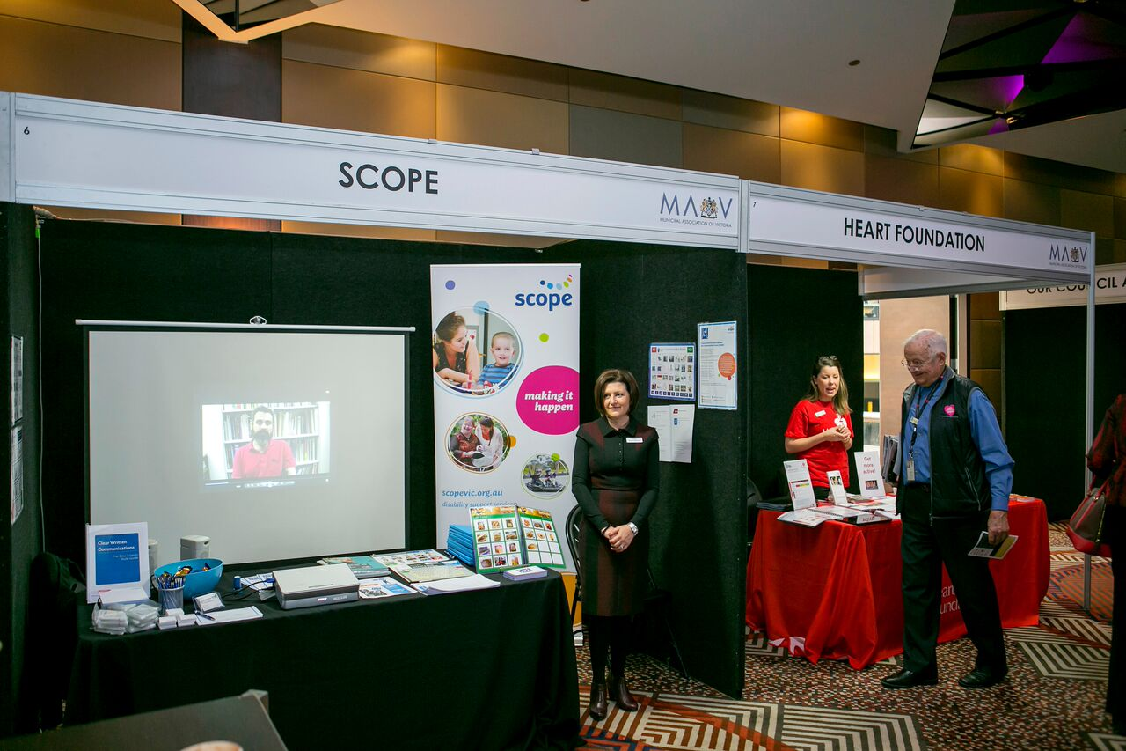
Standard exhibitor shell scheme package and floor plan
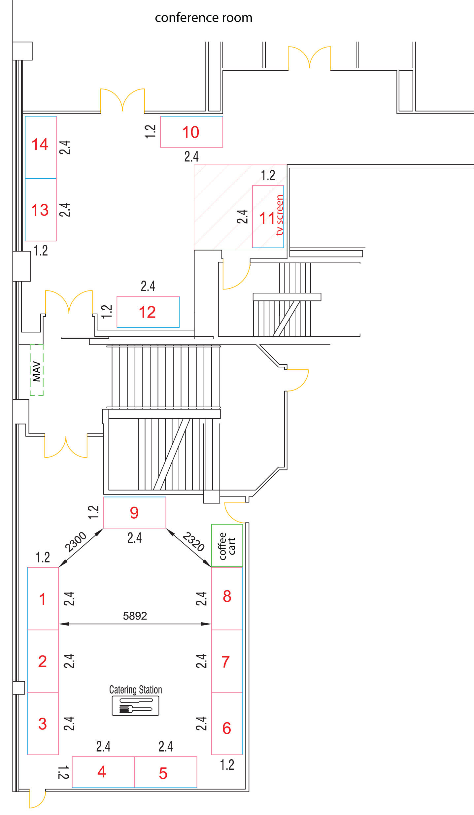 | The exhibition will be held in the foyer and 42nd Street, located on Level 1 of Rydges Melbourne. Morning tea, lunch and afternoon tea will be served in the same room.  Floor plan correct as at 1 April 2019 – subject to minor change without notice

INCLUSIVE IN YOUR TRADE BOOTH PACKAGE
Booth Size | 2.4m x 1.2m
Walls | 2.4m high velcro compatible panels
Fascia | 30cm high velcro compatible fascia board, across aisle frontages
Sign | 1 x white sign with black lettering per aisle frontage. Logo signage/corporate colours can be produced at an additional cost
Fascia | 2 x 150 watt adjustable spotlights installed at the back of the fascia
Power | 1 x 4amp power point per booth
Furniture | 1x 1.8 Banquet table with Black Cloth and 2x Black Atlanta Chairs

Please submit three booth preferences on your application form. The MAV will allocate floor space according to sponsorship value, your preferences, and date of application.

Applying to sponsor or exhibit
To apply for a sponsorship package, please complete the Sponsor Application Form on the last page of this document, and return to:
Julie-Ann Undrill, Manager, Events and Sponsorship.
Email: jundrill@mav.asn.au or phone 03 9667 5557.

Following email acceptance of application, sponsors will be sent additional exhibition information.

 | SPONSOR / EXHIBITOR APPLICATION FORM |  |  |  |  |  |  | 1. Definitions  - ‘The Event’ is the National Local Government Infrastructure and Asset Management Conference which will take place from 6-7 June 2019 at Rydges Melbourne.  - ‘Application’ means an application to be a sponsor or exhibitor.  - ‘Sponsor’ means any person, firm, body corporate, unincorporated association or authority allocated space by the organiser of the event and includes all employees, agents and representatives of such person, firm, body corporate, unincorporated association or authority.  - ‘Organiser’ means the Municipal Association of Victoria, its employees, agents and contractors.  - ‘Venue’ means the Rydges Melbourne.  2. Application for Participation and Acceptance  - A binding contract comes into existence in accordance with the Application and Terms and Conditions upon the Organiser’s acceptance of the Application.  - The Organiser has the right to reject or accept any Application.  3.Sponsor Obligations  - The Sponsor will provide all necessary information and material required for the Organiser to carry out its obligations to the Sponsor, by the dates stipulated by the Organiser.  - The Sponsor will make good and compensate Venue for damage caused by any act or omission of the Sponsor or other persons arising from or in connection with the use of the exhibition venue by the Sponsor.  - The Sponsor must have the display space ready with all exhibits completed and available for display by the time specified by the Organiser before the opening of the Exhibition.  - Sponsors are responsible for any damage or loss of own goods and equipment left in the Hotel or function area prior to or after the function and must secure all goods and equipment during the Event.  - All Sponsor deliveries to the Venue must be prior advised to the Venue and must be marked with the name and date of the Event and Sponsor.  4. Exhibition Space: Standard Fittings, Design and Signs  - The Organiser agrees to provide the Exhibition booth and fittings, as detailed in this application, whereby applicable to the sponsorship level selected.  - The Organiser will ensure that booth positions will be allocated according to sponsorship value and on a first served basis should value be equivalent.  5.Assignment  The Sponsor may not assign its rights under the agreement without the Organiser’s prior written consent.  6.Terms of Payment  The agreement will be terminated if the Sponsor does not pay the required fee prior to the event. In the event of termination by the Organisers, the Sponsor will not be entitled to any form of compensation.  7. Withdrawals  The Sponsor will not withdraw, cancel, alter or reduce in any way their Application.  In the event the Sponsor withdraws after receipt of signed application and confirmation of acceptance, the following terms shall apply:  - Withdrawal, cancellation or reduction of agreement 60 days before event 50% of sponsorship value will be charged.  - Withdrawal, cancellation or reduction of agreement 30 days before event 75% of sponsorship value will be charged.  - Withdrawal, cancellation or reduction of agreement <30 days before event 100% of sponsorship will be charged.  8. Insurance and Indemnity  - The Sponsor shall take out and maintain a policy of public liability insurance for an amount of not less than $5,000,000 during the Event.  - The Sponsor will indemnify the Organisers against any cost, claim, liability and expense to which the organisers are in any way subject arising from or in connection with any act or omission of the Sponsor.  9. Compliance  The Sponsor will comply with all applicable laws and regulations and all reasonable directions from the Organiser and the owner of the exhibition venue.
- Complete the Sponsorship Application Form and return to the MAV
- Confirmation of your booking will be acknowledged by email
- The MAV will raise an invoice for your prompt payment
- Payment must be received before the event date
 | PLEASE PRINT
 | Company Name
 | ABN
 | Address
 | Suburb |  | State
 | Postcode
 | Contact Name |  | Position
 | Telephone |  | Mobile
 | Email
 | Space number preferences (refer to page 4)
 | Sponsor / Exhibitor level applying for:
 |  | Sponsorship level  (tick one only) |  | Amount  (ex GST) |  | Total Amount  (incl GST)
 |  | Principal Sponsor |  | $10,000 |  | $11,000
 |  | Coffee Sponsor |  | $6,000 |  | $6,600
 |  | Morning Tea Sponsor |  | $4,000 |  | $4,400
 |  | Lunch Sponsor |  | $4,000 |  | $4,400
 |  | Afternoon Tea Sponsor |  | $4,000 |  | $4,400
 |  | Exhibitor |  | $3,000 |  | $3,300
 | We accept the sponsor package as outlined in this proposal and agree to the terms and conditions outlined on this application form. We agree to pay the sponsorship fee indicated (incl. GST) in accordance with the details provided.
 | Authorised Signature |  |  |  | / /
 | Print Name |  |  |  | Date
Return to:
Julie-Ann Undrill, Manager, Events and Sponsorship, MAV Phone: 9667 5557 Fax : 9667 5550 Email: jundrill@mav.asn.au

MUNICIPAL ASSOCIATION of VICTORIA ABN 24 326 561 315

