Victorian Maternal and Child Health (MCH) Nurse qualification requirement equivalence flowchart.

Background to the flowchart:
The Victorian MCH service has historically been regulated through accreditation of postgraduate nursing courses by the Nurses’ Board of Victoria (NBV). Once qualified, nurses received a notation recognising the qualification on their nursing registration, along with their registration as nurses and midwives.

This recognition acknowledged the minimum educational requirement for employment in the
service (i.e. nursing, midwifery and child and family health) had been achieved. The level of expected educational minimum changed over time, with postgraduate diploma being the minimum level for new Child and Family Health graduates in 1999. Nurses joining the workforce from interstate or overseas were also required to demonstrate an equivalent level of education and/or experience for recognition of ‘Maternal and Child Health Nurse’ qualification on their registration.

The change in oversight of registration from NBV to Nursing and Midwifery Board of Australia (NMBA) and the advent of the Australian Health Professionals Registering Authority (AHPRA) meant the notation of Maternal and Child Health qualification was no longer added to registration information, but this did not remove the need for an appropriately qualified workforce and Department of Education and Early Childhood Development (DEECD) policy maintained the requirement for nursing, midwifery and postgraduate child and family qualifications in the workforce.

To ensure consistency of qualification, the standard required for recognition by the NBV was maintained. As there is not currently an accrediting authority for the qualification standard and to ensure future nurses are not disadvantaged, it was decided that a recommended pathway for assessing equivalence of qualification be developed. La Trobe University, RMIT University, DEECD and the Municipal Association of Victoria (MAV) collaborated to create the following flowchart. It assesses educational equivalence and recommends pathways to achieve equivalence to the recommendations if needed.

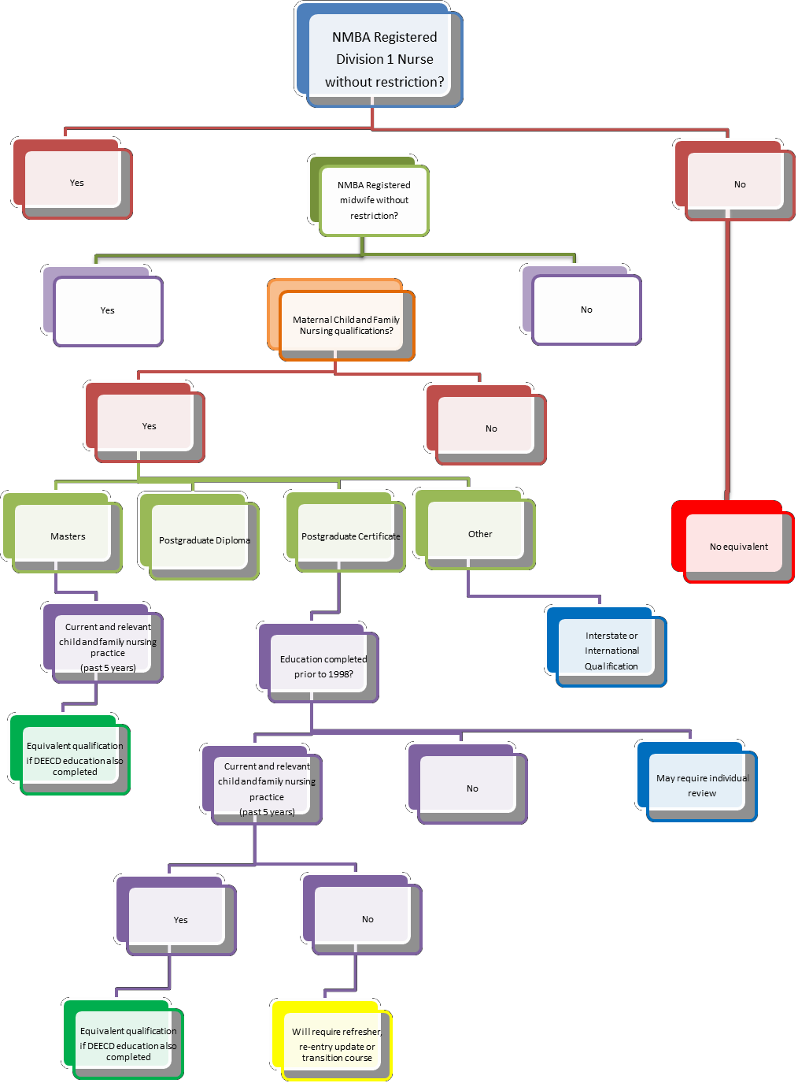Victorian Maternal and Child Health (MCH) Nurse qualification requirement equivalence flowchart.

Guidelines:
o DEECD education requirements (KAS training) available from
DEECD website
o Refresher program – recency of practice 0-5 years
o Re-entry program – recency of practice 5-10 years
o Transition program recommended if recent Postgraduate
Certificate or equivalent qualification – tailored to individual learning needs

