## Running reports in My Agency

<https://fac.dffh.vic.gov.au/my-agency-non-dffh-and-dh-staff>

This section provides step-by-step instructions for running and saving reports.

**Step 1**

From the My Agency homepage, select the hyperlink of the report you wish to run. In this example, we will run SAM02b - Current funding report.

**Figure 3 – Screenshot of the SAM02b Current funding report link**

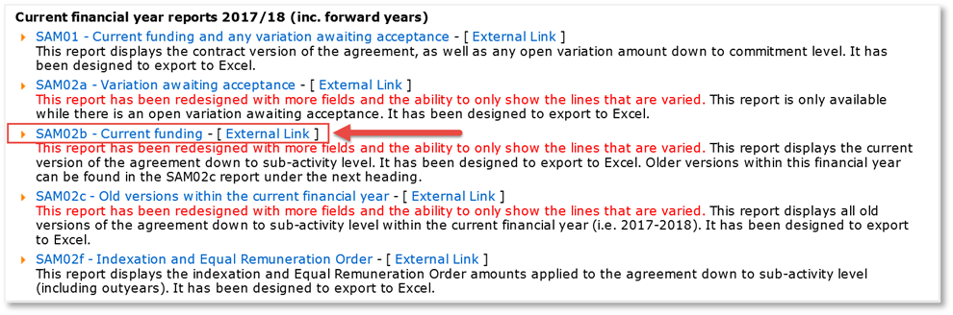

For all reports, the first page has information about the report particulars including the number of records, organisation details and time when the report was run. The report’s data is displayed from the second page onwards. Note, the parameters default to “All” and the financial year to the current financial year.

**Step 2**

Based on your requirements, select appropriate parameters from the drop-down filters at the top of the screen. After selecting your parameters, click the View Report button to refresh the data.

**Figure 4 – Screenshot of the filters and the view report button in SAM02b report**

**Select the following:**

* Department: DH
* Agreement Number: <All>
* Service Plan Template: Maternal Child Health (MCH) (unselect All)
* Area: None available
* Financial Year: 22/23
* Service Plan Division/Group/Region: <All>
* Activity: <All>

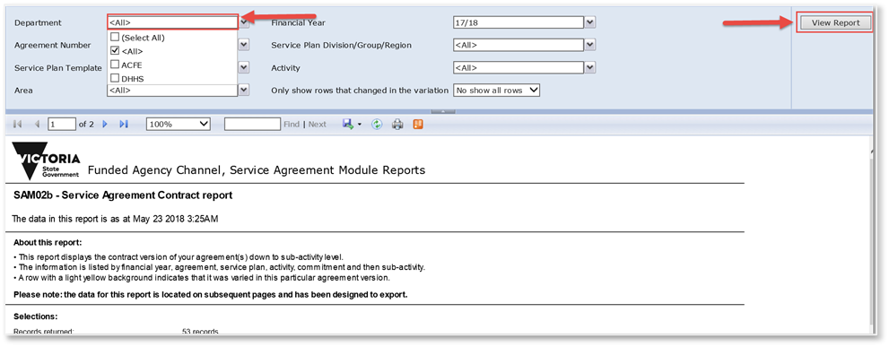

The page below is displayed. To view the next page and other pages in the report, click the forward arrow located below the parameters.

**Figure 5 – Screenshot of the forward button on the first page of SAM02b report**

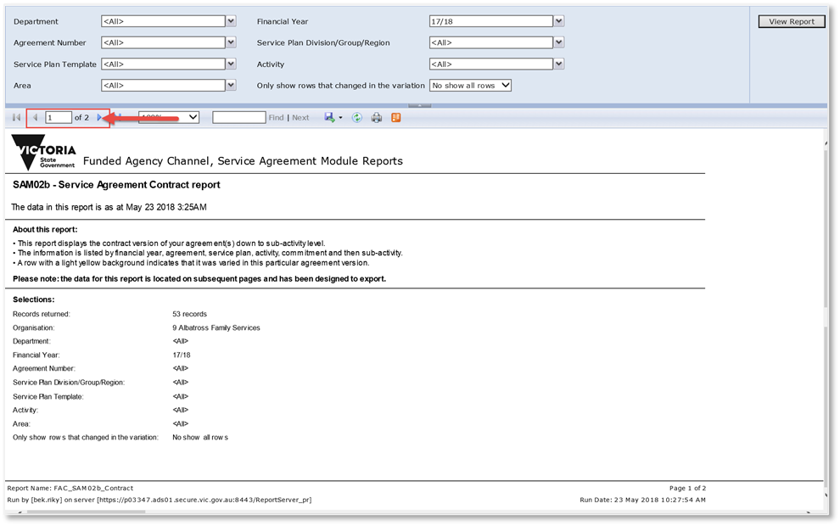

**Figure 6 – Example of the SAM02b -Current Funding report please note:**

This report will show you the funding that your organisation was receiving before the current variation was processed along with the changes that have taken place in the current variation.

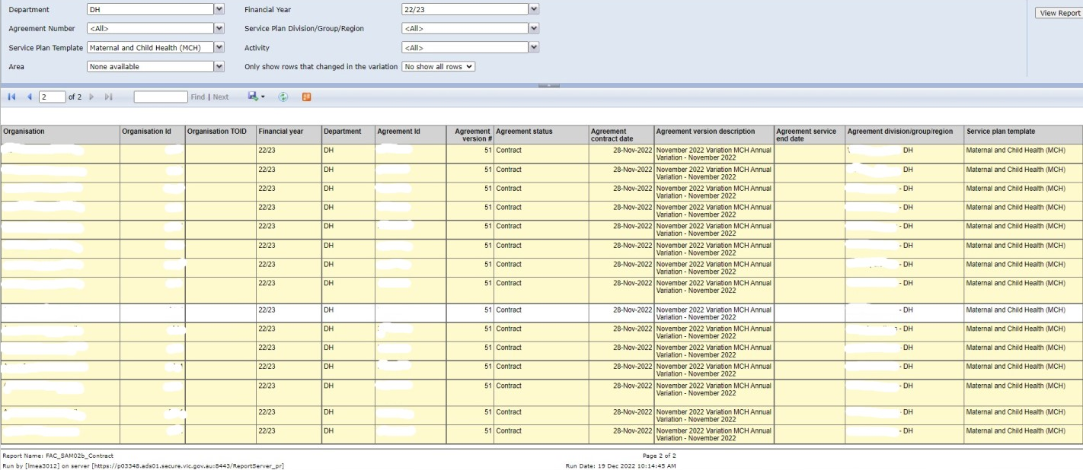

**Step 3**

To export data, click the drop-down arrow attached to the Save icon and select the format you want to export the data in. In this example, we have selected Excel.

**Figure 6 – Screenshot of the Save icon and the drop-down list of export formats**

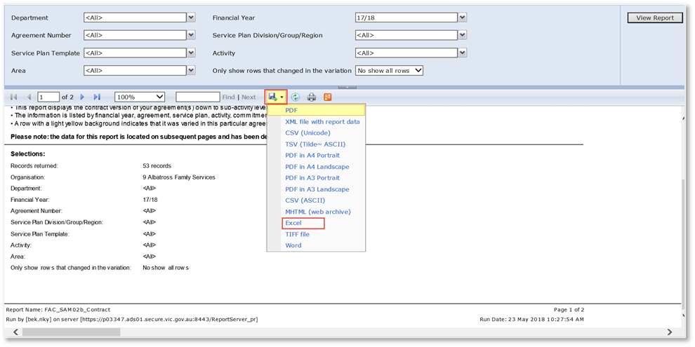

Save the exported data on your computer as per your normal process.

**Further information**

For more information and help with My Agency, visit the My Agency FAQs <https://fac.dffh.vic.gov.au/my-agency-faqs>