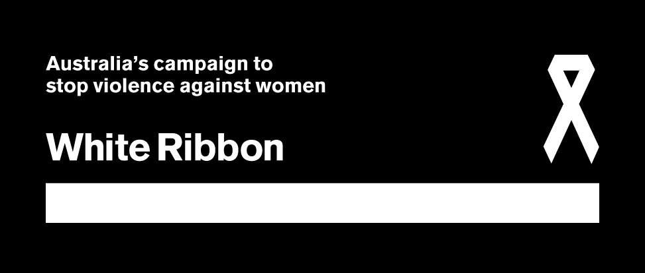

Vision
All women live in safety free
from violence and abuse.

Goal
To Change attitudes and behaviours that allow all forms of men’s violence against women to occur.

Mission
To prevent men’s violence against women in Australia through a male led campaign.
WR has two
Strategic Priorities

1. Primarily engage men’s
leadership in the WRC

2. Continue to grow a strong and sustainable organisation

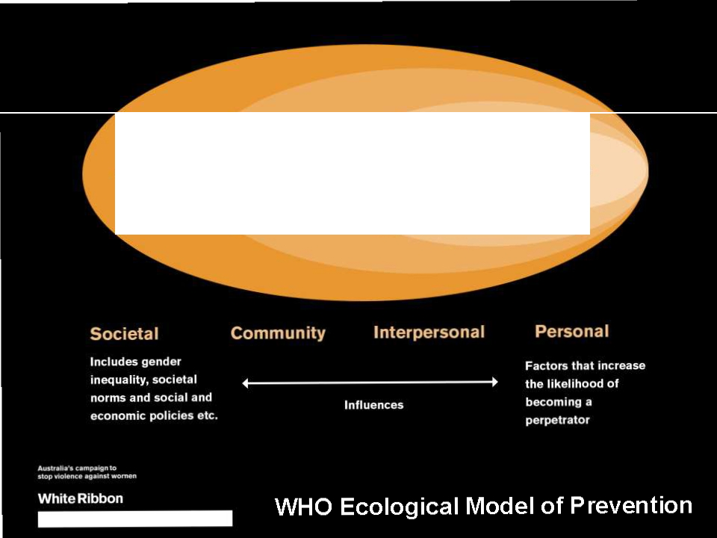

Societal Community Relationship Individual

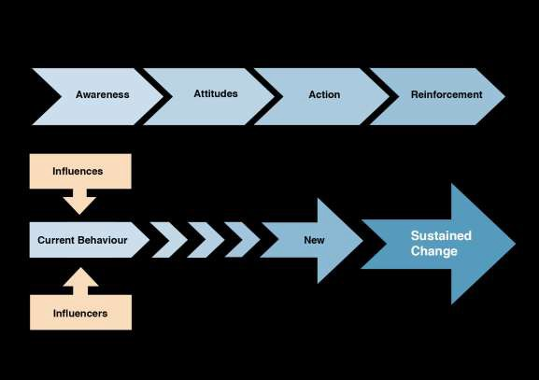Future direction informed by research

Normative change and social marketing drive sustainable change.

Identify influences and influencers that contribute to behaviours and sustainable change.

More Strategic 2012

Building on initiatives commenced
in 2010 and 2011…

WRC now

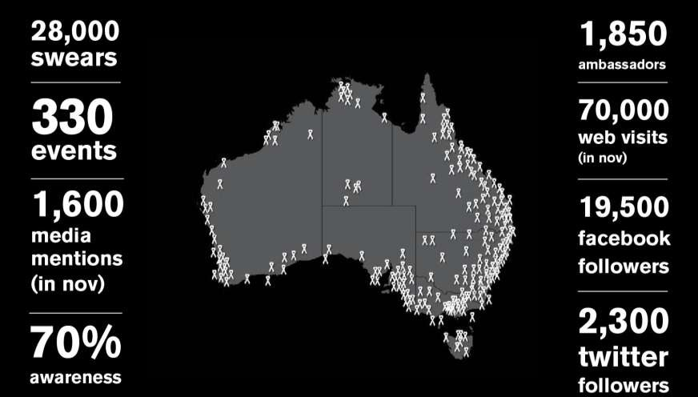

WRC now

Defined brand identity

• Clearly defined values, positioning and emotional drivers

• Branding is clean and professional and consistent across all
channels

• Branding is Brand guidelines distributed with every logo

• Branded resources available to event organisers and supporters

• State and territory committees supported nationally in delivering brand and operational integrity

WRC now

One Website, one portal

• One national, interactive website

• National portal through which all activity is recorded

• Ambassador, Events and Volunteer forms synced with the
White Ribbon database

• Simple to capture and display national Campaign information

WRC now

Merchandise reconciliation

Consignments now tracked via the Website through
a login and unique consignment ID number

Increase in direct sales

New merchandise added to the range to appeal to young men

Business development opportunities identified and
nurtured

WRC now

Database update

• State by State approach

• Skilled database use

• Consistent data entry process

WRC now

Core National Office Operational Capability

• Reviewed and revised operational systems

• Human Resources

WRC now

Ambassadors

• Successful connection of Ambassadors through phone and email
call-outs

• National Management Team in place

• Showcasing Ambassador involvement on the Website

• More resources available on the Ambassador-only page

• Expansion of Ambassador Networking platforms

• Increased Ambassador engagement in event activity

WRC now

Volunteer program development

• Volunteer policy and procedures in place

• Interns providing useful and skilled support to the office

• Volunteers are engaged and nurtured

WRC now

Policies and procedures

• Revised strategic direction and operational framework

• Online forms established (Ambassadors, volunteers etc)

• Style guide and media policy in place

• Campaign embedded in robust operational framework

WRC now

Relationships

• Strengthened relationships old and new partners

• New funding opportunities and support streams

• Many new relationships, including with Army, Telstra, FFA…

• Further developing partnerships strategy

WRC now

LGA Relationships

• Links to National Action Plan

• Many doing great PVAW work, some with links to White
Ribbon National Office

• Handful of formalised partners (e.g. City of Melbourne)

• Handful of informal partners in regular contact (e.g. City of
Darebin)

• A few involved in Workplace pilot (Moreland, Golden Plains
Shire, City of Sydney)

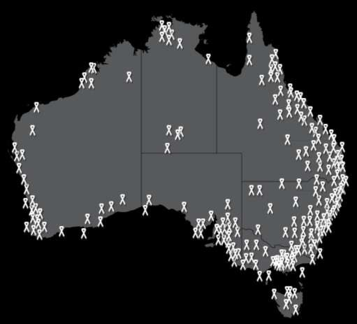WRC going forward

WRC going forward

Sustainable organisation

• Enhanced business development pathways

• Sustained funding

WRC going forward

Leading social marketing campaign

• Online communities mobilised

• Constant conversation online

• Youth engaged in the Campaign

• Extensive online resource base

• Broader online connectivity

WRC going forward

Events

• Major fundraising events replicated in every state

• Fundraising event packaged up and run nationally

• A clear event theme and purpose

• New partners and networks engaged

• Youth engaged through innovative events

WRC going forward

Engaged Ambassadors and Champions

• Established State and Territory Committees

• Committed and supportive Ambassadors

• Quality over quantity

• Participation in online and offline forums

• Female Champions recognised

WRC going forward

Youth engaged

• National expansion of Breaking the Silence

• White Ribbon in all major universities in each state

• More youth oriented events

• Greater breadth of online resources

WRC going forward

Workplaces engaged

• Implementing a best practice accreditation framework

• Developing a pilot pool

• Achieving workplace buy-in

WRC going forward

Becoming a household name

• Increased brand recognition and recall

• National brand integrity

• A valuable brand – one that companies want to be associated with

• Integrated in communities, workplaces, clubs and
educational institutions

WRC going forward

Integrated partnerships

• Enhanced connectivity across the partner organisation

• Individual needs of every partner met

• Campaign integrated into partner business model

• Key sector involvement

• New partners engaged

• Relationship longevity

The White Ribbon Cities
Initiative*

• Bottom-up/Top-down

• Engage LGAs, Local Government peak bodies, other stakeholders
• Develop joint, national activities

• Link these to the local level

• *Working title

Cities Initiative

Overview

• National office engagement of LGAs across Australia

• Supporting the White Ribbon work already underway

• Spark further local government and community involvement in the campaign

• Forms own distinct project for White Ribbon, and is based on a
partnerships model

• Over time, aim is to have a large proportion of 565 Australian LGAs endorse and participate in the initiative.

Cities Initiative

Potential benefits to engaged LGAs

• Acknowledgement of work already underway
• Access to event and communications support
• Access to ambassadors
• Support in campaign messaging
• Access to national office initiatives
• Access to work of other LGAs
• Access to work with other LGAs (including those that are far-flung)
• Increased brand integrity
• Sharing of best practice from across the country
• Involvement in the national conversation/agenda

Cities Initiative

But, what is it??

• A consultative model

• Important that we build an approach that :

• 1) Meets your needs

• 2) Provides benefit and achieves outcomes

• 3) Works in with the way that you work

•Work with you on the potential outputs

Cities Initiative

Potential outputs (pending consultation)

• Formalised relationships between engaged LGAs and White Ribbon

• Inclusion of the LGA in activities of the “Cities Collaboration”

• Tagging and branding of White Ribbon Cities/Towns/Communities

• Platforms for sharing best practice and learnings such as

– A web portal to share and communicate
– A national conference
• Community based events that are nationally oriented/ linked to a national campaign

• Mentor/Mentoree councils

Initial targets

• Engage key stakeholders (current partners, peak bodies)

• Consultation

• Further develop projected outputs

• Engage at least 1 LGA in each State and Territory by June
2013

• Engage at least 30 LGAs across Australia by June 2013

• Build the program exponentially from there.

Next steps

1. Q&A/Discussion (today)

1. Timeframe discussion

2. A questionnaire to complete (completely voluntary)

3. An MOU to consider

Contact details

Michelle Noon
National Partnerships Manager, Executive Officer for Victoria & Tasmania

Ph: 03 9602 5160
Mob: 0499 999 160 michelle.noon@whiteribbon.org.au

