Information Sharing for mch services

Making a request Correspondence Template

& SUpporting tools

Updated December 2020

Information Sharing for mch

- Correspondence Templates and SUpporting tools
________________________________________________________________________

available Information sharing Correspondence Templates
Responding to Information Request Template
Update to the Responder Post Sharing Template
Proactively Sharing Template

Contents
Making a Request Template …………………2

Key Reference Tools
Information Sharing Checklist under FVISS ….3
FVISS 1 Page Overview ………………………...4
CISS 1 Page Overview…………………………..5

Terms of Reference

Abbreviation | Meaning
CISS | Child Information Sharing Scheme
FVISS | Family Violence Information Sharing Scheme
ISE | Information Sharing Entity
ISS, or IS | Information Sharing Schemes, Information Sharing
MCH services | Maternal and Child Health services
MARAM Framework | Multi-Agency Risk Assessment and Risk Management Framework
RAE | Risk Assessment Entity(FVISS only)

For further support, please VISIT:
Guides, Templates and Tools for Information Sharing and MARAM

Making a Request Correspondence Template

[Date:]
[*Flag if 'Urgent']
Subject: Request for information under the child and family violence information sharing schemes
Request to: [Name] of [ISEOrganisation]

- ISE is also an RAE
My name is [Name] and I am a [Role] at [Organisation]. I am authorised, within Maternal and Child Health (MCH) as a prescribed ISE, to make requests under the child and family violence information sharing schemes.

I require information in relation to [Name/s], [DOB] [Address]to...
(include which is relevant);
- under the CISS - promote the wellbeing or safety of a [child/ group of children]
-under the FVISSassess or manage the risk of family violencefor aprotectionpurpose

In relation to the above, I am seeking the following information [specific detail here].
To assist you in providing the relevant information, below is some context.
[Brief explanation of the circumstances prompting the request
- outline under what context you are working with the family,
- the risk (wellbeing or safety to a child; or reason for seeking information to assess or manage a risk of family violence for protection purpose;
  - if the request is being provided to an ISE that is not also an RAE this must demonstrate reasonable belief there is a family violence risk),
  - and who is causing or being impacted by the risk (if request relates to FV and is being provided to an ISE that is not also an RAE this should outline who the perpetrator and victim survivor and how you have reached that conclusion),
  - include identified risk factors, and assessed MARAM level of risk
Please include any further information you deem relevant to appropriately manage this risk.Please get in touch should you require any further information.
Thank you,

[E-mail signature block, including Organisation details]

Key Reference Tools

Information Sharing Checklist under FVISS

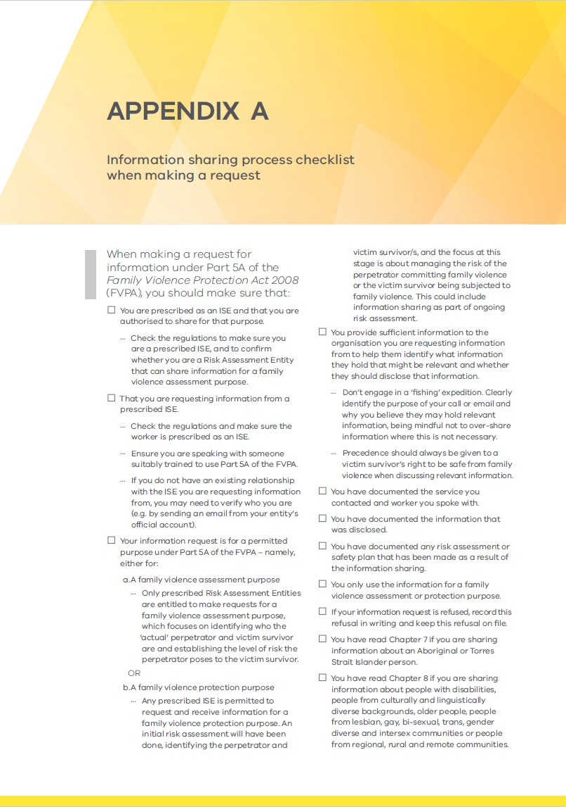
This information sharing process checklistshould guide you when making a request.

FVISS Ministerial Guidelines, p139 (April 2021 updated version)

FVISS1 Page Overview

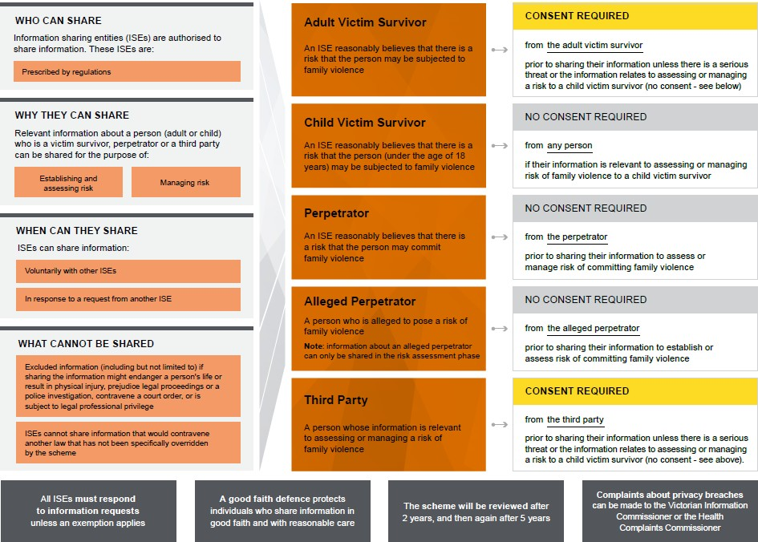

FVISS Ministerial Guidelines, p23 (April 2021 updated version)

CISS 1 Page Overview

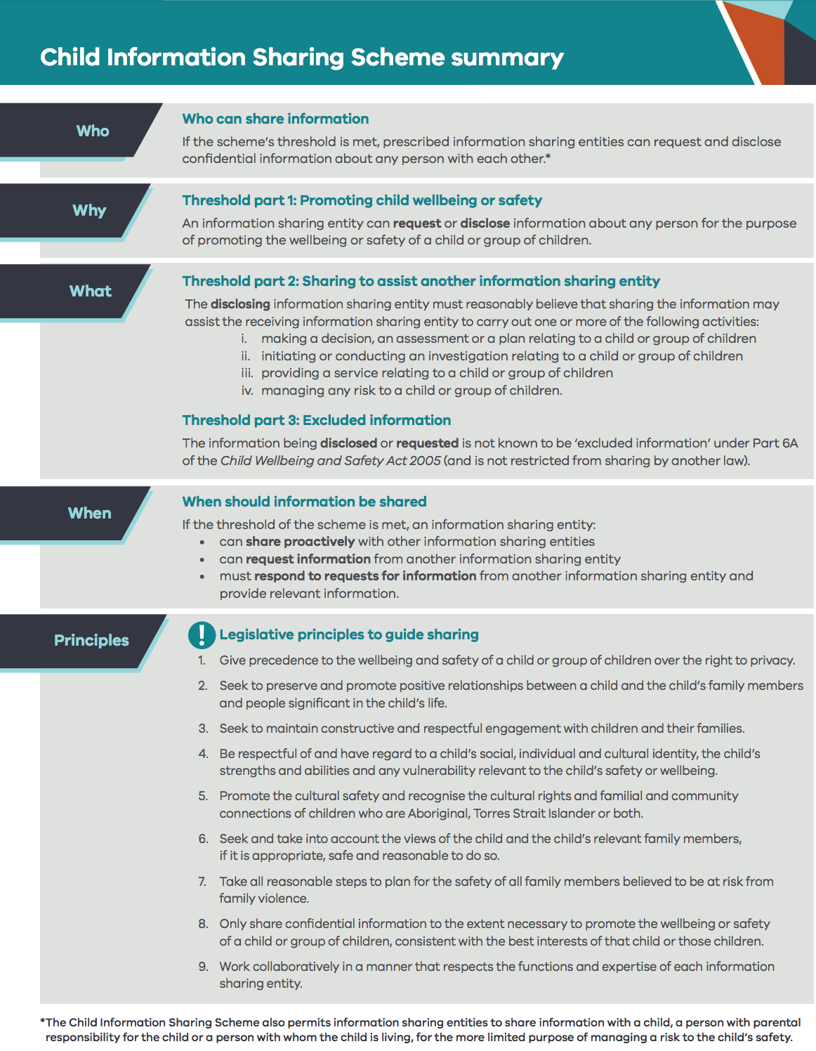

Child Information Sharing Scheme on a page

