Information Sharing for mch services

Responding to a Request

Correspondence Template

& SUpporting tools

Updated December 2021

Information Sharing for mch

- Correspondence Templates and SUpporting tools
________________________________________________________________________

available Information sharing Correspondence Templates
Making a Request Template
Update to the Responder Post Sharing Template
Proactively Sharing Template

Contents
Responding to Information Request Template...........................................2

Key Reference Tools
Information Sharing Consent Guidancefor FVISS.............................................3
Information Sharing Checklist under FVISS......................................................4
FVISS 1 Page Overview....................................................................................5
CISS 1 Page Overview......................................................................................6

Terms of Reference

Abbreviation | Meaning
CISS | Child Information Sharing Scheme
FVISS | Family Violence Information Sharing Scheme
ISE | Information Sharing Entity
ISS, or IS | Information Sharing Schemes, Information Sharing
MCH services | Maternal and Child Health services
MARAM Framework | Multi-Agency Risk Assessment and Risk Management Framework
RAE | Risk Assessment Entity(FVISS only)

For further support, please VISIT:
Guides, Templates and Tools for Information Sharing and MARAM

Responding to a Request

Correspondence Template

[Date:]
Subject: RE: Request for information under the child and family violence information sharing schemes
To: [Requester Name],[ISE Organisation]
- ISE is also an RAE

Thank you for your request for information under the child and family violence information sharing schemes.
I note the request meets the requirements of the schemes and I am providing the following relevant information:
[Include specific detail here]

The information you requested cannot be provided, given:
- your organisation does not appear to be an ISE. If you could clarify this, we may be able to proceed with your request.
- the information you have requested is not relevant to promoting the wellbeing or safety of a child or group of children, or assessing or managing the risk of family violence.
- information is excluded under section 41Q of the Child Wellbeing and Safety Act 2005 or section 144C of the Family Violence Protection Act 2008, or it would contravene another law.
- we require consent to release the information, and do not have consent.
- we do not hold any relevant information to your request.

[Add any further notes as relevant to request.]
Please get in touch should you require further assistance.
Regards,
[E-mail signature block,
including Organisation details]

Key Reference Tools

Information Sharing Consent Guidance for FVISS
This guide will help determine whether consent is required.

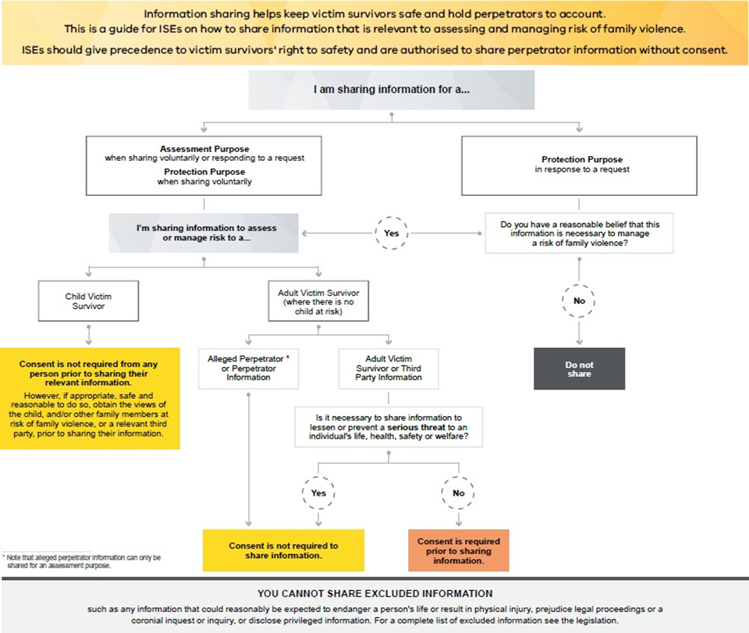

FVISS Ministerial Guidelines, p64 (April 2021 updated version)

Information Sharing Checklist under FVISS
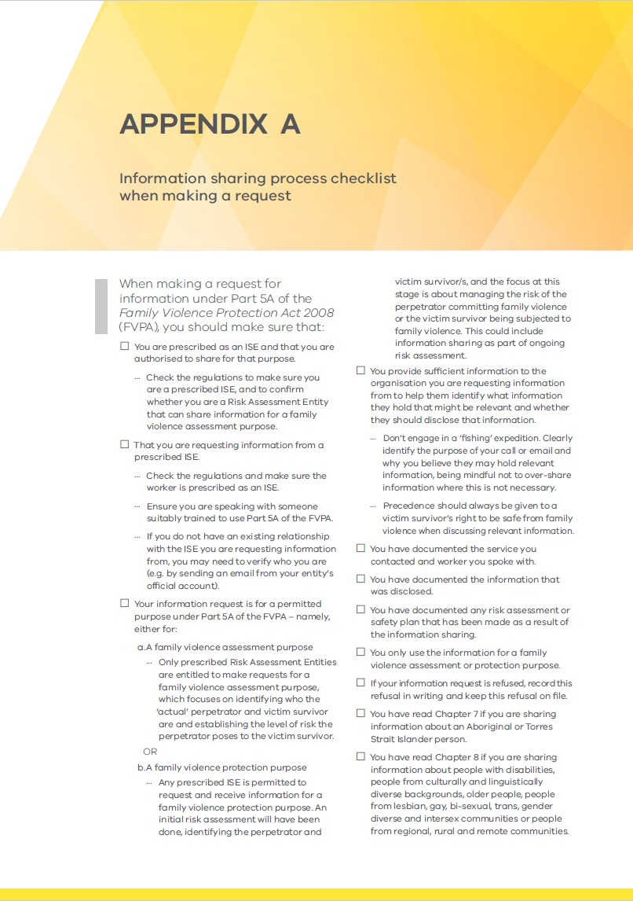
This checklist should guide you when making a request.

FVISS Ministerial Guidelines, p139 (April 2021 updated version)

FVISS1 Page Overview
This one-page overview of the FVISS will help you assess when to share information.

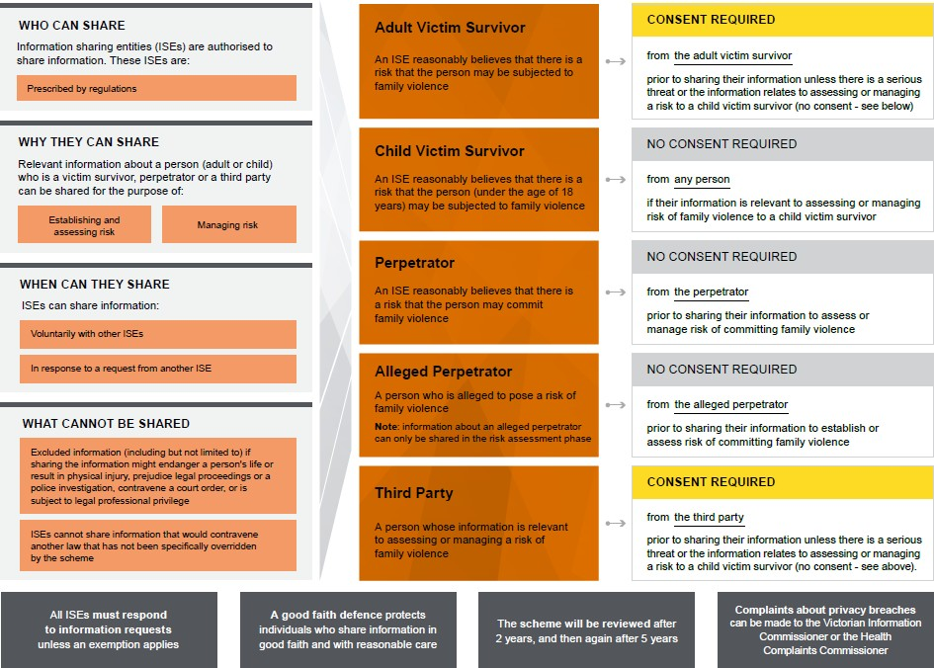

FVISS Ministerial Guidelines, p23 (April 2021 updated version)

CISS 1 Page Overview
This one-page overview of the CISS will help you assess when to share information.

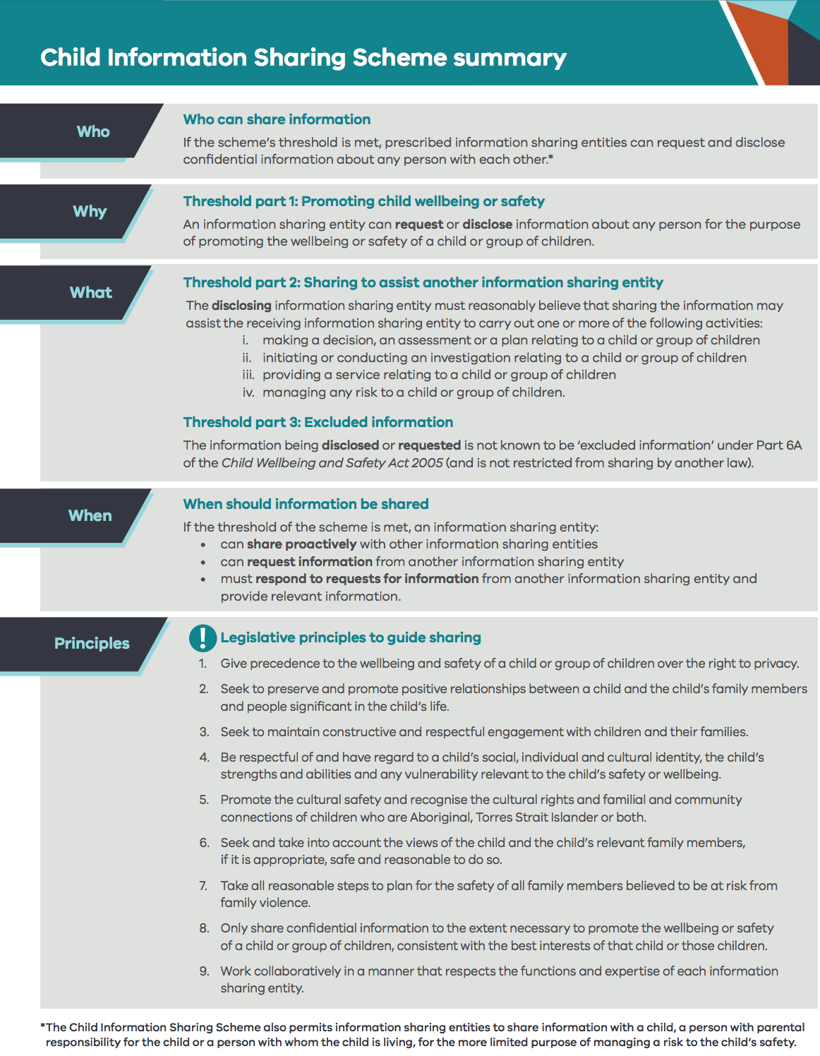

Child Information Sharing Scheme on a page (April 2021 updated version)

