Information Sharing for mch services

Update to Responder post sharing Correspondence Template

& SUpporting tools

Updated December 2021

Information Sharing for mch

- Correspondence Templates and SUpporting tools
________________________________________________________________________

available Information sharing Correspondence Templates
Making a Request Template
Responding to Information Request Template
Proactively Sharing Template

Contents
Update to the Responder Post Sharing Template……………………………..2

Key Reference Tools
Information Sharing Consent Guidanceunder FVISS………………………………3
Information Sharing Checklist for FVISS…………………………………………….4
FVISS 1 Page Overview……………………………………………………………….5
CISS 1 Page Overview………………………………………………………………...6

Terms of Reference

Abbreviation | Meaning
CISS | Child Information Sharing Scheme
FVISS | Family Violence Information Sharing Scheme
ISE | Information Sharing Entity
ISS, or IS | Information Sharing Schemes, Information Sharing
MCH services | Maternal and Child Health services
MARAM Framework | Multi-Agency Risk Assessment and Risk Management Framework
RAE | Risk Assessment Entity(FVISS only)

For further support, please VISIT...
Guides, Templates and Tools for Information Sharing and MARAM

Update to Responder post sharingCorrespondence Template

[Date:]
Subject: RE: Request for information under the child and family violence information sharing schemes.

Dear [Recipient Name],[ISE Organisation]

Thank you for promptly responding to our request for information.
The information you provided was invaluable in supporting the safety of the [child and/or victim survivor]. We used the information to:
- [Brief description of how the information was used to mitigate risk.
Eg; ‘We used the address you provided to locate the victim survivor and her daughter, allowing MCH tomaintain engagement through the appropriate local MCH service.]
Thank you for your assistance, and please get in touch if you require anyfurther information from MCH.
Regards,
[E-mail signatureblock,
including Organisation details]

Key Reference Tools

Information Sharing Consent Guidance under FVISS
This simple decision-making guidewill help determine whether consent is required.

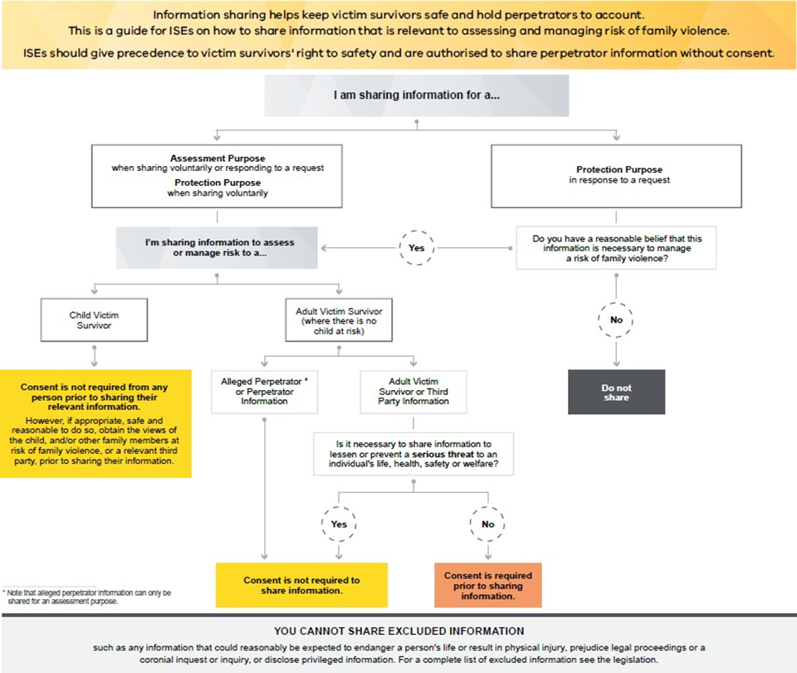

FVISS Ministerial Guidelines, p64 (April 2021 version)

Information Sharing Checklist for FVISS
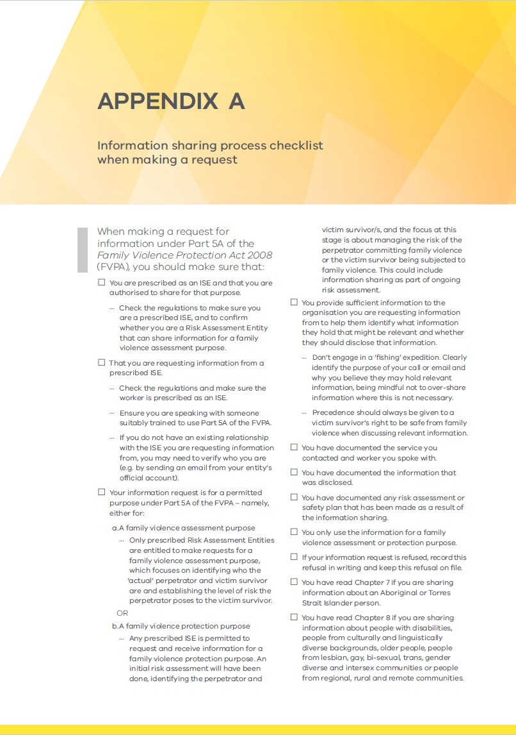
This information sharing process checklistshould guide you when making a request.

FVISS Ministerial Guidelines, p139 (April 2021 version)

FVISS1 Page Overview
This one-page overview ofthe FVISSwill help you assess when to share information.

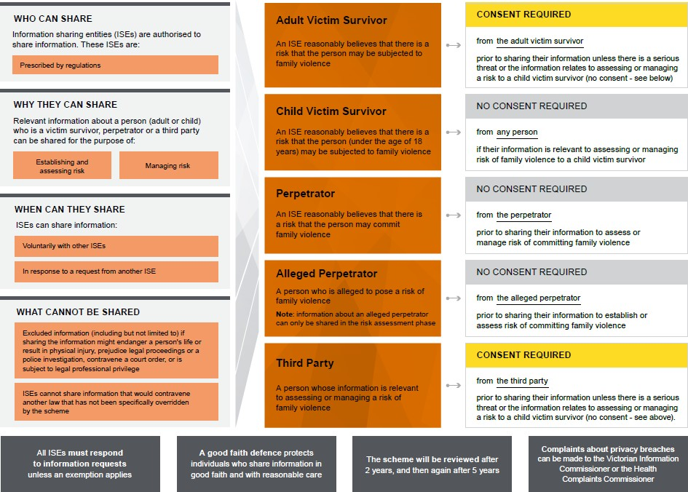

FVISS Ministerial Guidelines, p23 (April 2021 version)

CISS 1 Page Overview
This one-page overview of the CISS will help you assess when to share information.

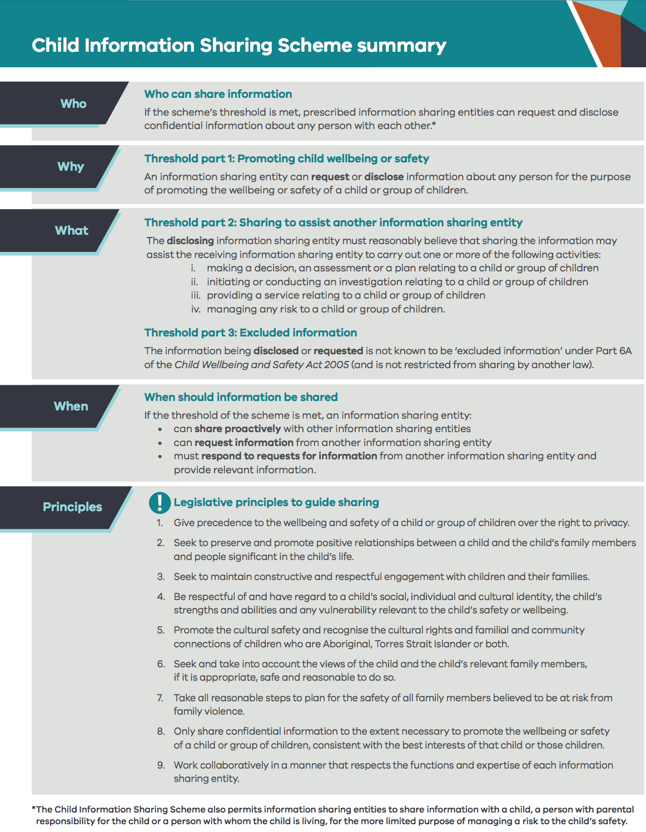
Child Information Sharing Scheme on a page

