Information Sharing for mch services

Proactively Sharing Correspondence Template

& SUpporting tools

Updated December 2021

Information Sharing for mch

- Correspondence Templates and SUpporting tools
________________________________________________________________________

available Information sharing Correspondence Templates
Making a Request Template
Responding to Information Request Template
Update to the Responder Post Sharing Template

Contents
Proactively Sharing Template...........................................2

Key Reference Tools
Information Sharing Consent Guidance under FVISS.........4
FVISS 1 Page Overview......................................................5
CISS 1 Page Overview........................................................6

Terms of Reference

Abbreviation | Meaning
CISS | Child Information Sharing Scheme
FVISS | Family Violence Information Sharing Scheme
ISE | Information Sharing Entity
ISS, or IS | Information Sharing Schemes, Information Sharing
MCH services | Maternal and Child Health services
MARAM Framework | Multi-Agency Risk Assessment and Risk Management Framework
RAE | Risk Assessment Entity(FVISS only)

For further support, please VISIT...
Guides, Templates and Tools for Information Sharing and MARAM

Proactively Sharing Correspondence Template

[Date:]
[*Flag if 'Urgent']
Subject: Proactively Sharing information under the child and family violence information sharing schemes

Dear [Requester Name],[ISE Organisation]
- ISE is also an RAE

My name is [Name] and I am a [Role] at [Organisation]. I am authorised, within Maternal and Child Health (MCH) as a prescribed ISE, to make requests under the child and family violence information sharing schemes.
I am sharing information in relation to[Name/s],to (include which is relevant);
- promote the wellbeing or safety of a[child/ group of children]
- assess or manage the risk of family violence[assessment / protectionpurpose]
In relation to the above, I am proactively sharing the following concerns to assist in appropriately managing the risk;
[Brief explanation of the circumstances prompting the proactiveshare
- outline under what context you are working with the family,
- the risk (wellbeing or safety to a child; or reason for seeking information to assess or manage a risk of family violence;
  - if the request is being provided to an ISE that is not also an RAE this must demonstrate reasonable belief there is a family violence risk),
  - and who is causing or being impacted by the risk (if request relates to FV and is being provided to an ISE that is not also an RAE this should outline who the perpetrator and victim survivor and how you have reached that conclusion)]
*Regarding consent:
MCH work with children as the client and therefore, as per information sharing legislation, no consent is required when sharing to promote the wellbeing or safety of a child, or assessing or managing a family violence risk to a child, both directly and indirectly.

Consent is only required when sharing information about an adult victim survivor or third party where there are no children at risk of family violence - unless sharing of information is necessary to lessen or prevent a serious threat to an individual’s life, health, safety or welfare.
- Consentis not required as information relates to the wellbeing or safety, or family violence risk to a child. I [have/have not]obtained the views of [Child and/or Parent/ Guardian, or Child and/or Adult Victim Survivor]
[If views were not obtained, must explain why it was unsafe, inappropriate or unreasonable to do so]
- Consentis not required as the information is sought to lessen or prevent a serious threat to [name]’s life, health safety or welfare.
- Consent was obtained...[in writing / verbally / implied (obtained in previous interaction)]from[Adult Victim/ Survivor or third party]
If you have further information which would assist me in managing this risk, or should you require any further information please get in touch via email or phone call.
Thank you,
[E-mail signature block,
including Organisation details]

Key Reference Tools

Information Sharing Consent Guidance under FVISS
This simple decision-making guide will help determine whether consent is required.

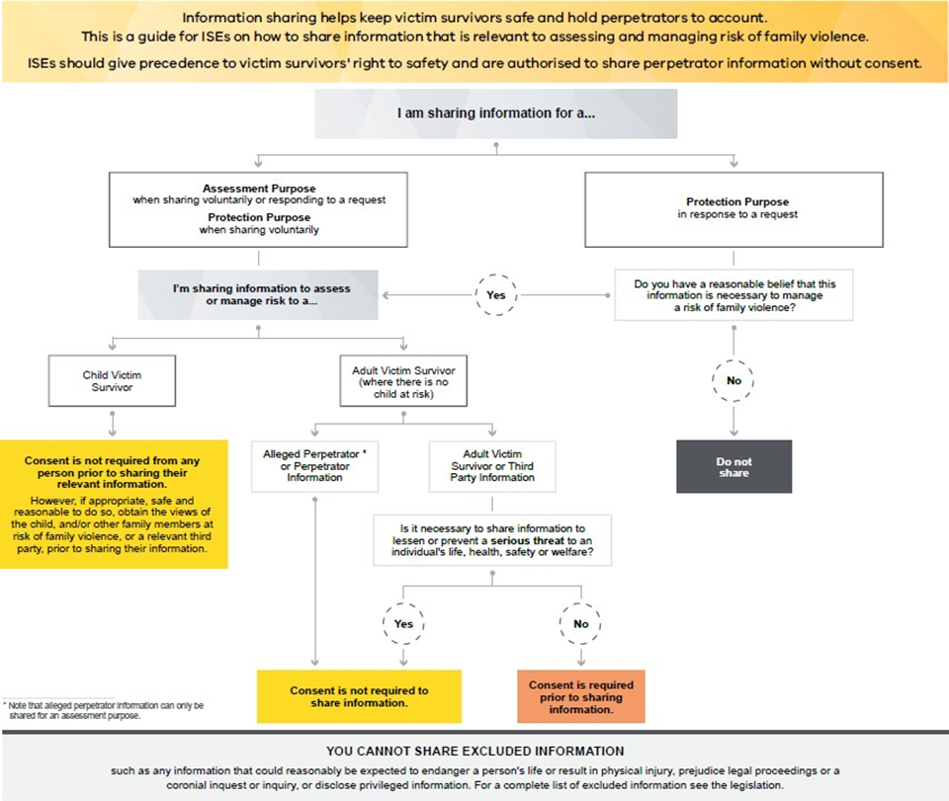

FVISS Ministerial Guidelines, p64 (April 2021 updated version)

FVISS1 Page Overview
This one-page overview ofthe FVISSwill help you assess when to share information.

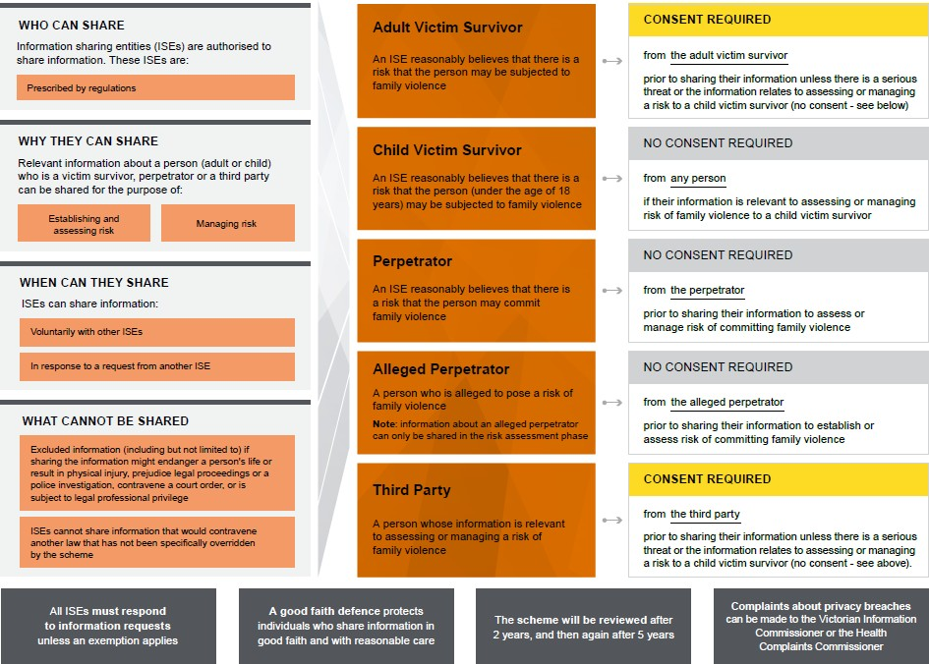

FVISS Ministerial Guidelines, p23 (April 2021 updated version)

CISS 1 Page Overview
This one-page overview of the CISS will help you assess when to share information.

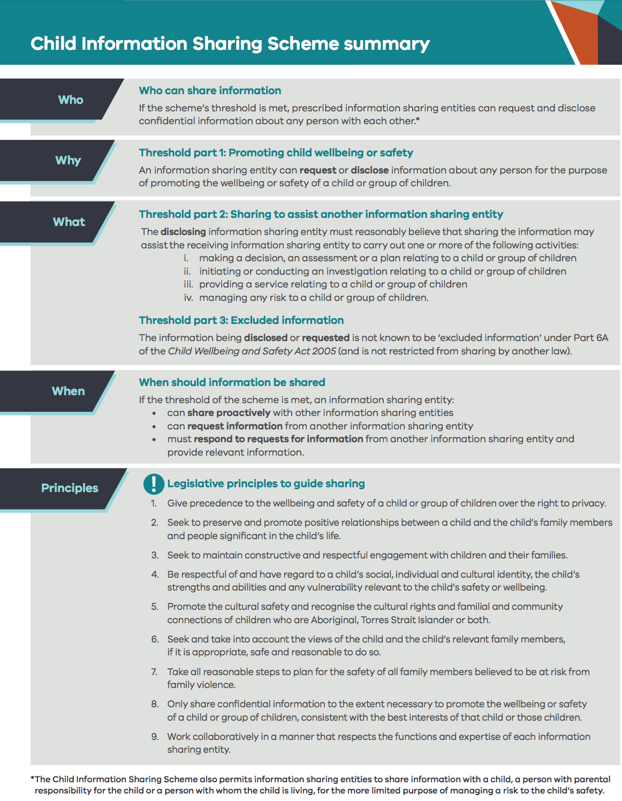

Child Information Sharing Scheme on a page

