CDIS: Recording a Stillborn birth notification
Victorian Maternal and Child Health (MCH) Child Development Information System (CDIS) April 2022

The recording of a stillborn birth notification is required to be recorded in a specific order & process. This practice note has been developed as this is a frequent user data-entry error in CDIS.
Failure to follow this process will result in the incorrect reporting of stillborn records, with the risk of these files not being counted in MCH reports or families inadvertently receiving MCH service correspondence.

The following is a step-by step process for the recording of a stillborn birth notification.
A comparable process is to be used for recording a child death within a month.

- Create a new CDIS record for the stillborn child birth notification (see Dept Health MCH website> CDIS: Birth Notification process).

- From this create a new client screen, mark that a birth notification was received.

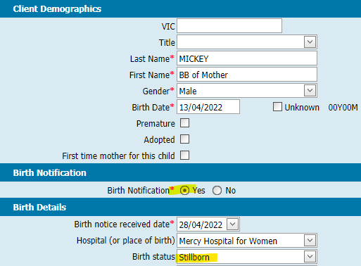
- Mark the Birth status as Stillborn.

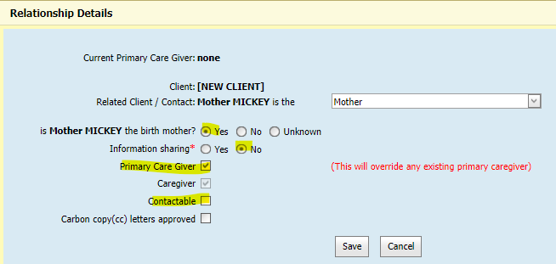
- Continue with the create client page. Add the Mother relationship, creating a new CDIS record if she does not already have one. Tick birth mother: yes, Primary care giver: yes, Information sharing: no, Contactable: no.

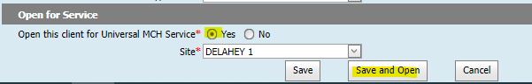
- Ensure to open the Stillborn child to service, at the usual assigned MCH site. Save & open the client file.

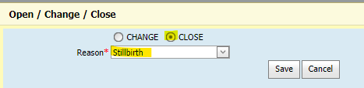
- Staying in the stillborn child record, Go to open/change/close. Close the record, selecting reason Stillborn.

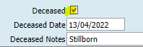
- Go to update client details. Mark the record as deceased, recording the date of birth as the deceased date. In the free-text field, record the child as Stillborn.

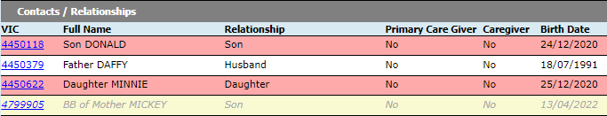
- In following the above processes, the Stillborn birth notice will be recorded accurately for reports and the client file will be clearly marked as deceased, reducing risk of a communication error with the family.

- If the mother does not appear to have other children, her CDIS record can be closed, selecting reason: Primary Care Giver of Stillborn/Deceased Child.
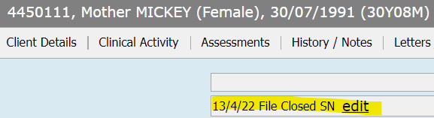
*NOTE: whenever closing any CDIS file ensure to record an EDIT note at the top of the summary page, highlighting that the file is closed for future reference.

