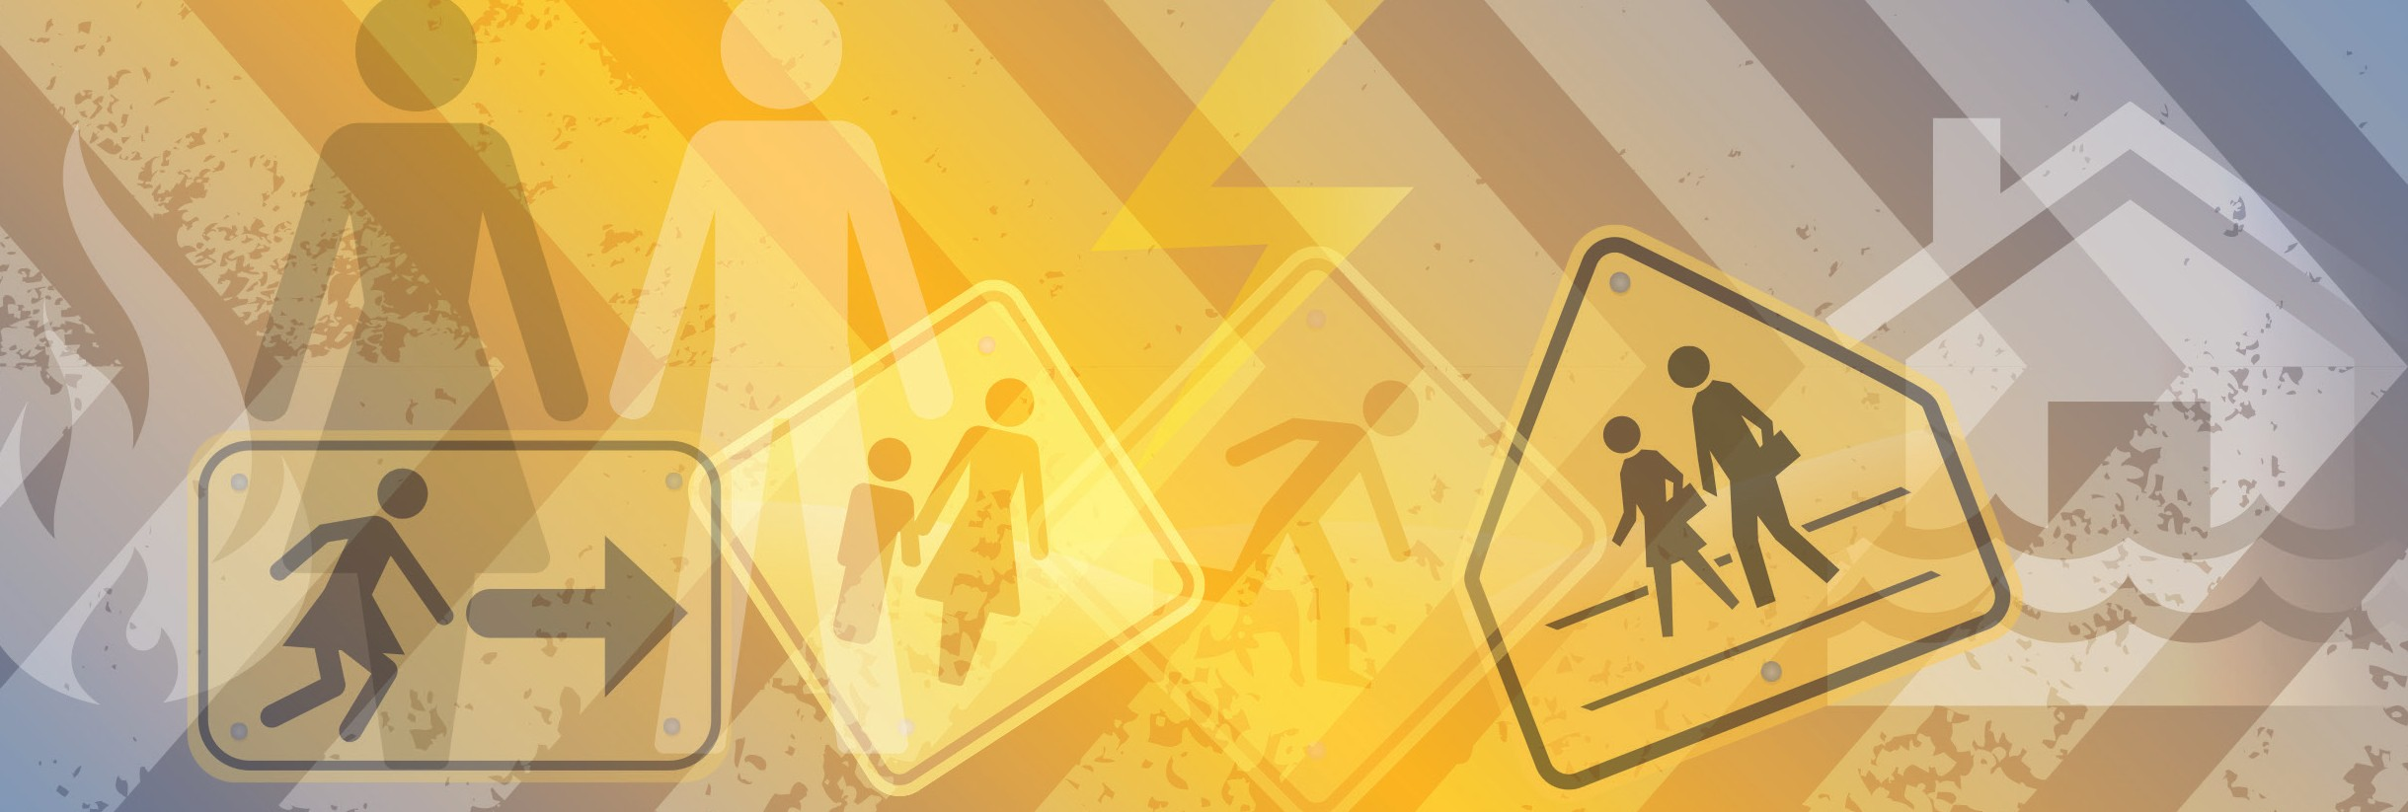

Gender and Emergency Management Factsheet

The Municipal Association of Victoria (MAV) has developed a gender and emergency management (GEM) strategy which aims to reduce the negative consequences of gender-blind practices.

Studies have shown that the incidence of family violence increases post-disaster and that there are significant differences in how men and women experience and recover from disasters. In developed countries men are more likely to die in floods and bushfires than women, and men strongly influence family decisions to stay and defend homes during bushfires, sometimes with tragic results. Mental health issues, including suicide, can
also manifest in different ways for men and women. To positively affect such outcomes, the influence of gender roles and differences must be understood and addressed.

The MAV’s GEM strategy will help councils and
their partners improve their understanding of gender
differences and incorporate gender considerations into
their emergency management policy, planning, decision-
making and service delivery. As a first step this fact
sheet has been developed to raise awareness of how
gender and emergency management interact, and to
provide practical advice to help councils make a positive
difference.

Local government’s role in emergency management

Local government plays an important role in emergency management, both in partnership with others, and through its own legislated emergency management obligations. Councils are not emergency response agencies, however they currently have the following roles:
• developing emergency management plans
• undertaking mitigation activities
• communicating with, and providing information
to, communities
• providing support to response agencies, and
• co-ordinating relief and recovery for local
communities.
Why is gender relevant to emergency management?

Women and men experience disasters differently. Gendered roles such as caring for children or knowing how to operate a generator or water pump affect how women and men will experience and recover from natural disasters. Gender often shapes how people perceive
what is risky, who makes decisions and how individuals get support or help following disasters. Being blind to these different needs can have serious implications for the protection and recovery of people caught up in disasters.

What are the benefits of integrating gender considerations into emergency management?

Addressing gender issues in emergency management will result in more resilient and equitable communities.

Emergency management is more effective when based on an understanding of the different needs, vulnerabilities, interests, capacities, contributions and coping strategies
of women and men of all ages before, during and after
disaster.

Integrating gender considerations into emergency management decision-making, policy development and service delivery will contribute to:

• better targeting of council resources
• increased community understanding of council support
and services
• reduced incidents of family violence
• reduced levels of risk taking during and after an
emergency
• greater community participation and equality, and
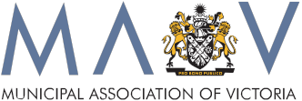• increased social, economic and community resilience.

Gender and Emergency Management Factsheet

How can local government take gender into account in emergency management?

Emergency management committees, planning and decision-making
• Include gender specific organisations and groups on
committees.
• Pre-disaster, develop an action plan with a contact list of gender specific support organisations.
• Ensure committees consider gender representation.
• Understand community composition when developing
policy and plans.
• Involve women, men, boys and girls in identifying and
addressing local hazards.
• Take into account different needs and capacities of women and men, girls and boys.
• Identify groups of women and men who may be
particularly vulnerable in the community.
• Ensure disaster recovery packages are gender
equitable.

Relief centres
• Ensure there is a safe space for women and children.
• Ensure relief staff are appropriately trained in identifying family violence and other predatory behaviours.
Communication
• Tailor disaster risk and recovery information for
women and men when needed.
• Take notice of who attends community meetings and
make it easier for women and men to participate.

Evaluation and performance measures
• Ask questions about whether and how gender is
considered in emergency management policies, plans,
activities and the use of resources.
• Analyse data by gender and age.
• Include a gender focus in research.

Volunteers
• Recognise how gender stereotyping affects the
development and sustainability of emergency management volunteer groups.
• Partner with existing women’s and men’s groups.
• Extend the volunteer opportunities and roles available to women, men, girls and boys.

Recovery
• Ensure support is available in ways that both men and
women will find useful.
• Provide women-friendly and men-friendly activities and
outreach services.
• Provide mental health and family violence information in formats and places where women and men already meet and support each other.

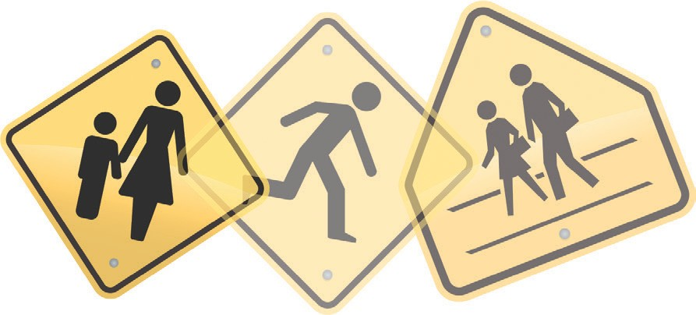Useful resources and information
Municipal Association of Victoria
MAV gender and emergency management strategy
Further information and resources can be found on the
MAV website.
www.mav.asn.au/policy-services/emergency-management
emergencymgt@mav.asn.au
Women’s Health Goulburn North East
Information sheets, check lists, training, presentations and stories. www.whealth.com.au/publications_information_sheets.html
Department of Human Services
Emergency Management Planning for Children and
Young People: Planning guide for Local Government
www.dhs.vic.gov.au
Australian Journal of Emergency Management
AJEM Volume 28 Number Two, April 2013
- Gender edition
www.em.gov.au/ajem

Australian Emergency Management Knowledge Hub Gender Resources Pack www.emknowledge.gov.au/resource/?id=3526
Bushfire Cooperative Research Centre Fire Note 101 - Gender and bushfire www.bushfirecrc.com/resources/firenote/gender-and-bushfire
Beyondblue
Beyondblue is an independent, not-for-profit organisation working to increase awareness and understanding of depression and anxiety in Australia. www.beyondblue.org.au
1800 RESPECT
1800 RESPECT is a 24/7 national counselling helpline, information and support for people experiencing sexual assault or domestic and family violence. www.1800respect.org.au

